|  |  |
| --- | --- |
|  | **FPT ACADEMY INTERNATIONAL**  **FPT – APTECH COMPUTER EDUCATION** |

**Centre Name: ACE-HCMC-2-FPT.**

**Address: 21Bis Hau Giang, Tan Son Nhat, Ho Chi Minh City, Viet Nam.**

**SMART BUILDING MANAGEMENT SYSTEM**  **Design Document**

|  |  |  |
| --- | --- | --- |
| **Supervisor:** | Mr. TRUONG THANH TRUNG | |
| **Semester:** | 1 | |
| **Batch No:** | T3.2308.A0 | |
| **Group No:** | 1 | |
| **Team member:** | **Full name** | **Roll No.** |
| 1. | Huỳnh Tấn Lực | Student1507630 |
| 2. | Đặng Trí Thức | Student1438991 |

**Month**: September **Year**: 2025

Table of Contents

REVIEW 1: Problem Definition & Requirement 4

1. INTRODUCTION 4

1.1 Background and significance of the topic 4

1.2 Main and secondary objectives 5

1.3 Project scope 6

1.4 System users 7

2. PROBLEM IDENTIFICATION 7

2.1 Current situation and difficulties 7

2.2 Problems to be addressed 9

2.3 Proposed solutions 10

3. SYSTEM REQUIREMENTS 11

3.1 Non-functional requirements 11

3.2 Functional requirements 12

3.3 Hardware/software requirements 14

4.TASK SHEET FOR REVIEW 1. 16

REVIEW 2 Architecture & Design 17

1. SYSTEM ARCHITECTURE 18

1.1 3-tier architecture (Presentation, Business Logic, Data Access) 18

1.2 Detailed roles of each tier + technologies used 18

1.3 Overall system architecture 21

1.4 Microservices architecture diagram 21

1.5 Microservices details 22

1.6 Data flows in the architecture 26

2. DATA FLOW DIAGRAM (DFD) 30

2.2 Overall data flow diagram 39

3. USE CASE DIAGRAM 39

3.2 Staff Use Cases (Maintenance handling, facility management) 47

3.3 Resident Use Cases (Booking, payment, receiving notifications) 51

TASK SHEET FOR REVIEW 2. 59

REVIEW 3 DATABASE & GUI DESIGN SMART BUILDING MANAGEMENT SYSTEM 61

1. DATABASE DESIGN 62

1.1 List of main entities 62

1.2 ERD (Entity-Relationship Diagram) 64

1.3 Detailed tables (attributes, primary keys, foreign keys) 64

1.4 Relationships between tables 65

2. USER INTERFACE (UI/UX) DESIGN 66

2.1 Website interface 66

2.2 Mobile App interface 68

2.3 UI/UX principles 70

Have successfully Designed & Developed

SMART BUILDING MANAGEMENT SYSTEM

Approved by: Mr.TRUONG THANH TRUNG

**Date of Issue: 09/2025**

# 

# REVIEW 1: Problem Definition & Requirement

## 1. INTRODUCTION

### 1.1 Background and significance of the topic

In the current context of rapid urbanization, managing apartment buildings

has become extremely complex and challenging. Traditional management systems

based on paperwork and manual processes no longer meet the increasing needs

for management efficiency, resident services, and operational optimization.

The current situation shows:

• Rapid increase in the number of apartment buildings and units

• Manual management processes causing delays and errors

• Difficult communication between management board and residents

• Lack of effective monitoring and reporting systems

• Increasingly diverse needs for amenities and services

Significance of the topic:

• Solve real-world problems in apartment management

• Apply modern technology to automate processes

• Improve service quality and resident experience

• Create an intelligent, sustainable management platform

• Contribute to smart city development

### 1.2 Main and secondary objectives

Main objectives:

• Develop a comprehensive and integrated building management platform

• Automate administrative processes and minimize manual work

• Improve communication and information between management and residents

• Optimize facility booking and maintenance management

• Simplify billing, payment processes, and financial management

• Provide mobile access to building services

• Create an integrated, friendly, and easy-to-use interface

Secondary objectives:

• Implement real-time notification and update systems

• Provide comprehensive reports and analytics on building operations

• Ensure high scalability and security of the system

• Create a responsive and accessible user interface

• Implement multi-language support (Vietnamese/English)

• Provide comprehensive documentation and user guides

• Integrate with external systems when needed

### 1.3 Project scope

The project scope includes the following main areas:

Core management functions:

• User and role management (Admin, Staff, Resident)

• Apartment and unit management in the building

• Facility booking and management system

• Maintenance request and incident handling

• Invoice and payment management

• Internal notification and communication system

Technical features:

• Web-based administrative dashboard

• Mobile application for residents

• Integrated RESTful API architecture

• Real-time notification system

• Detailed role and permission management

• Data backup and security

### 1.4 System users

Primary users:

• Apartment building management board (Admin)

• Operations and maintenance staff (Staff)

• Residents living in the building (Resident)

• Apartment owners

User characteristics:

• Admin: Has management knowledge, basic computer skills

• Staff: Operations staff, needs a simple interface

• Resident: Diverse in age, varying technology skills

• Owners: Concerned about financial information and reports

## 2. PROBLEM IDENTIFICATION

### 2.1 Current situation and difficulties

Current building management systems face many important challenges:

Management processes:

• Manual, time-consuming administrative processes

• Complex paperwork, prone to loss and errors

• Lack of effective monitoring and reporting systems

• Difficulties in storing and retrieving information

Communication and information:

• Lack of real-time communication between management and residents

• Delayed, unsynchronized notifications

• Difficulty collecting feedback from residents

• Lack of official and effective communication channels

Facility and service management:

• Manual, inefficient facility booking systems

• Difficulties in scheduling and maintenance management

• Lack of usage tracking and reporting

• Slow maintenance request processing

Finance and billing:

• Complex, manual billing and payment processes

• Difficulties tracking payments and outstanding debts

• Lack of automatic warning and reminder systems

• Financial reports not accurate and timely

Access and usage:

• Limited access to building information and services

• Lack of mobile access for modern users

• Unfriendly, hard-to-use interfaces

• Poor integration across management functions

### 2.2 Problems to be addressed

Based on the analysis, the main issues to solve include:

Process issues:

• Automate manual management processes

• Standardize request handling and reporting procedures

• Optimize workflows and task assignment

Communication issues:

• Improve communication and notification systems

• Create effective two-way communication channels

• Ensure information is delivered timely and accurately

Facility management issues:

• Optimize facility booking processes

• Improve maintenance and incident management

• Increase resource utilization efficiency

Financial issues:

• Simplify payment and invoice management

• Automate calculation and invoice generation

• Improve financial tracking and reporting

Access issues:

• Enhance access to information

• Develop a mobile application for residents

• Integrate management functions into a single platform

### 2.3 Proposed solutions

The proposed Smart Building Management System includes:

System architecture:

• Comprehensive web management platform for admin and staff

• Mobile application for residents

• Integrated RESTful APIs to connect components

• 3-tier architecture: Presentation, Business Logic, Data Access

Technology solutions:

• Backend: Spring Boot with Java 17

• Frontend: React.js with TypeScript

• Mobile: Flutter cross-platform

• Database: MySQL

• Authentication: JWT with Spring Security

Key features:

• User management and role-based access control

• Integrated apartment and resident management

• Smart facility booking system

• Maintenance and incident management

• Automated billing and payment system

• Real-time notification and communication

## 3. SYSTEM REQUIREMENTS

### 3.1 Non-functional requirements

Performance:

• System response time < 2 seconds for 95% of requests

• Support 1000+ concurrent users

• 99.9% system availability

• Optimized database queries for large datasets

• Application startup time < 5 seconds

Security:

• Encrypted data transmission (HTTPS/TLS)

• Secure user authentication (JWT tokens)

• Role-based access control (RBAC)

• Encryption of sensitive data

• Regular security checks and penetration tests

• Protection against SQL injection and XSS

Scalability:

• Horizontal scalability

• Load balancing support

• Database sharding strategies

• Microservices architecture support

• Performance optimization for high load

User experience (UX/UI):

• Intuitive, easy-to-use user interface design

• Responsive design for all device types

• Accessibility compliance (WCAG 2.1)

• Multi-language support (Vietnamese/English)

• Consistent, easy-to-learn interface

• Fast response for user interactions

Reliability:

• 24/7 stable system operation

• High fault recovery capability

• Automatic, frequent data backups

• Detailed logging for debugging and monitoring

### 3.2 Functional requirements

User and role management:

• User registration and authentication with email verification

• Role-based access control (Admin, Staff, Resident)

• Manage and update user profiles

• Password reset and account recovery

• Session management and security

Apartment and resident management:

• Register apartments and manage detailed information

• Assign residents and link them to apartments

• Track apartment status (vacant, occupied, maintenance)

• Maintenance history and related documents

• Manage contact and emergency information

Facility and service management:

• Facility catalog and availability

• Online booking and reservations

• Usage tracking and statistical reports

• Maintenance scheduling and coordination

• Manage facility usage fees

Billing and payment system:

• Automatically generate periodic invoices

• Support multiple payment methods

• Track payments and transaction history

• Late payment notifications and automatic reminders

• Financial reports and statistics

Notification and communication system:

• Create and distribute building-wide notifications

• Collect feedback from residents

• Manage support tickets and requests

• Real-time notifications and alerts

• Communication and exchange history

Reporting and analytics:

• Overview dashboard with statistics

• Detailed reports on building operations

• Trend analysis and performance

• Export reports to PDF/Excel

• Charts and visual graphs

### 3.3 Hardware/software requirements

Server requirements:

• CPU: Intel Core i5 or higher, or equivalent AMD Ryzen 5

• RAM: Minimum 8GB, recommended 16GB

• Storage: SSD 256GB or more

• Operating system: Windows 10/11, Ubuntu 20.04 LTS

• Network connection: 100Mbps or higher

Client requirements:

• Web browsers: Chrome 90+, Firefox 88+, Edge 90+, Safari 14+

• Mobile devices: Android 8.0+, iOS 12.0+

• RAM: Minimum 4GB for mobile devices

• Stable internet connection

Database requirements:

• MySQL

• Redis 6+ for cache and session

• Storage capacity: Minimum 100GB

• Automatic daily backups

Development tools:

• IDE: IntelliJ IDEA, Visual Studio Code, Android Studio

• Version control: Git with GitHub

• Database tools: pgAdmin, Redis Desktop Manager

• Testing tools: JUnit 5, Jest, Flutter testing framework

Technology requirements:

• Backend: Spring Boot 3.x, Java 17+

• Frontend: React.js 18+, TypeScript 5+

• Mobile: Flutter 3.x, Dart 3+

• Database: MySQL

• Authentication: JWT, Spring Security

• Build tools: Maven, npm, Flutter CLI

## 4.TASK SHEET FOR REVIEW 1.

### 

| Task ID | Task Description | Assignee | Start Date | End Date | Status | Notes |
| --- | --- | --- | --- | --- | --- | --- |
| R1-01 | Research and document background and significance of the topic | Huỳnh Tấn Lực | 25/08/2025 | 03/09/2025 | Completed | Urbanization, manual processes, communication gaps |
| R1-02 | Define main and secondary objectives | Đặng Trí Thức | 25/08/2025 | 05/09/2025 | Completed | Automation, UX, scalability, security, i18n |
| R1-03 | Specify project scope and core management functions | Huỳnh Tấn Lực | 25/08/2025 | 05/09/2025 | Completed | Users, apartments, facilities, billing, notifications |
| R1-04 | Identify system users and their characteristics | Đặng Trí Thức | 25/08/2025 | 05/09/2025 | Completed | Admin, Staff, Resident, Owner; skills and needs |
| R1-05 | Analyze current situation and difficulties | Huỳnh Tấn Lực | 25/08/2025 | 05/09/2025 | Completed | Process, communication, facility, finance, access issues |
| R1-06 | Identify key problems to be addressed | Đặng Trí Thức | 25/08/2025 | 05/09/2025 | Completed | Process automation, notifications, booking, payments |
| R1-07 | Propose overall system solutions and architecture | Huỳnh Tấn Lực | 25/08/2025 | 05/09/2025 | Completed | Web + Mobile + REST APIs; 3-tier architecture |
| R1-08 | Define non-functional requirements (performance, security, scalability, UX) | Đặng Trí Thức | 25/08/2025 | 05/09/2025 | Completed | <2s response, 99.9% uptime, TLS, JWT, RBAC |
| R1-09 | Define functional requirements by module | Huỳnh Tấn Lực | 25/08/2025 | 05/09/2025 | Completed | User, Apartment, Facility, Billing, Notifications, Reporting |
| R1-10 | Specify hardware/software and tooling requirements | Đặng Trí Thức | 25/08/2025 | 05/09/2025 | Completed | Server specs, clients, DB, Redis, tooling |
| R1-11 | Consolidate Review 1 document and obtain approval | Huỳnh Tấn Lực | 25/08/2025 | 05/09/2025 | Completed | Prepare final PDF/MD for submission |

# REVIEW 2 Architecture & Design

### 

## 1. SYSTEM ARCHITECTURE

### 1.1 3-tier architecture (Presentation, Business Logic, Data Access)

The Smart Building Management System is designed with a traditional 3-tier

architecture to ensure clear separation of concerns and easy maintenance and

scalability.

### 1.2 Detailed roles of each tier + technologies used

**Presentation Layer (User Interface):**

Roles:

• Provide interactive user interfaces

• Process user input and display output

• Ensure the best user experience

• Handle responsive design for different devices

Technologies used:

• **Web Application (Admin Dashboard):**

- React.js 18+ with TypeScript 5+

- Tailwind CSS for styling

- React Router for navigation

- Axios for HTTP requests

- React Query for state management

• **Mobile Application (Resident App):**

- Flutter 3.x with Dart 3+

- Material Design 3

- Provider for state management

- HTTP package for API calls

- Shared Preferences for local storage

**Business Logic Layer:**

Roles:

• Process the core business logic of the system

• Execute business rules and validation

• Orchestrate between presentation and data access layers

• Handle authentication and authorization

• Manage business rules and workflows

Technologies used:

• **Spring Boot 3.x Framework:**

- Spring Security for authentication and authorization

- Spring Data JPA for data access

- Spring Web for REST APIs

- Spring Validation for input validation

- Spring Mail for email services

- Spring Scheduling for background tasks

• **Business Services:**

- User Management Service

- Apartment Management Service

- Facility Booking Service

- Billing Service

- Notification Service

- Maintenance Service

**Data Access Layer:**

Roles:

• Manage data storage and retrieval

• Ensure data integrity and security

• Optimize query performance

• Manage connection pooling and caching

• Backup and recovery

Technologies used:

• **Primary Database:**

- MySQL

- Hibernate ORM for object-relational mapping

- Connection pooling with HikariCP

- Database migration with Flyway

• **Cache Layer:**

- Redis 6+ for session storage

- Redis for frequently accessed caching

- Redis for real-time notifications

• **File Storage:**

- Local file system for development

- Cloud storage (AWS S3) for production

- Image optimization and compression

### 1.3 Modular Monolith Architecture

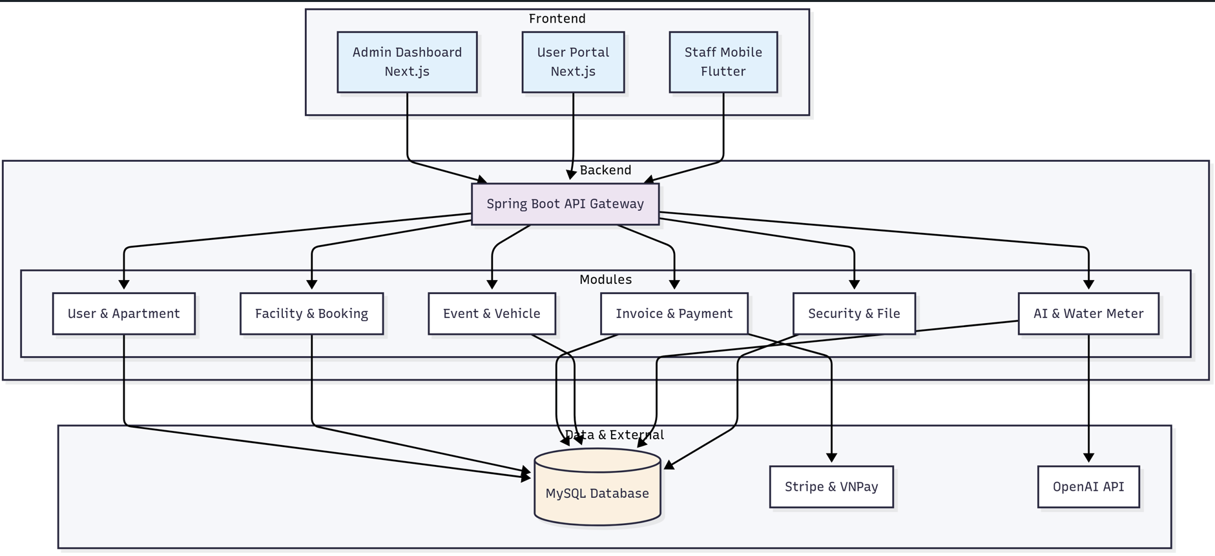

### 1.4  Modular Monolith Architecture Diagram

### 

### 1.5 Modular Monolith modules

#### 1.5.1 System Architecture Overview

The Smart Building Management System uses a **Modular Monolith** architecture - a single Spring Boot application with clear modular structure.

Key Features:

- **Single Application**: One Spring Boot app with 11 modules

- **Shared Database**: One MySQL database for all modules

- **Multiple Frontends**: 3 frontend applications (Admin, User, Mobile)

#### 1.5.2 Overall System Structure

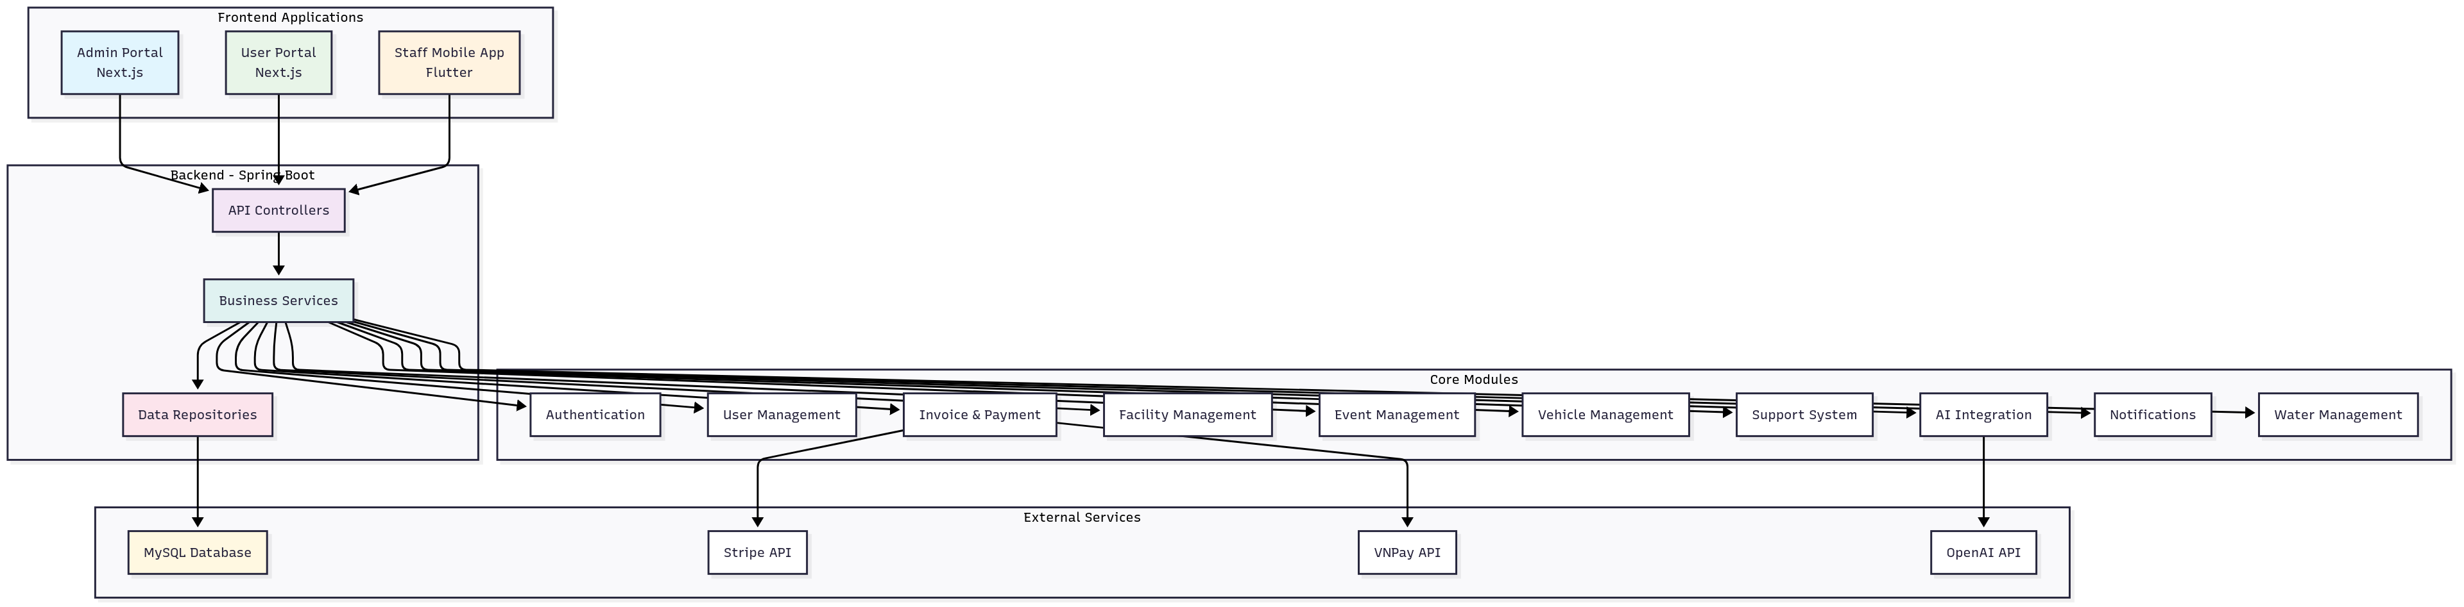

1.5.3 Backend Structure Details

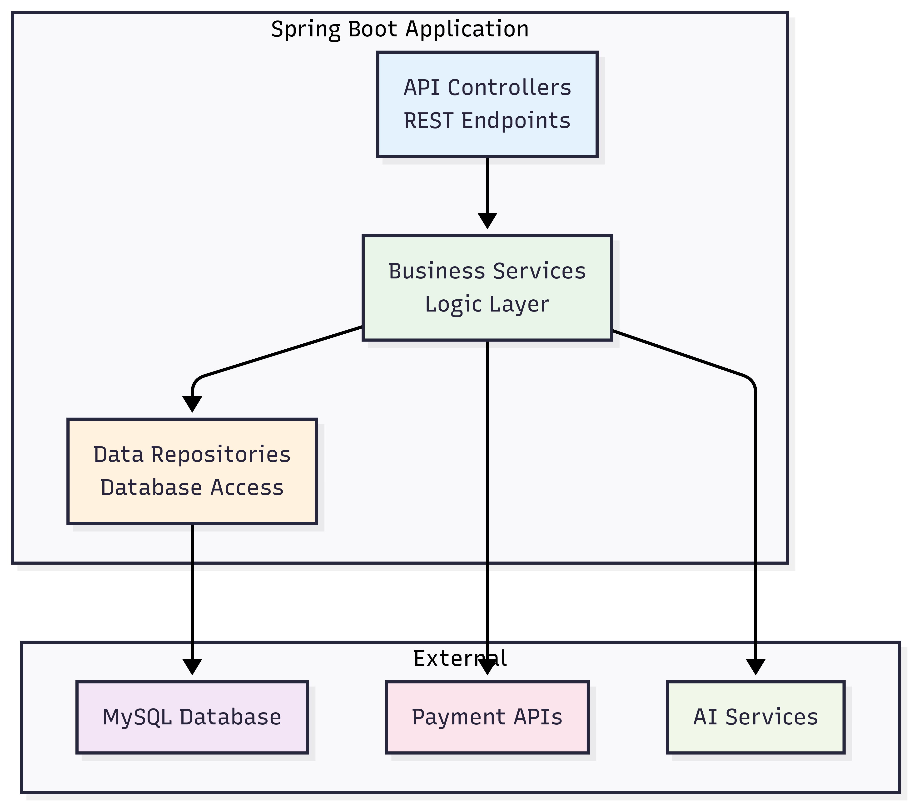

#### 1.5.4 Main Modules

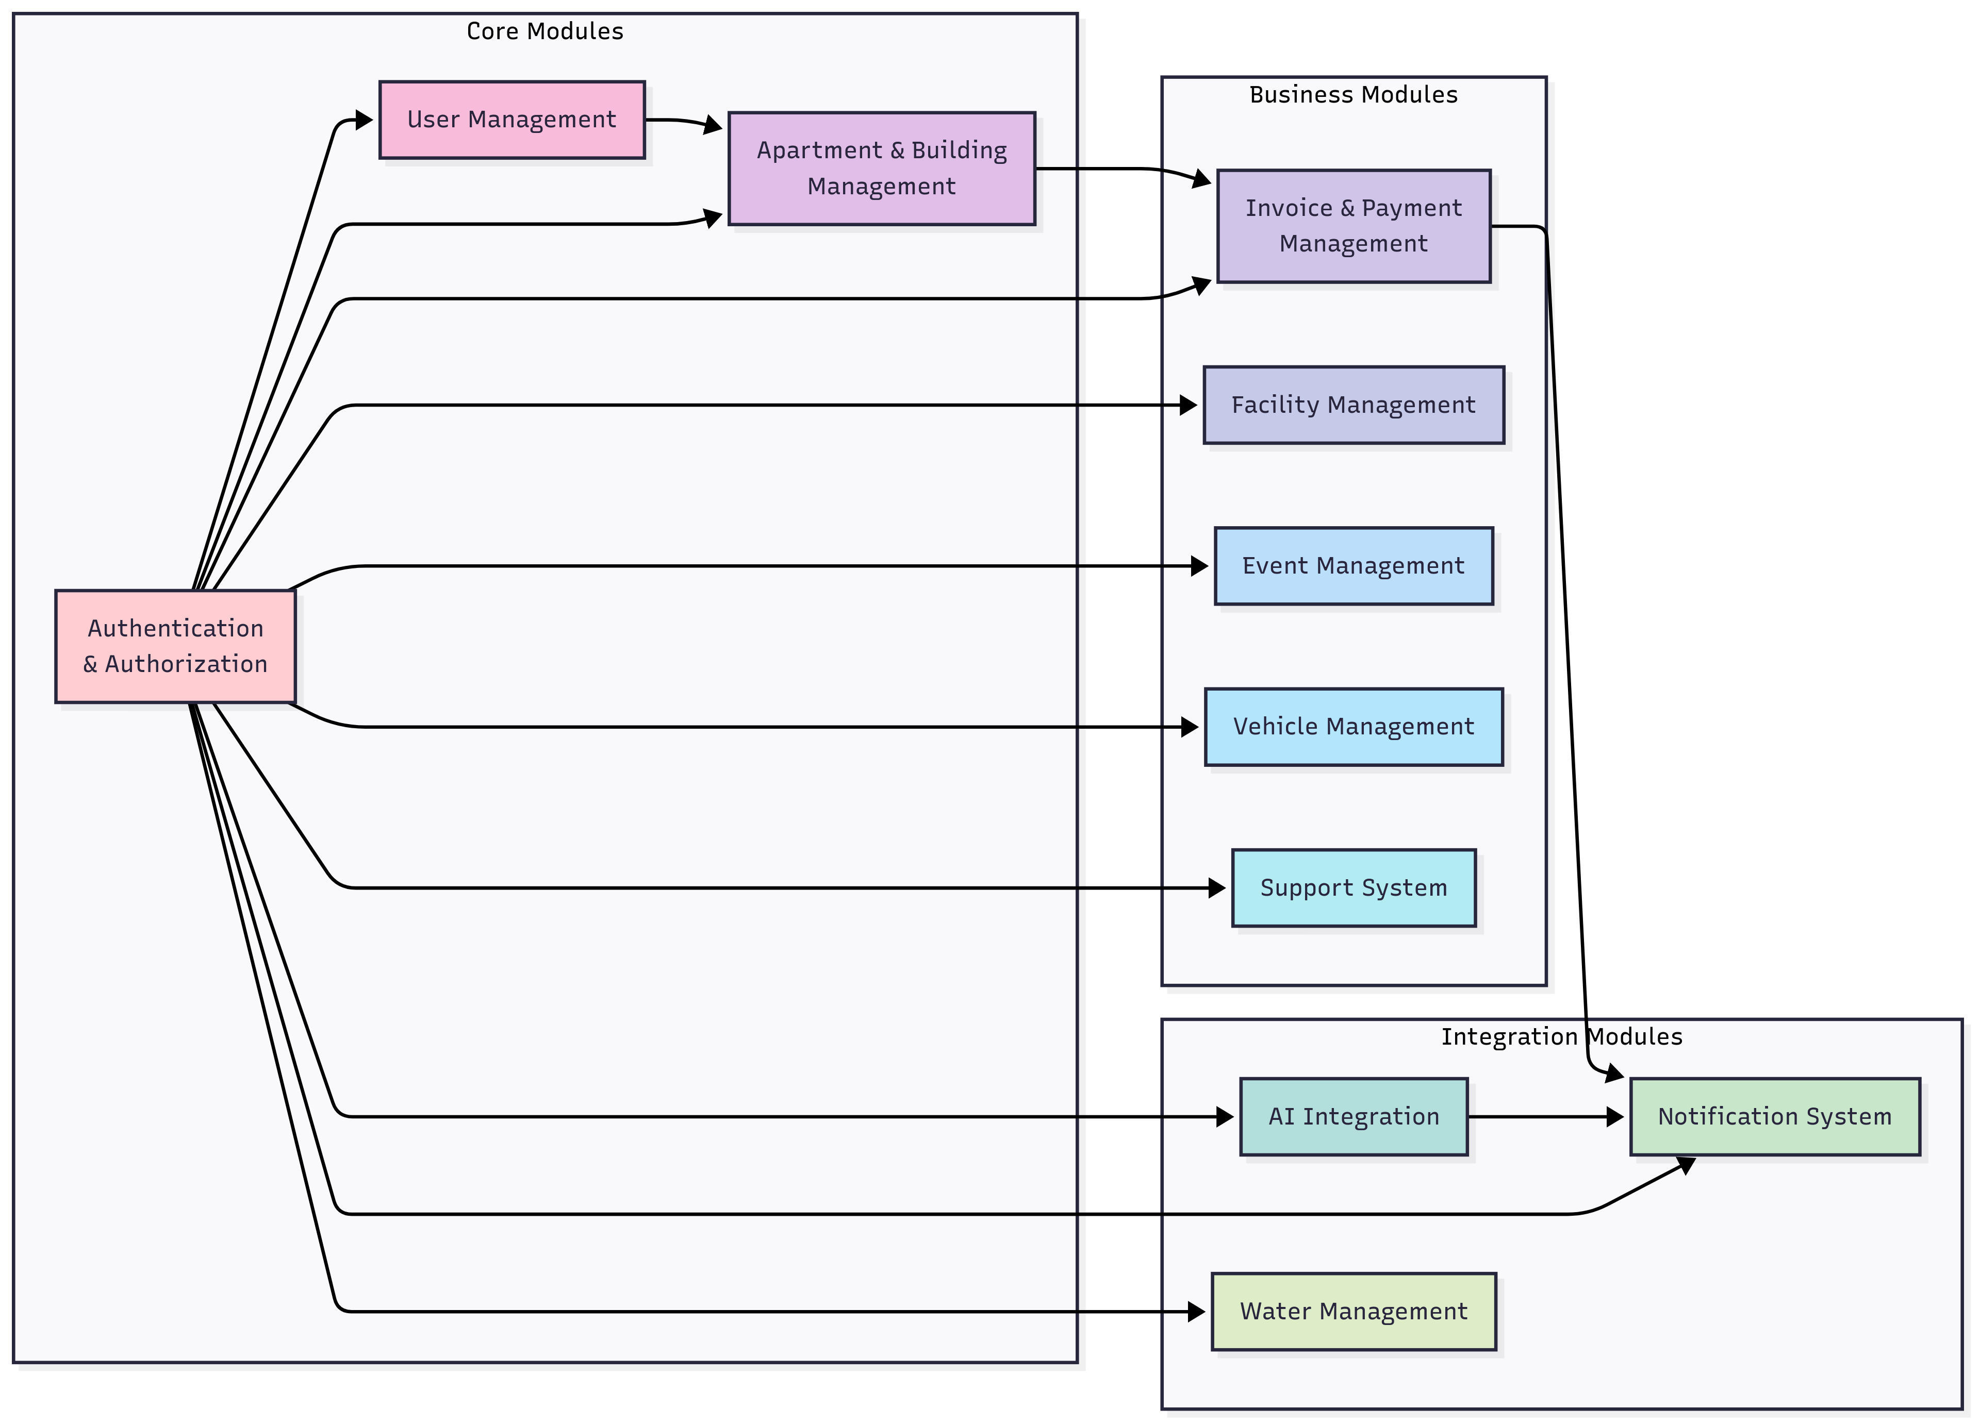

#### 1.5.5 Data Flow

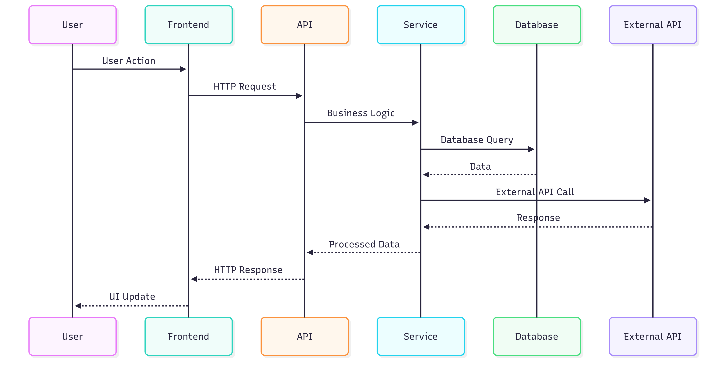

#### 1.5.6 Deployment Architecture

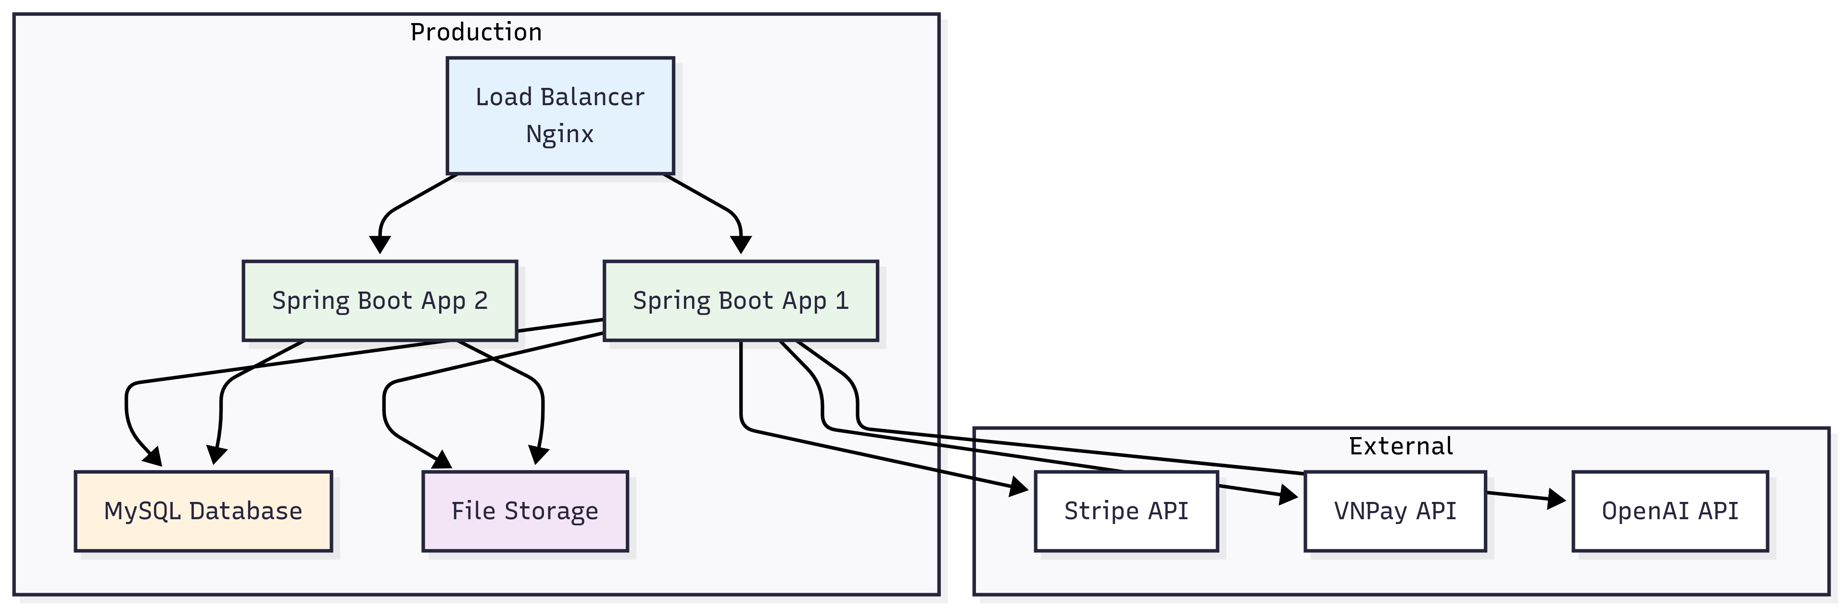

### 1.6 Data flows in the architecture

1. 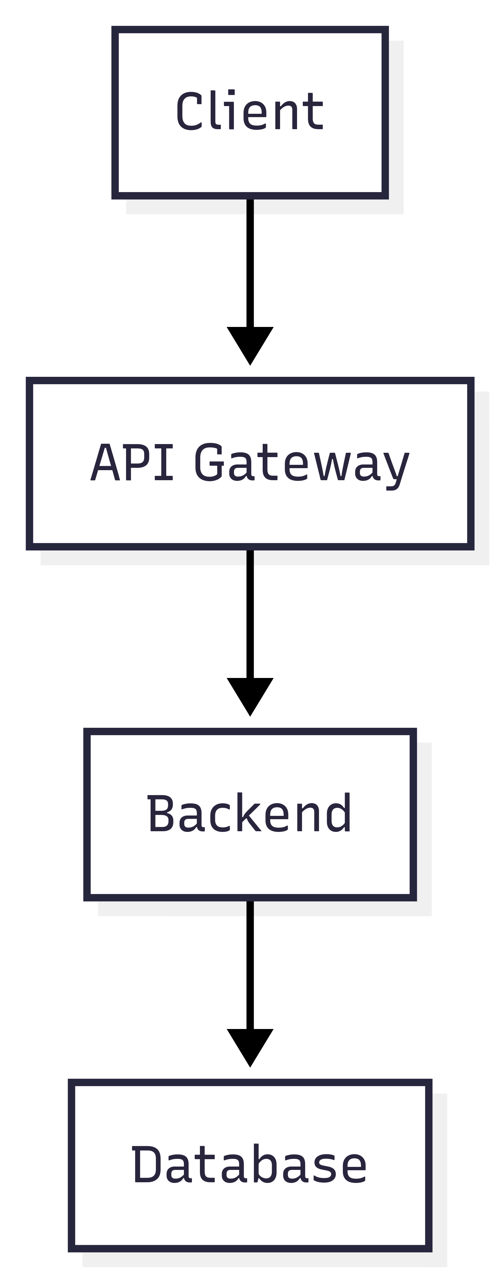User Request Flow:

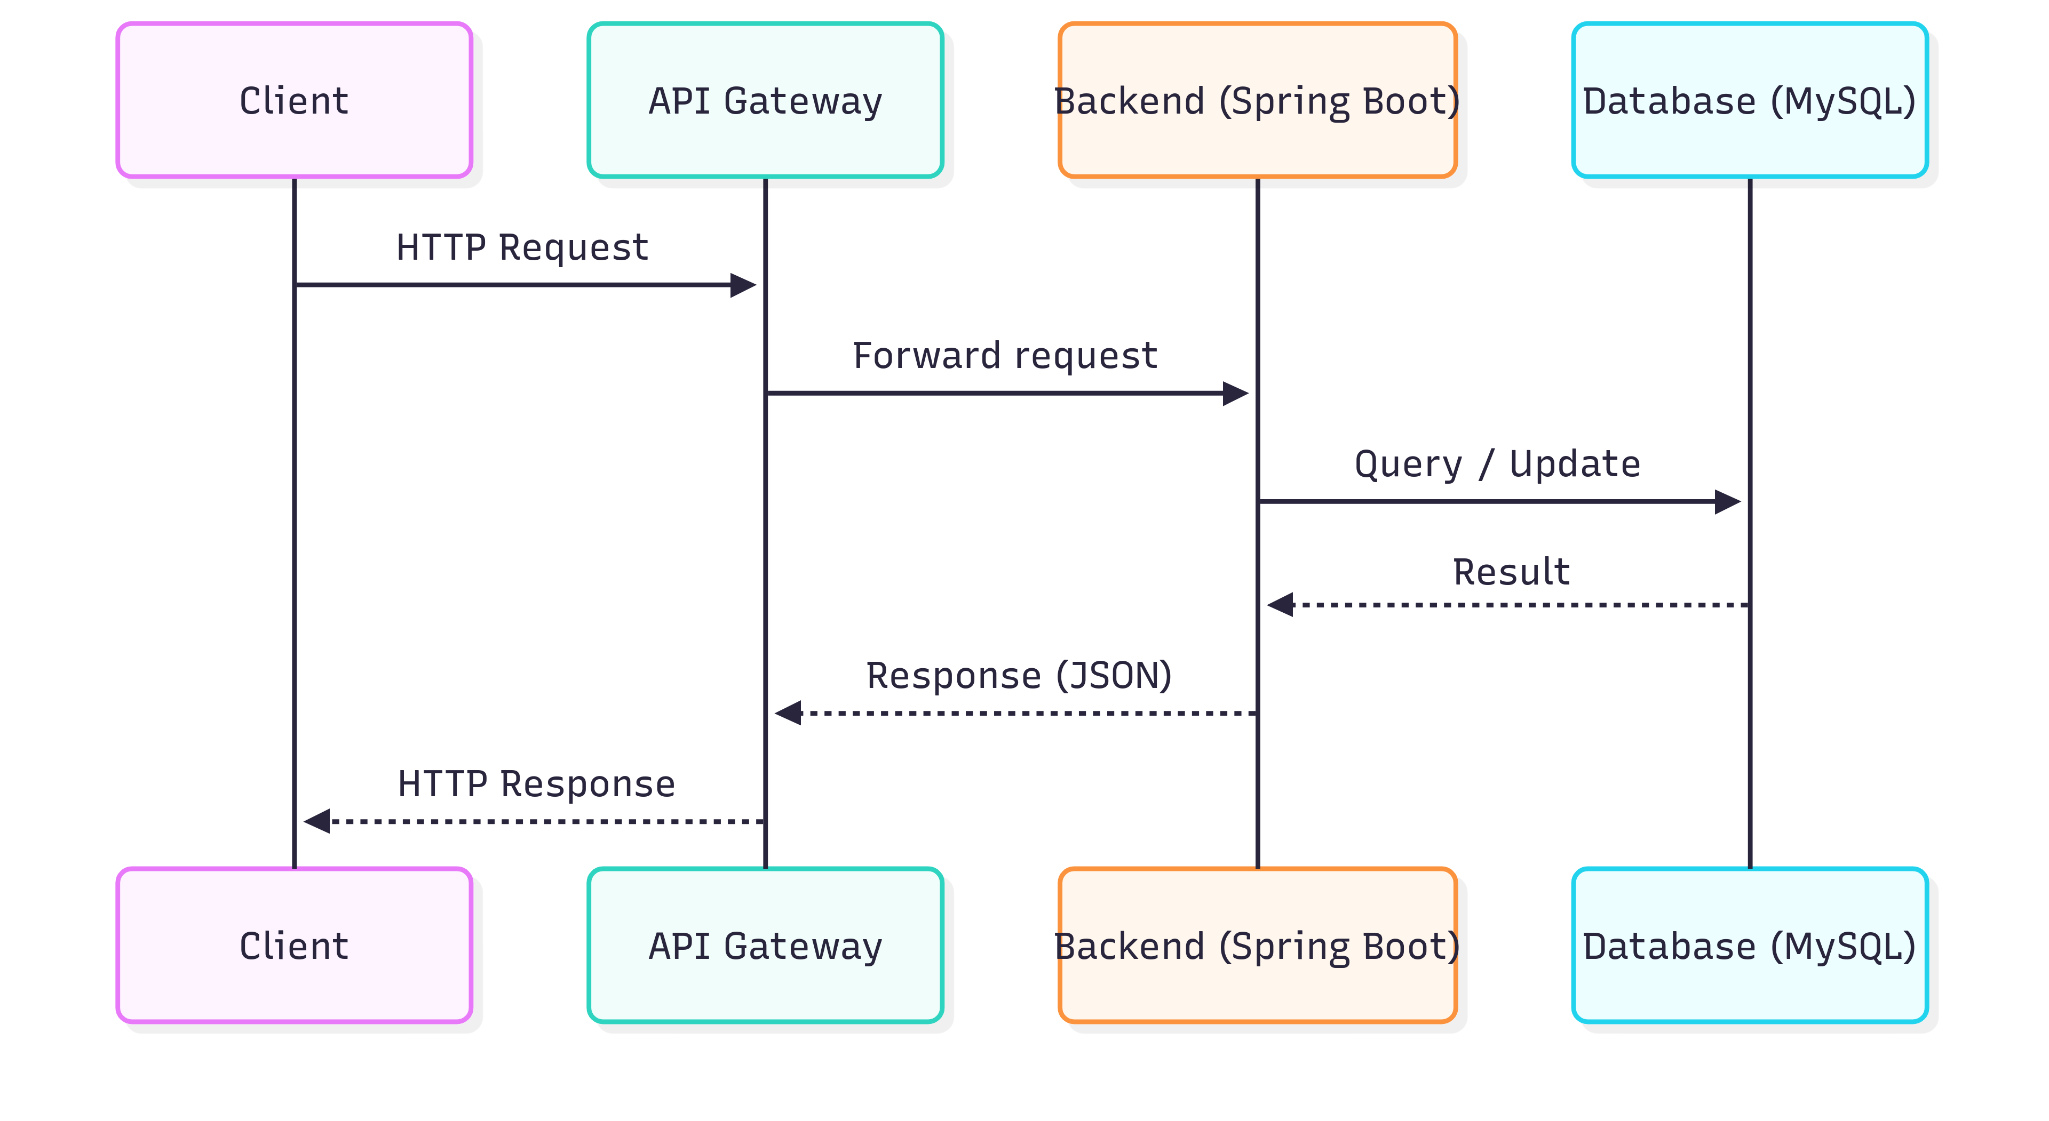

1. 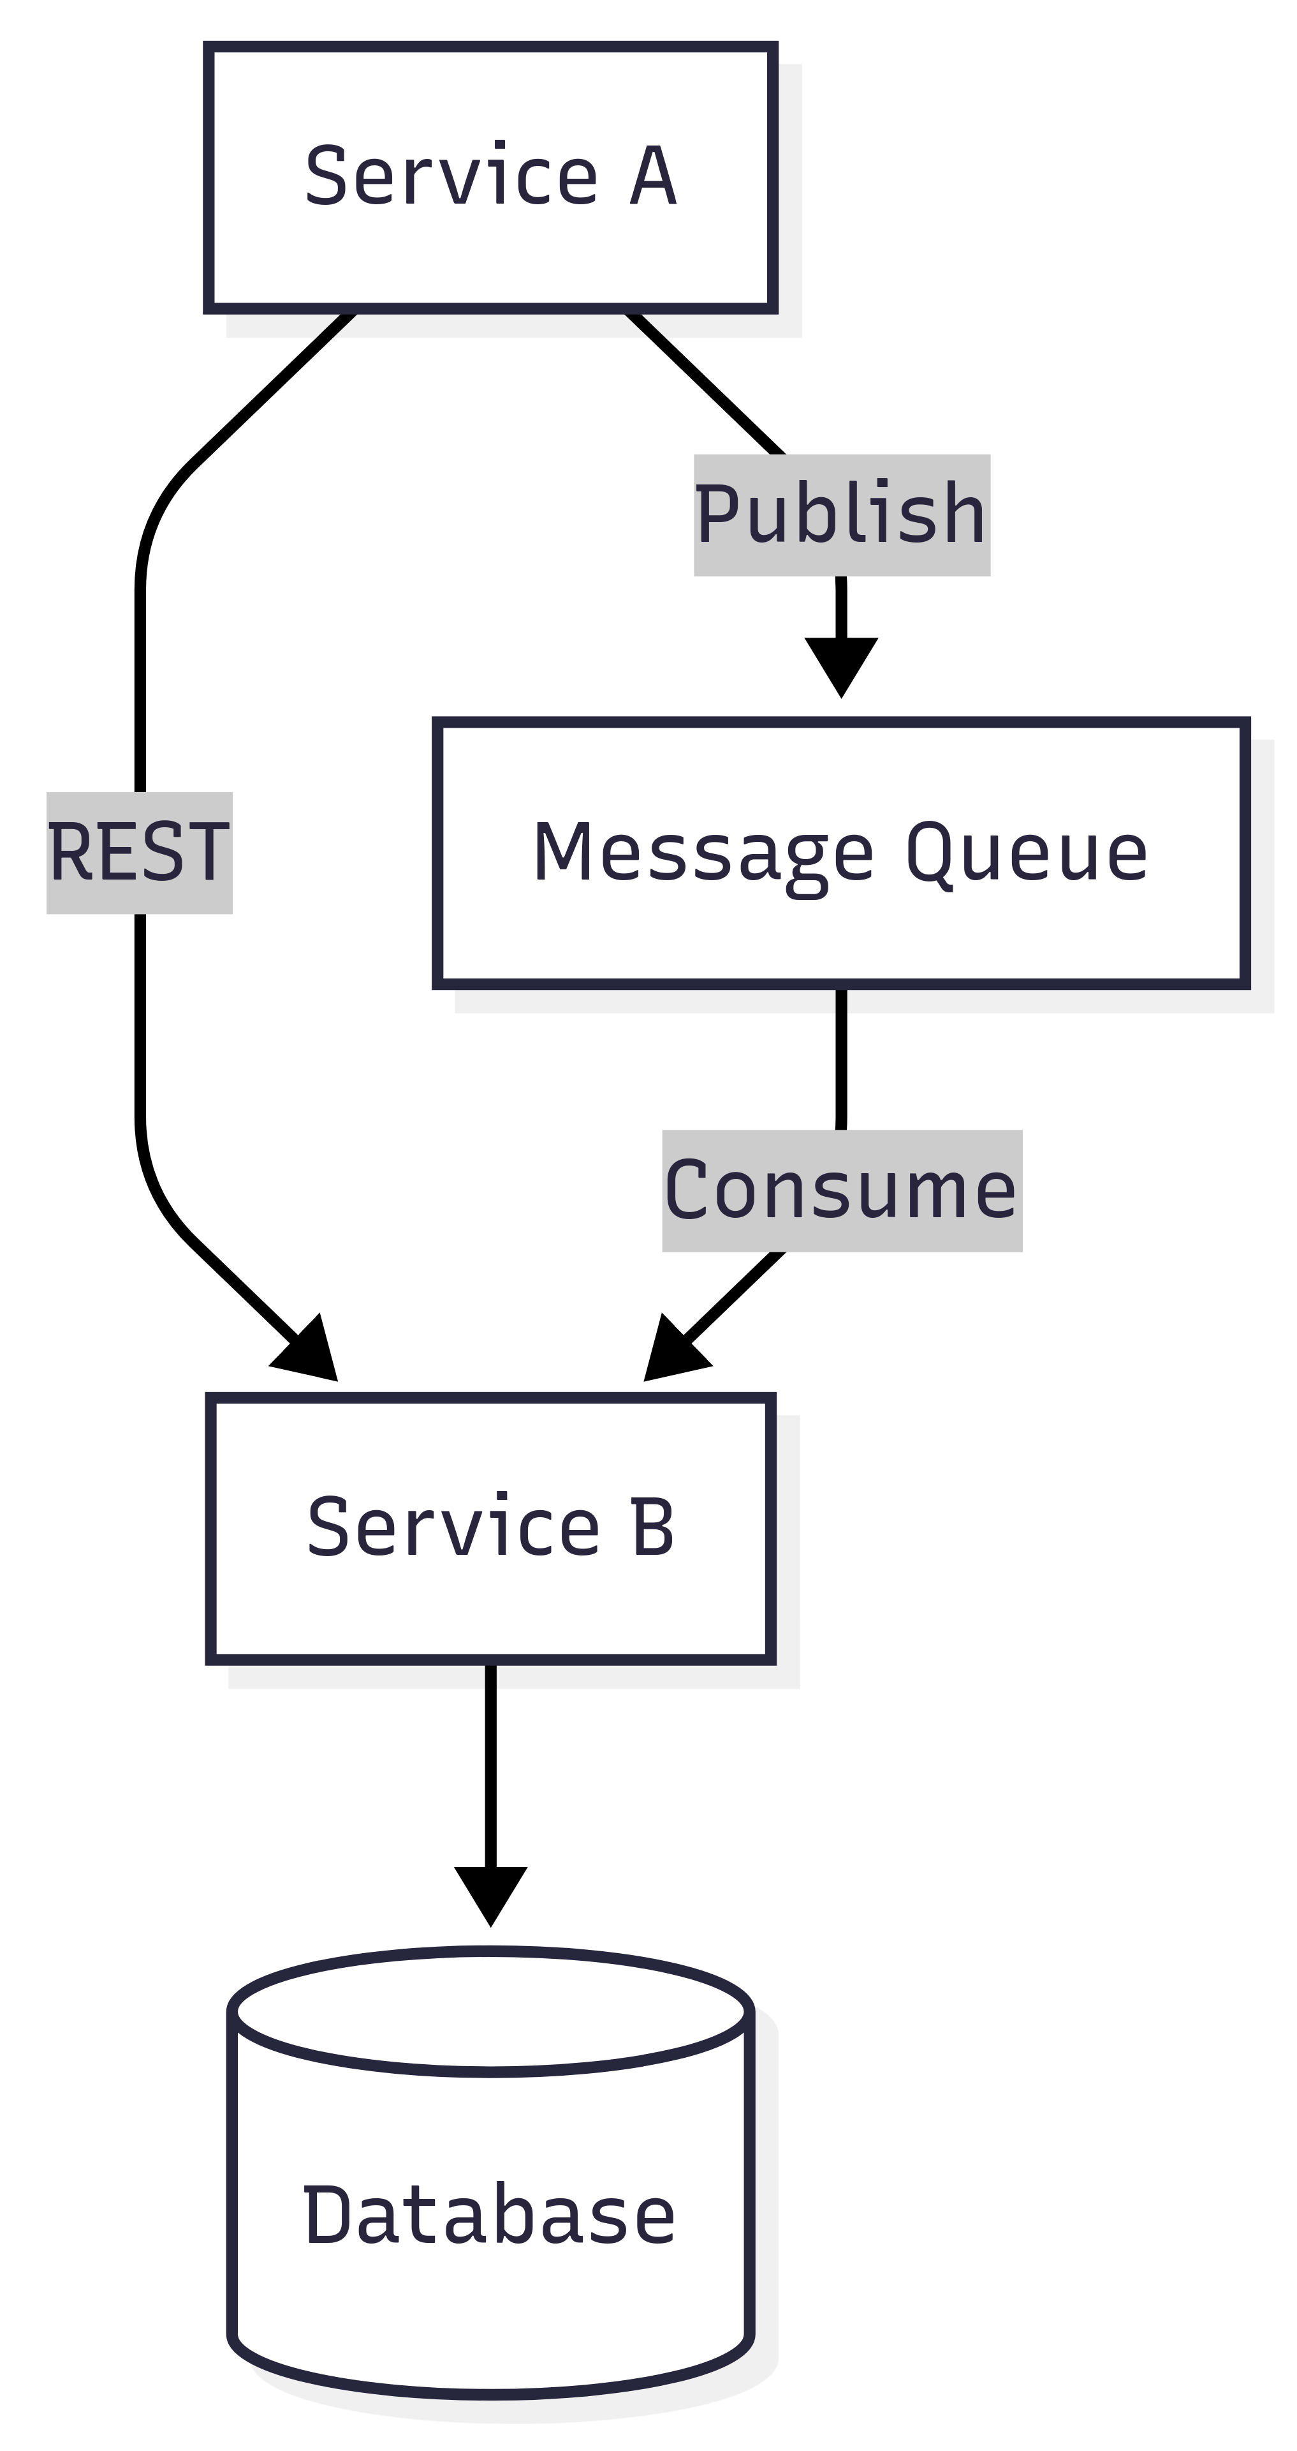Inter-Service Communication:

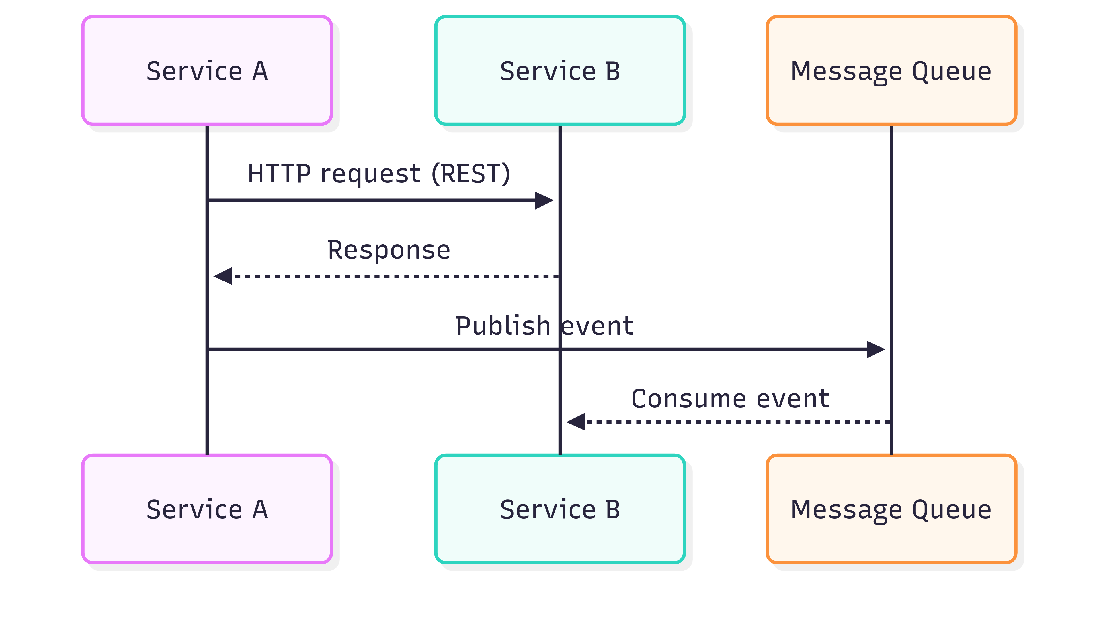

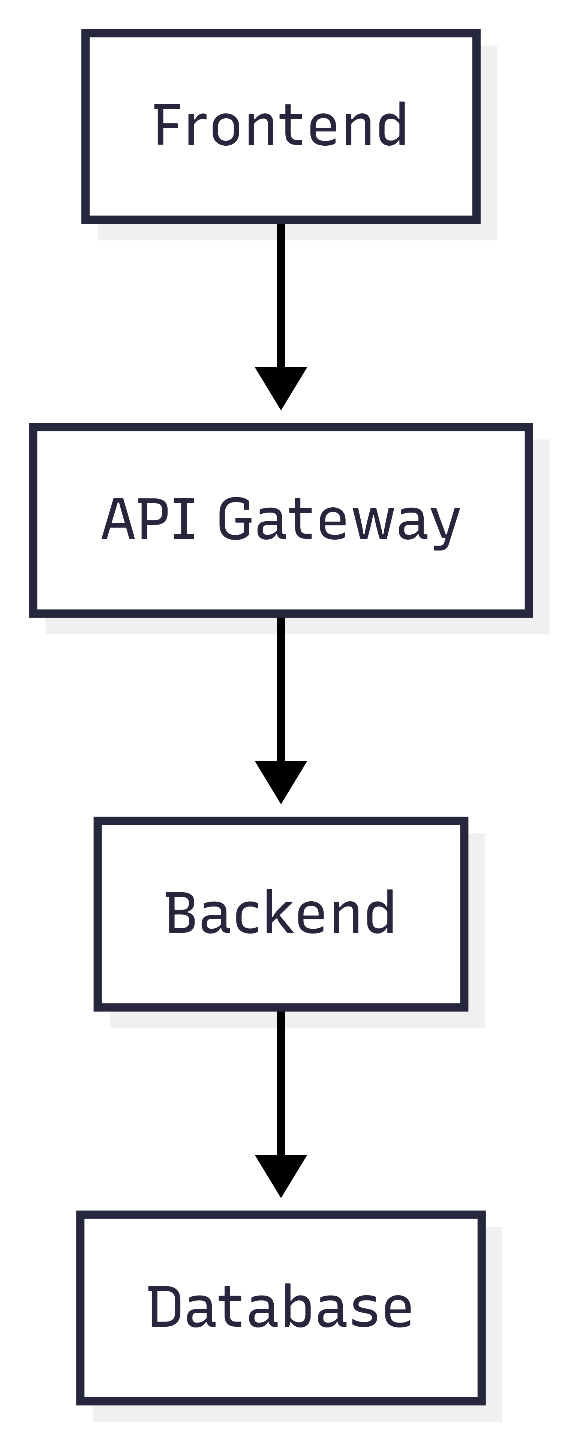3. Data Flow:

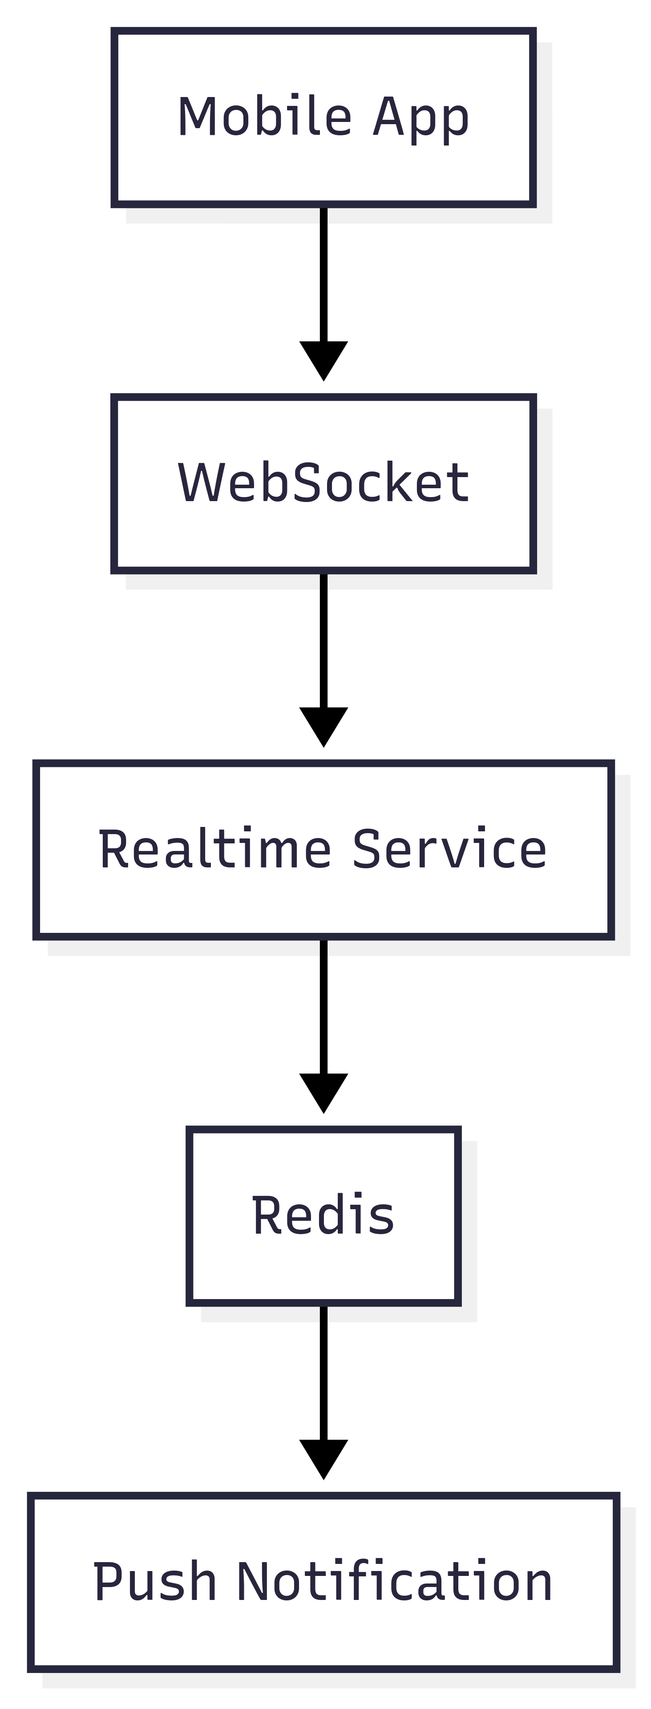4. Real-time Communication:

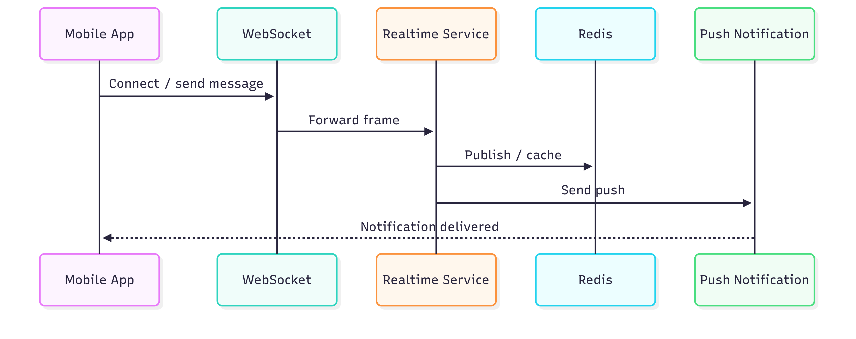

## 2. DATA FLOW DIAGRAM (DFD)

#### 2.1 Main flows of the system

**Flow 1: Login and authentication**

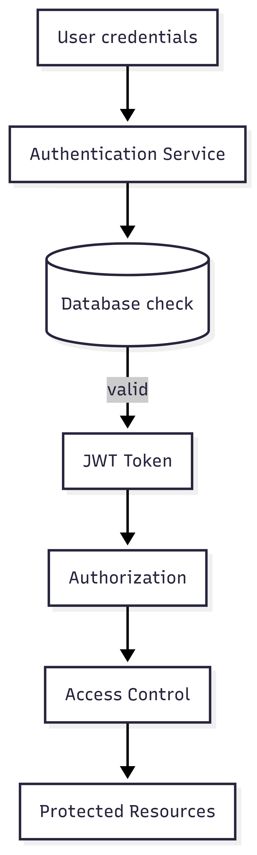

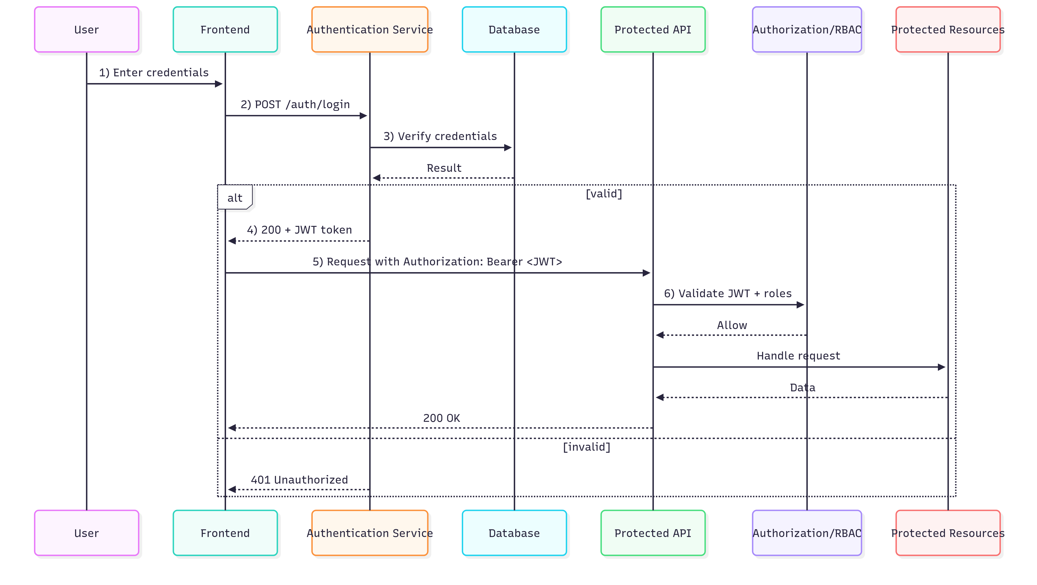

Flow details:

1. The user enters login information

2. Frontend sends a request to the Authentication Service

3. The service validates credentials against the database

4. Generate a JWT token and return it to the client

5. The client stores the token and uses it for subsequent requests

6. Each request is checked by the Authorization Service

**Flow 2: Facility booking**

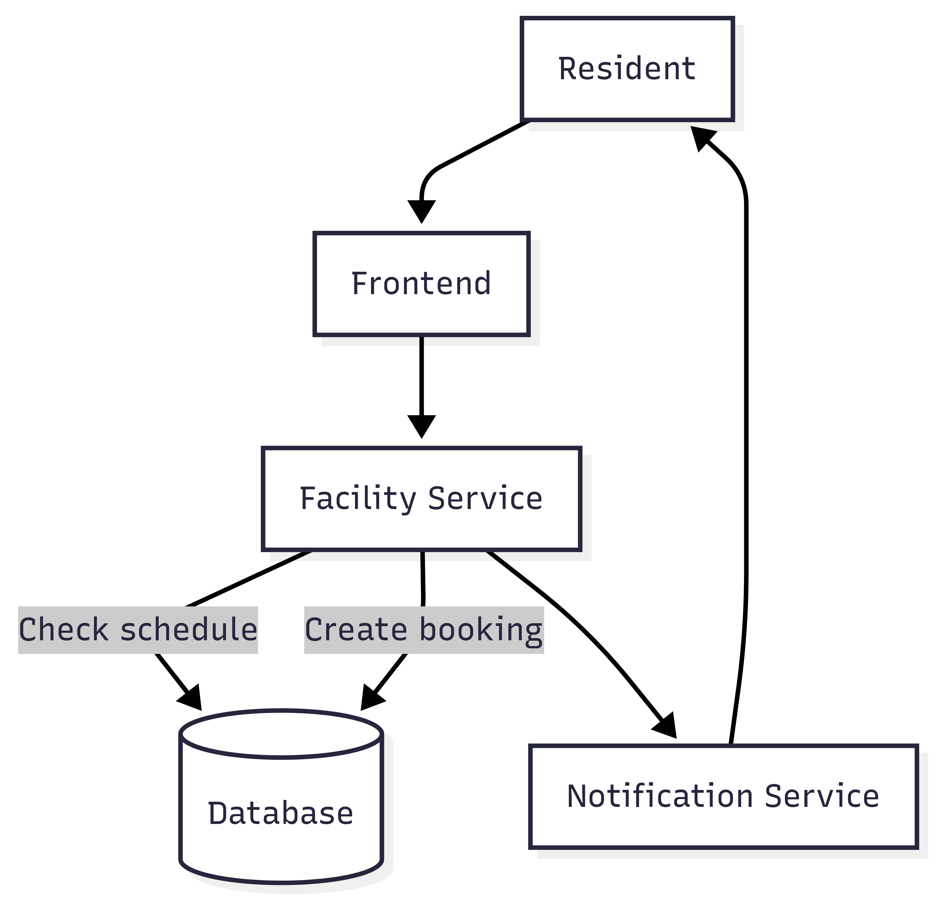

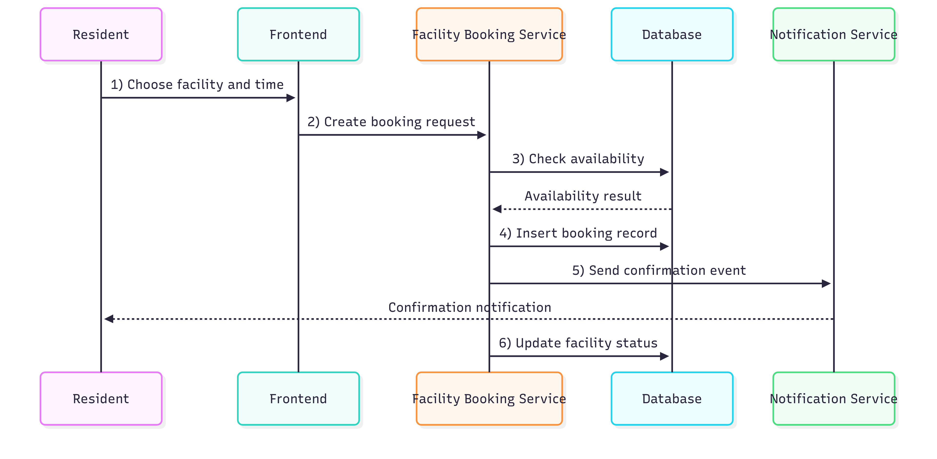

Flow details:

1. The resident selects a facility and time

2. Frontend sends a request to the Facility Booking Service

3. The service checks facility availability

4. Create a booking record in the database

5. Send confirmation via the Notification Service

6. Update facility status

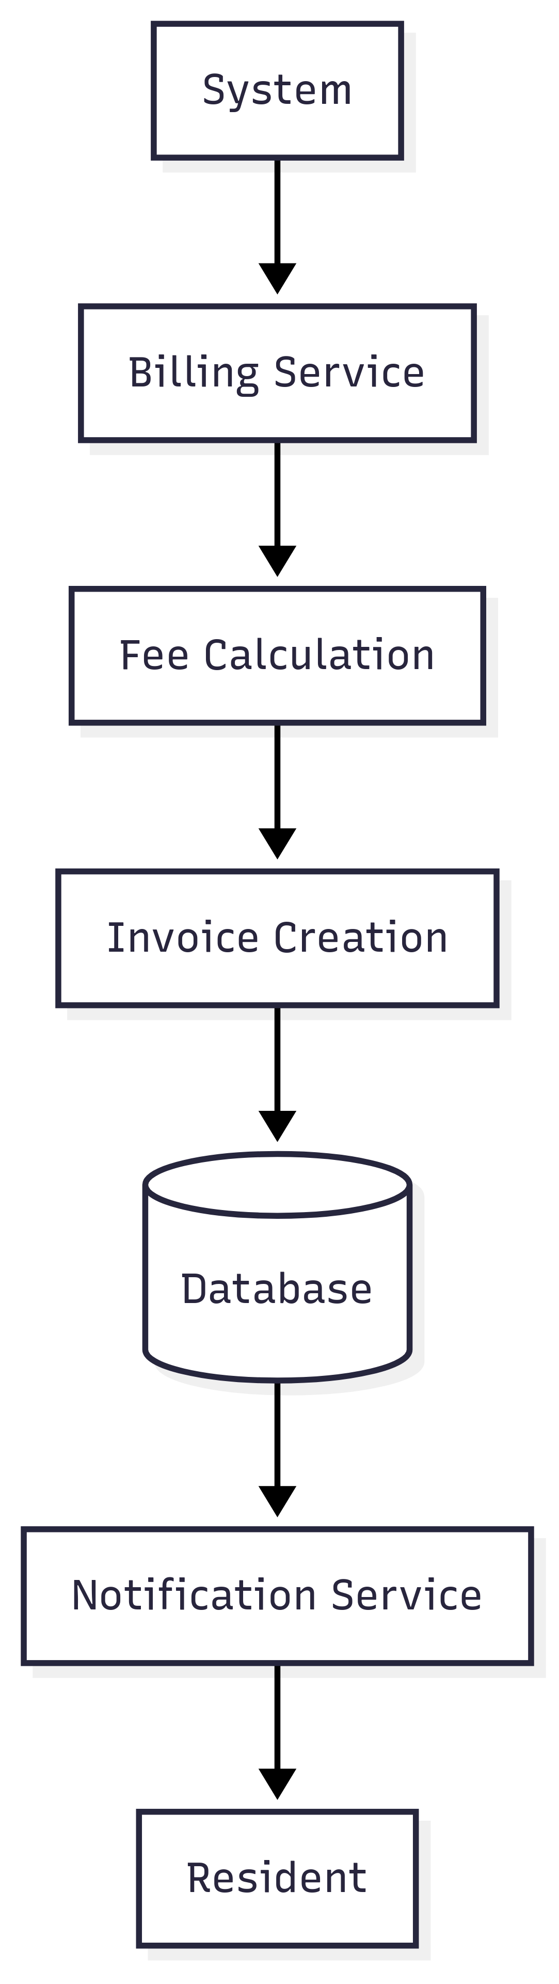**Flow 3: Billing process**

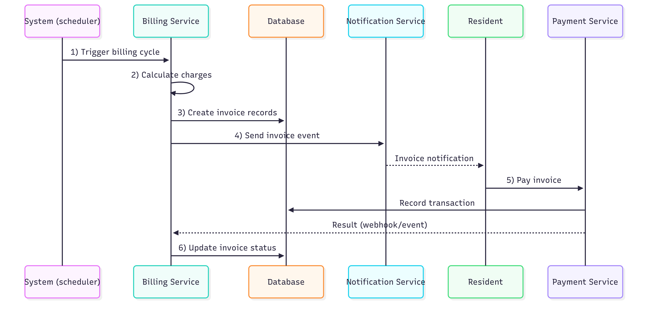

Flow details:

1. The system automatically generates periodic invoices

2. Billing Service calculates fees

3. Create the invoice and save it to the database

4. Send the invoice notification to the resident

5. Resident views and pays the invoice

6. Update payment status

**Flow 4: Notification system**

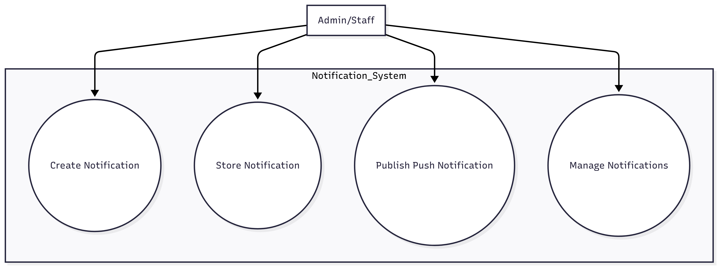

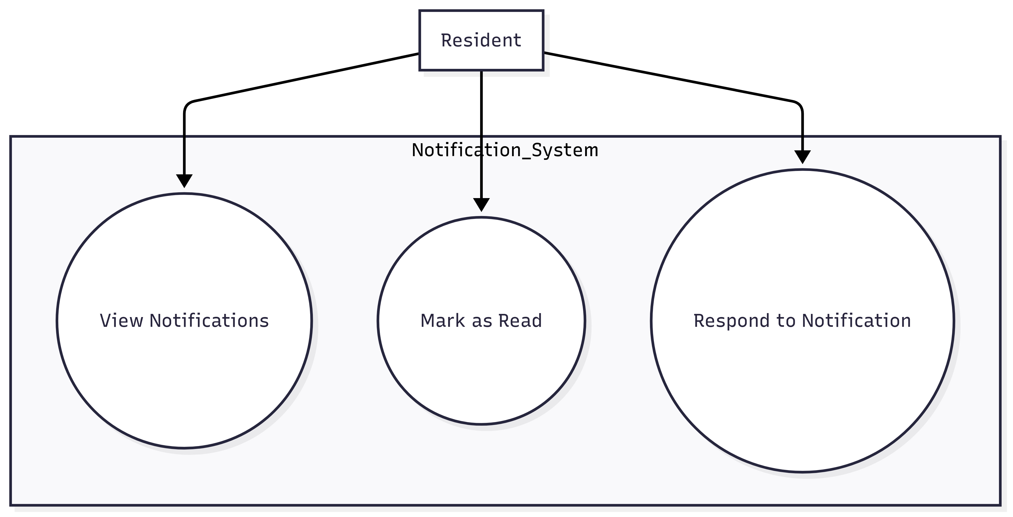

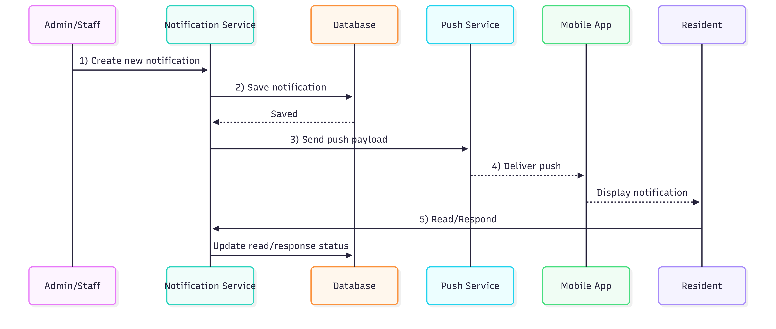

Admin/Staff → Create notification → Notification Service → Database

↓

Store notification → Push Notification → Mobile App → Resident

Flow details:

1. Admin or Staff creates a new notification

2. The notification is saved to the database

3. Notification Service sends a push notification

4. Mobile app receives and displays the notification

5. Resident can read and respond to the notification

**Flow 5: Maintenance request handling**

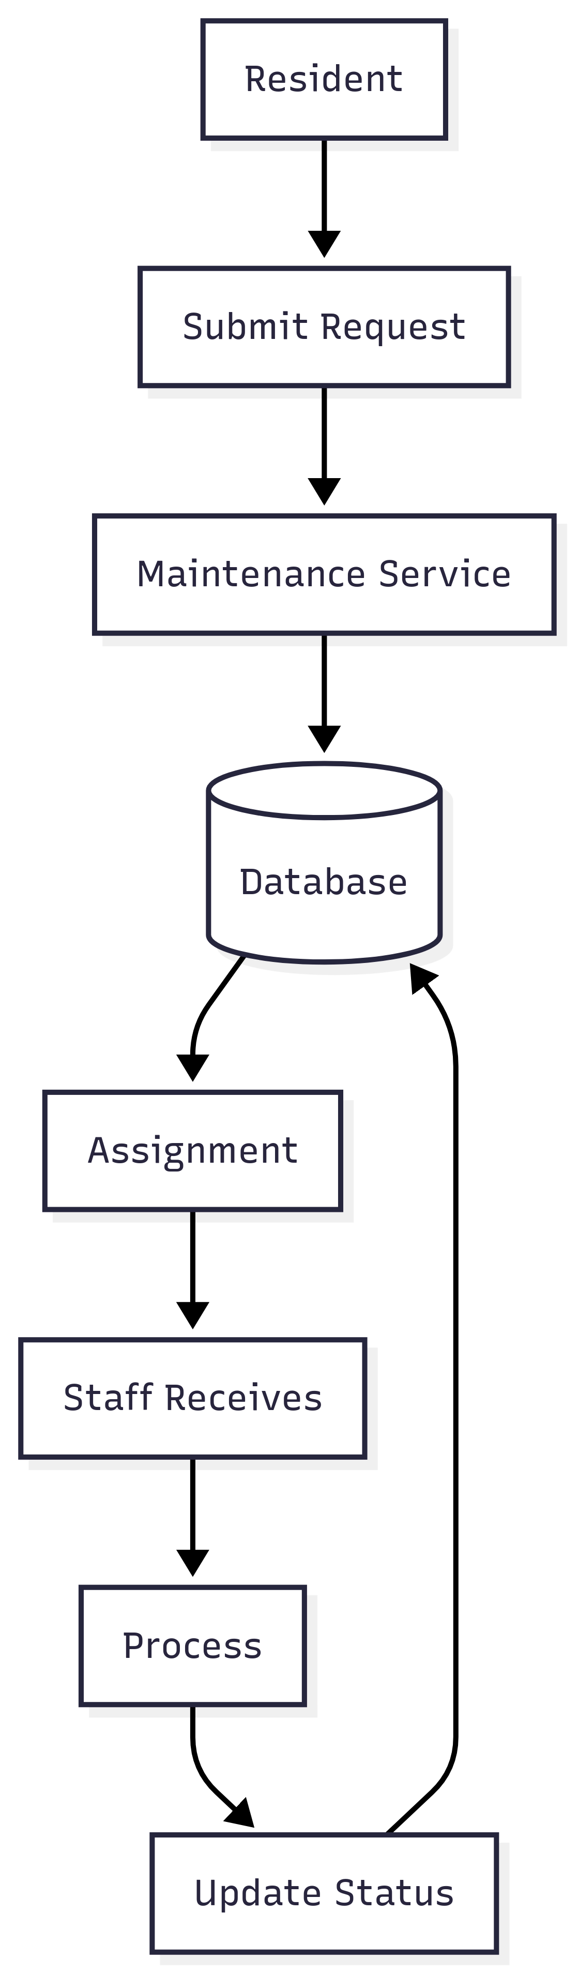

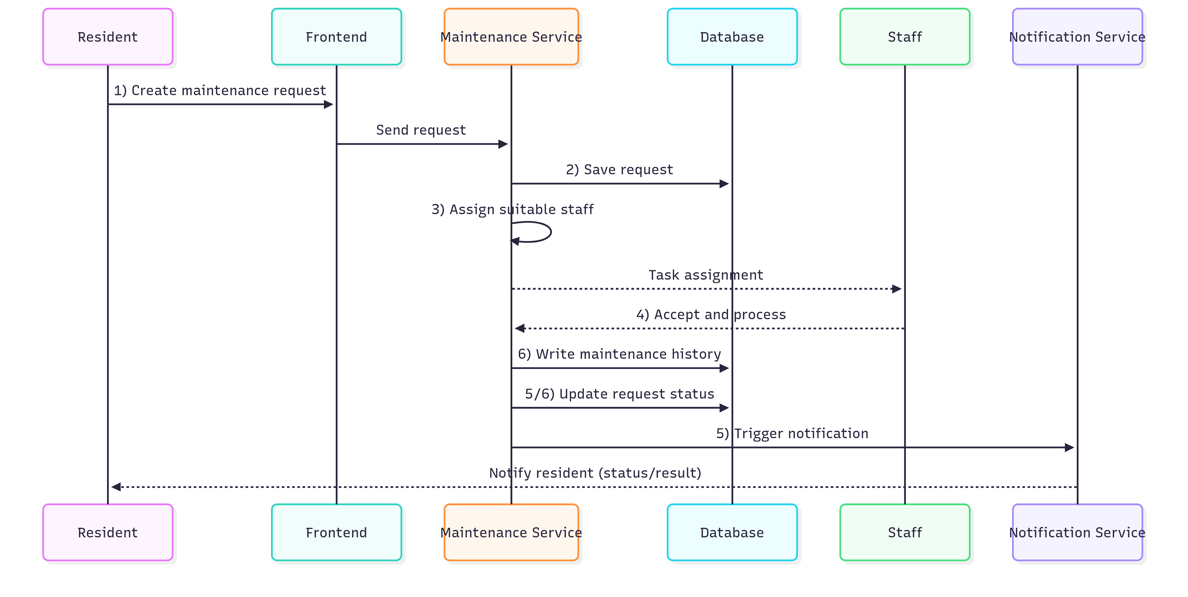

Flow details:

1. Resident submits a maintenance request

2. Maintenance Service saves the request to the database

3. The system assigns it to appropriate staff

4. Staff receives and processes the request

5. Update status and notify the resident

6. Save maintenance history

### 2.2 Overall data flow diagram

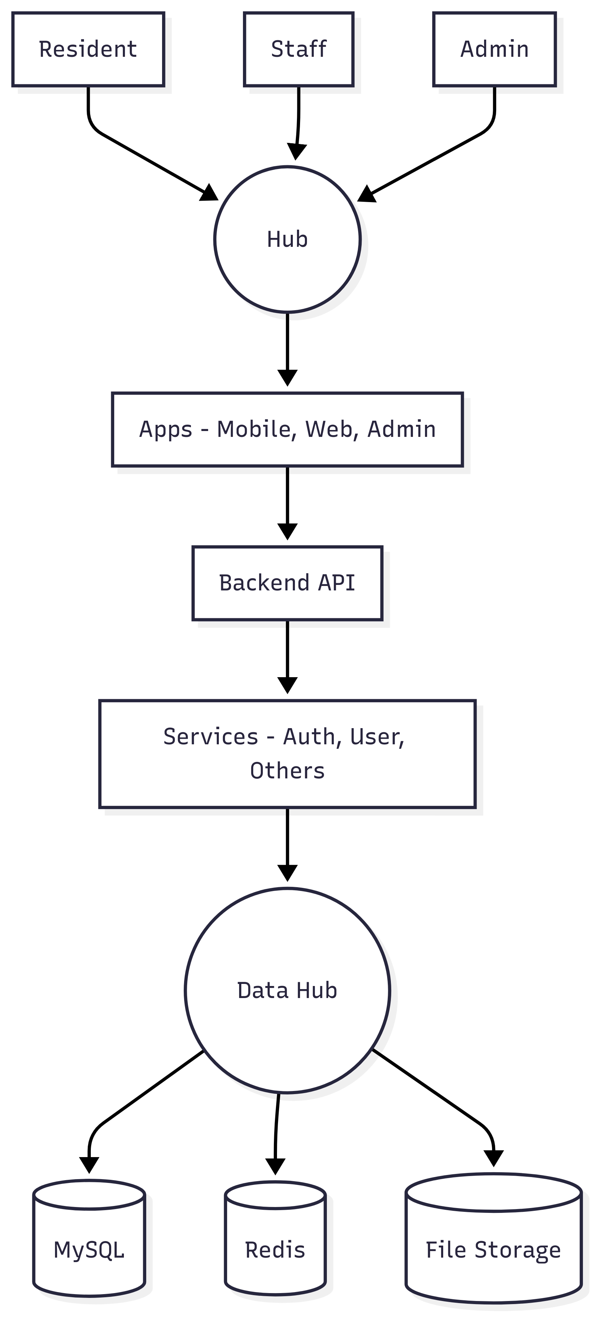

## 3. USE CASE DIAGRAM

#### 3.1 Admin Use Cases (System-wide management)

**Admin Use Case Description:**

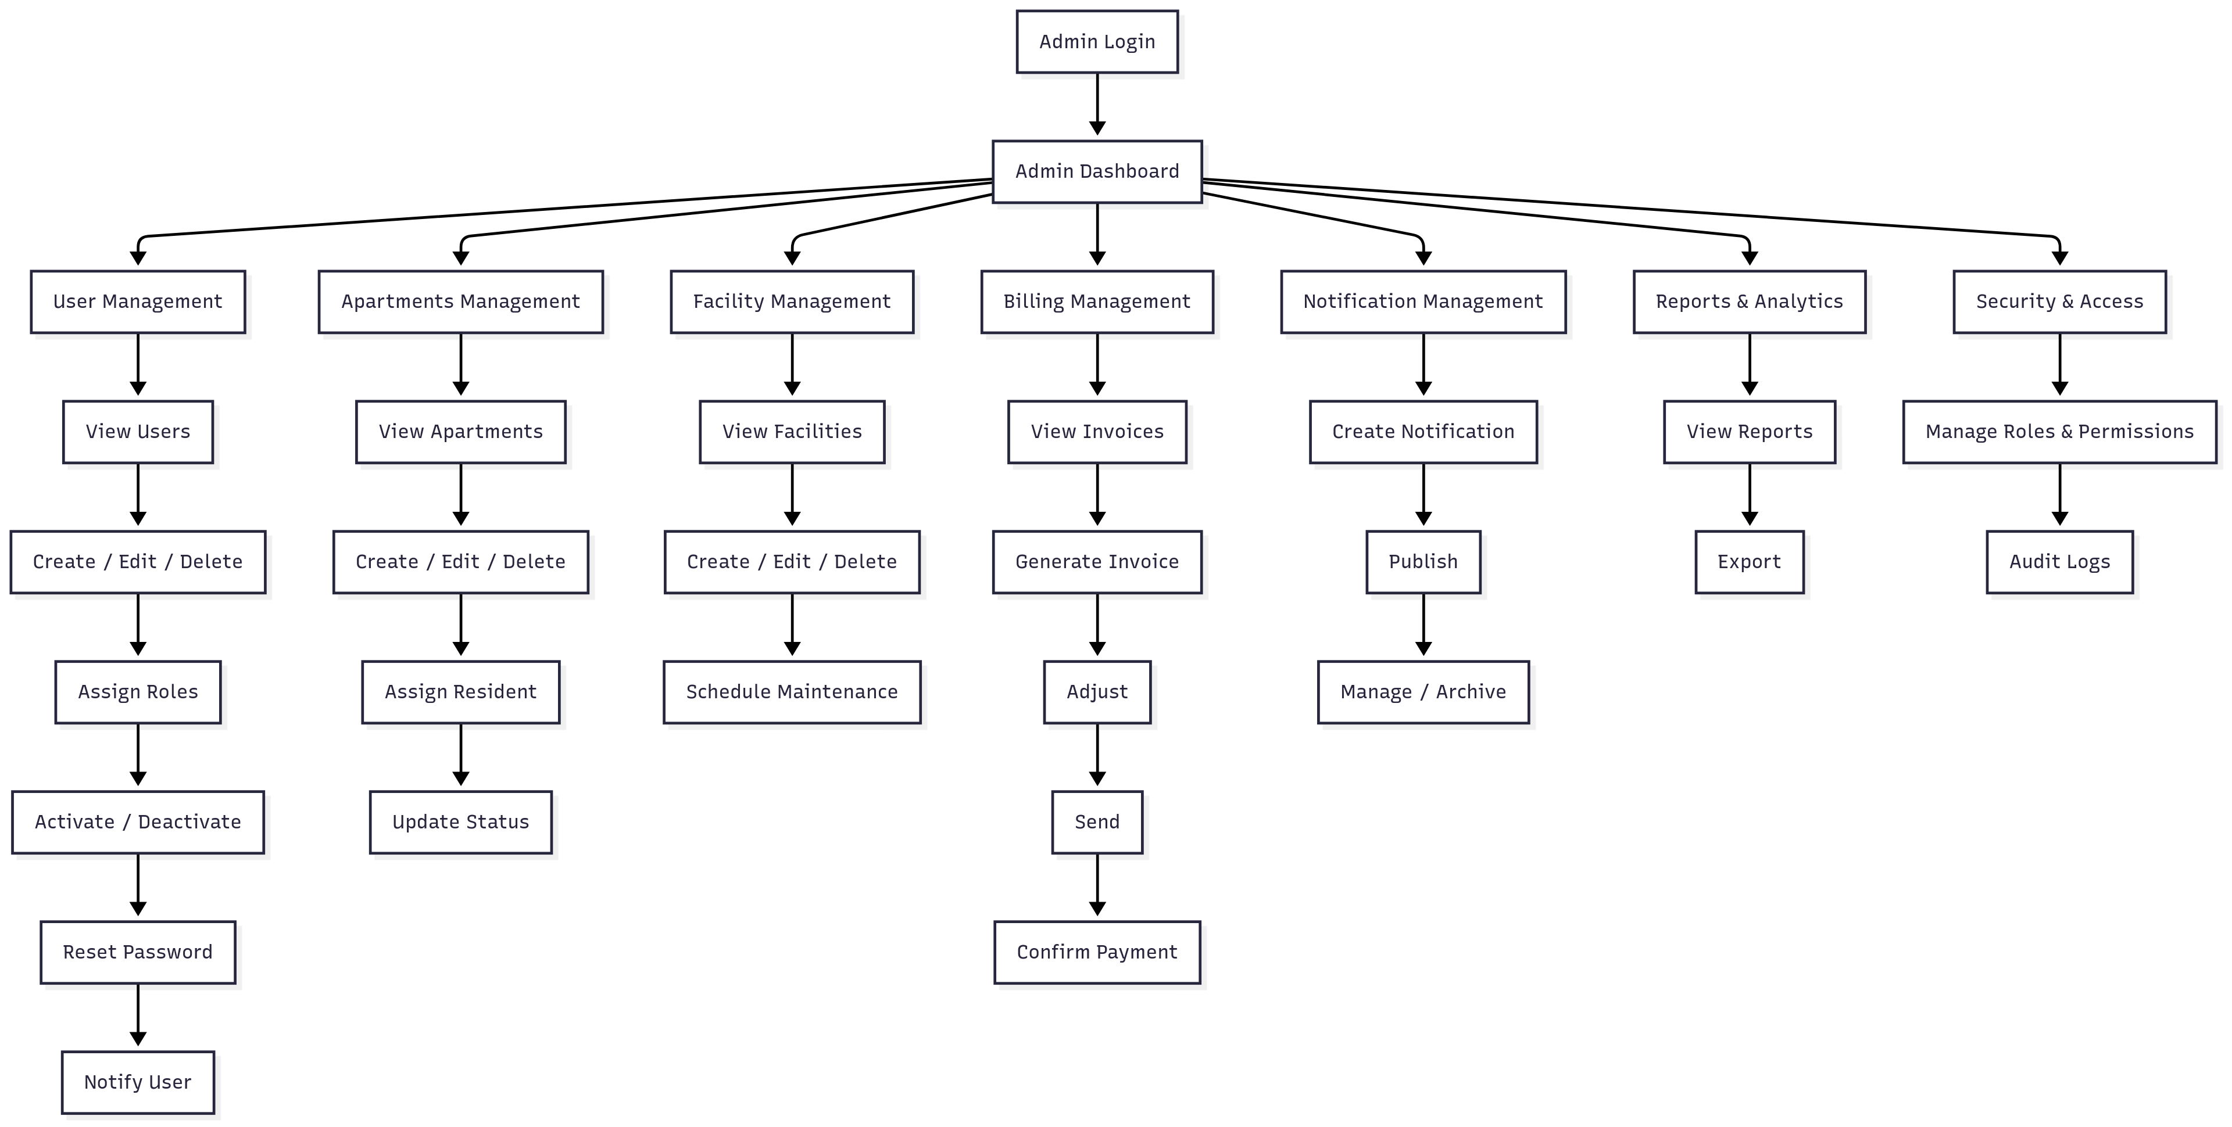

The Admin has the highest privileges in the system and can manage all

components and functions.

**Main Use Cases:**

1. **User Management**

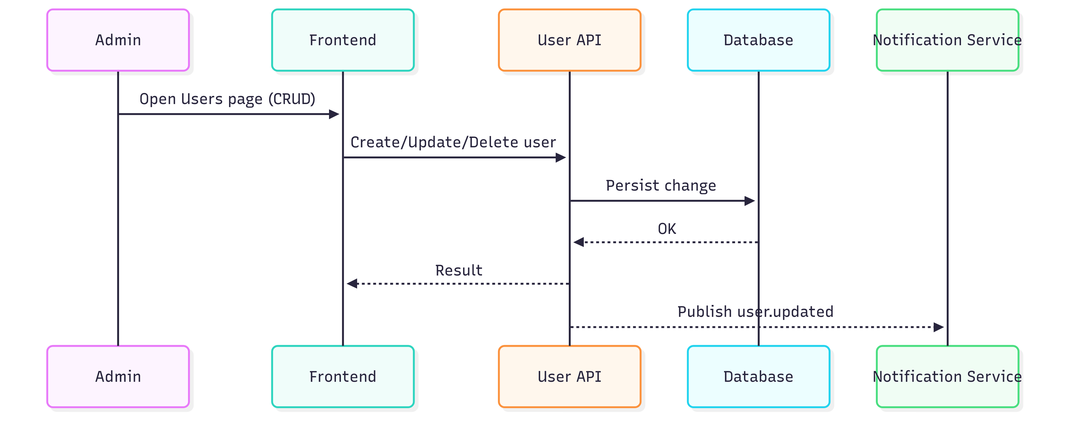

- Actor: Admin

- Description: Admin can create, edit, delete, and manage all users

- Precondition: Admin has successfully logged in

- Main Flow:

* Admin accesses the user management page

* The system displays the list of all users

* Admin can perform CRUD operations

* The system updates the database and sends notifications

- Postcondition: User information is updated

2. **Apartment Management**

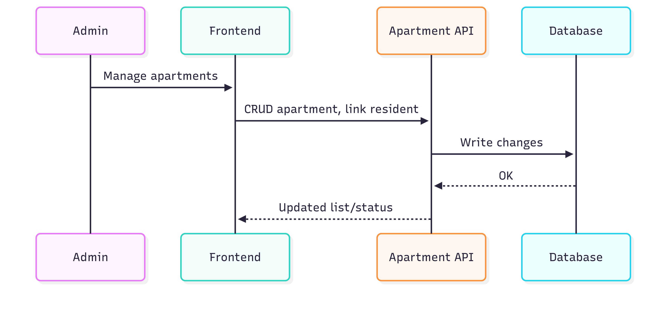

- Actor: Admin

- Description: Admin manages apartment info, assigns residents, tracks status

- Precondition: Admin has apartment management rights

- Main Flow:

* Admin views all apartments

* Add/edit/delete apartment information

* Assign residents to apartments

* Update apartment status

- Postcondition: Apartment information is updated

3. **Facility Management**

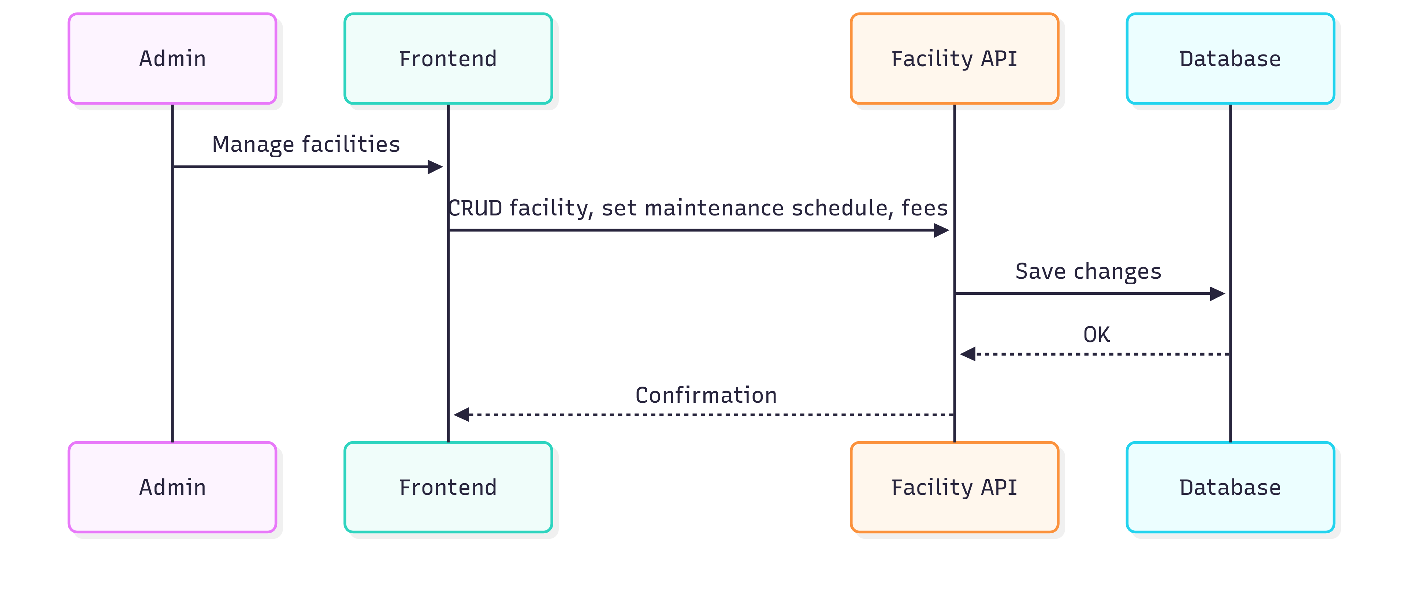

- Actor: Admin

- Description: Admin manages facility catalog, maintenance schedules, usage fees

- Precondition: Admin has facility management rights

- Main Flow:

* Admin views the list of facilities

* Add/edit/delete facilities

* Set maintenance schedules

* Update usage fees

- Postcondition: Facility information is updated

4. **Billing Management**

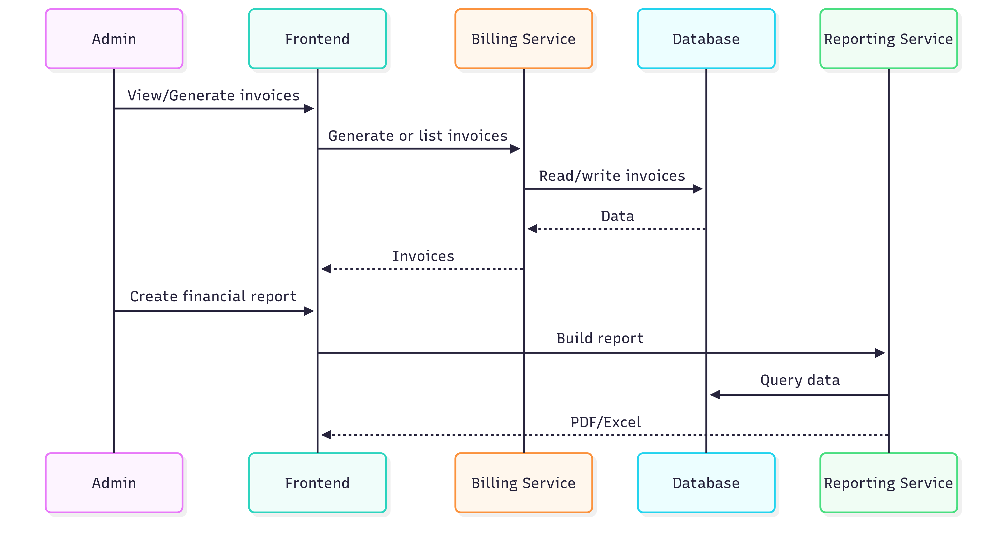

- Actor: Admin

- Description: Admin manages invoices, tracks payments, generates financial reports

- Precondition: Admin has financial management rights

- Main Flow:

* Admin views the list of invoices

* Manually create invoices if needed

* Track payment statuses

* Generate financial reports

- Postcondition: Invoices and reports are created

5. **Notification Management**

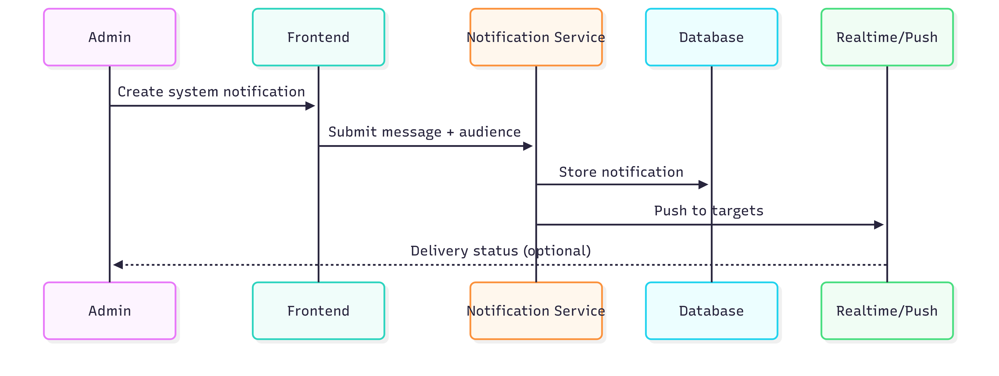

- Actor: Admin

- Description: Admin creates and sends system-wide notifications

- Precondition: Admin has permission to send notifications

- Main Flow:

* Admin creates a new notification

* Selects target recipients

* Sends the notification

* Tracks delivery status

- Postcondition: Notification is sent successfully

6. **View reports and analytics**

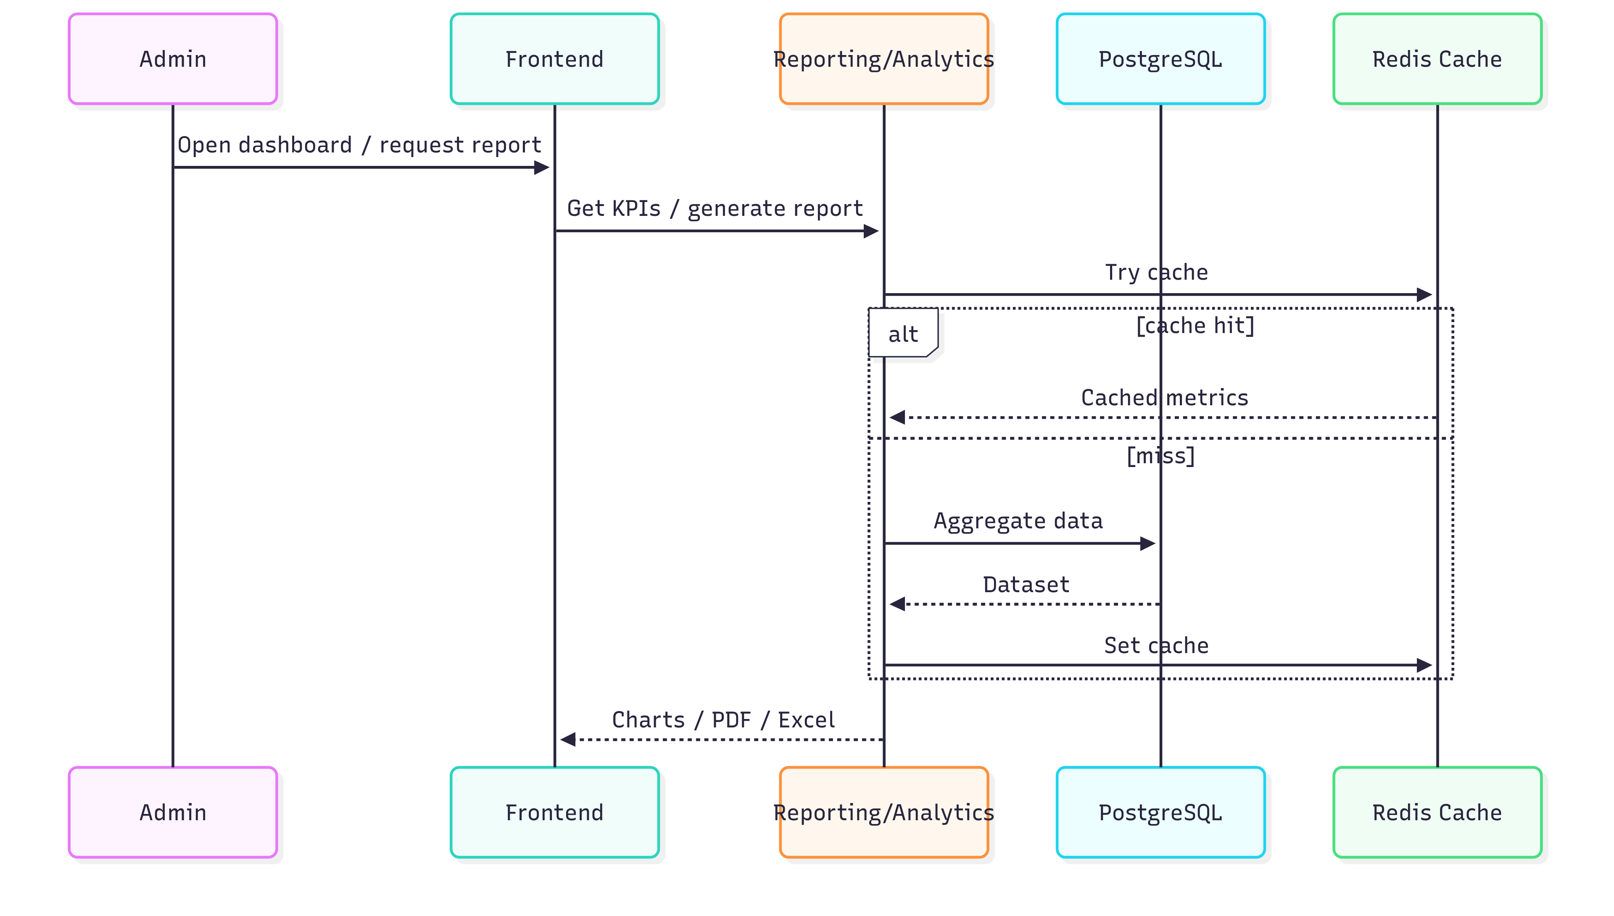

- Actor: Admin

- Description: Admin views overview reports and system statistics

- Precondition: Admin has permission to view reports

- Main Flow:

* Admin accesses the dashboard

* Views overview statistics

* Generates on-demand reports

* Exports reports to PDF/Excel

- Postcondition: Reports are generated and displayed

### 3.2 Staff Use Cases (Maintenance handling, facility management)

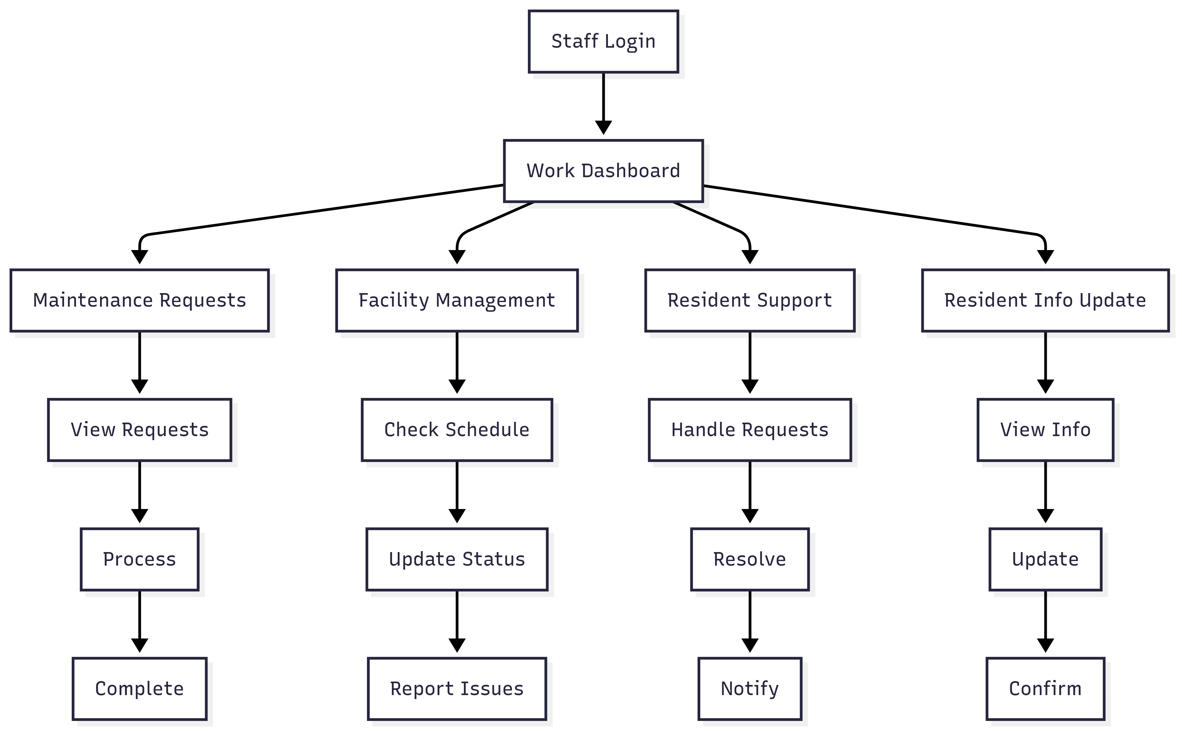

**Staff Use Case Description:**

Staff are operations personnel with permissions to handle maintenance

requests, manage facilities, and support residents.

**Main Use Cases:**

1. **Maintenance Request Handling**

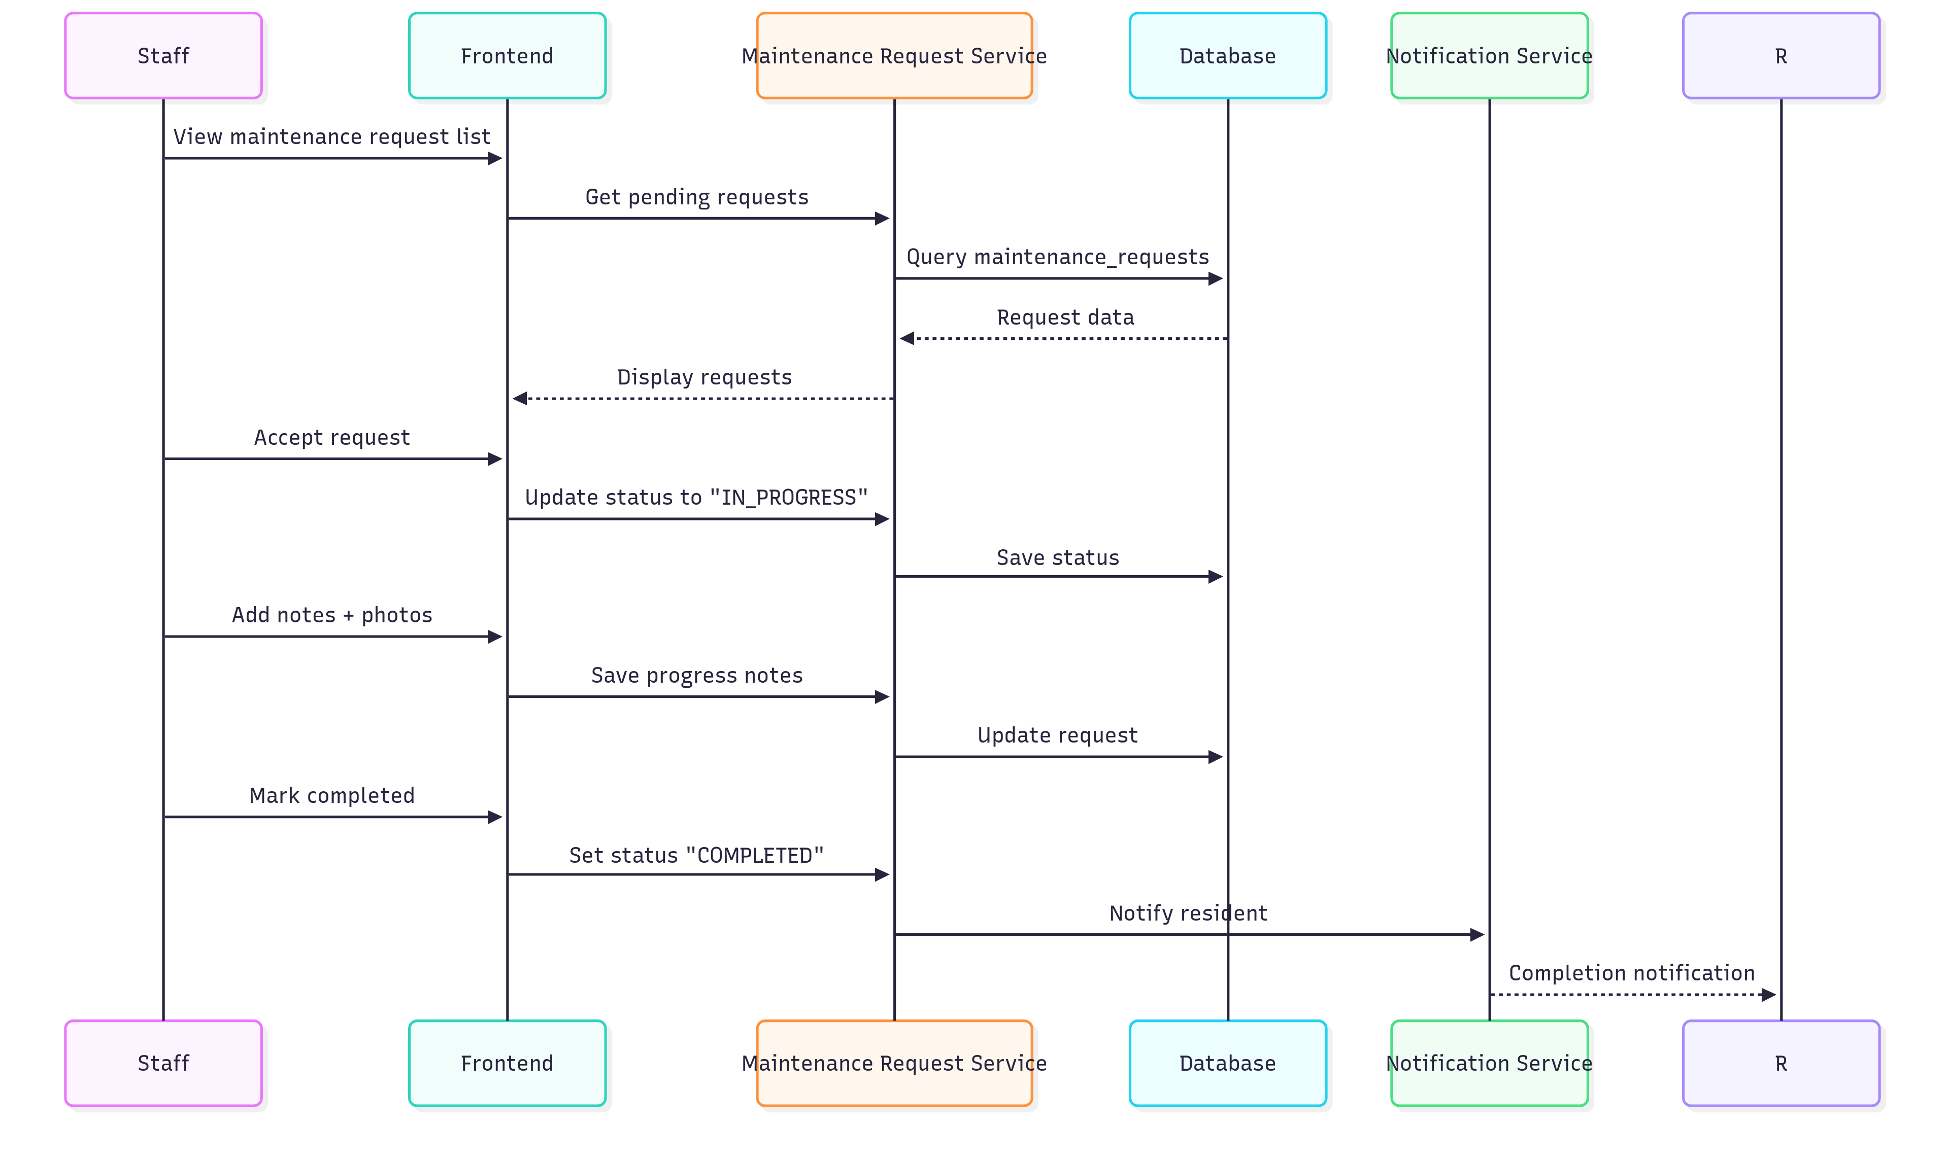

- Actor: Staff

- Description: Staff receives and handles maintenance requests from residents

- Precondition: Staff is logged in and there are maintenance requests

- Main Flow:

* Staff views the list of maintenance requests

* Takes the request to handle

* Updates processing status

* Records notes and images during processing

* Completes and notifies the resident

- Postcondition: Maintenance request is fully processed

2. **Facility Management**

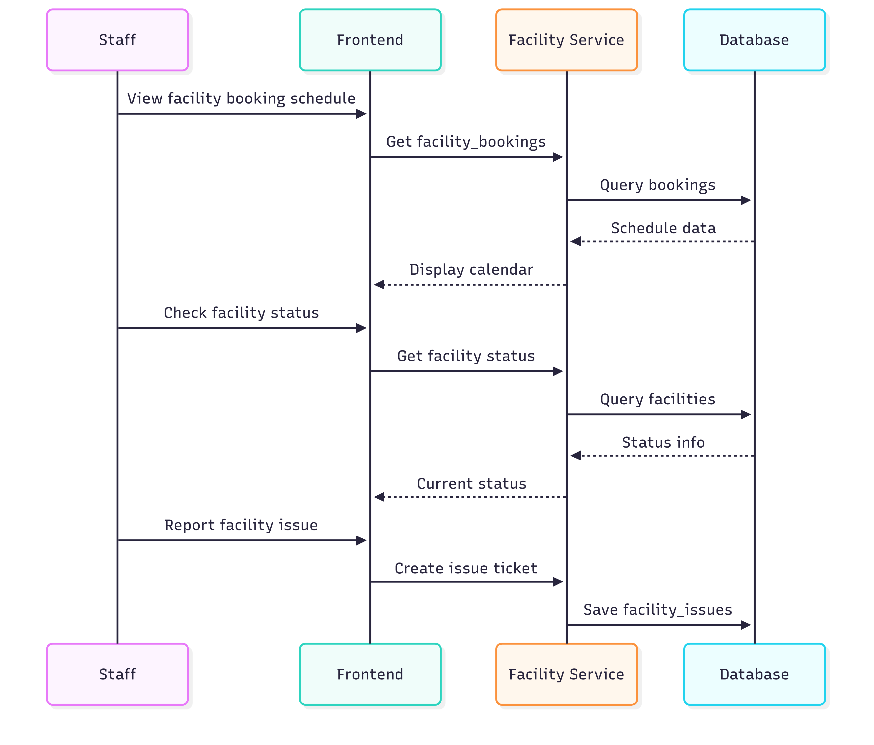

- Actor: Staff

- Description: Staff manages daily facility operations

- Precondition: Staff has facility management rights

- Main Flow:

* Staff views the facility booking schedule

* Checks facility status

* Updates facility status

* Handles incidents if any

- Postcondition: Facilities operate normally

3. **Resident Support**

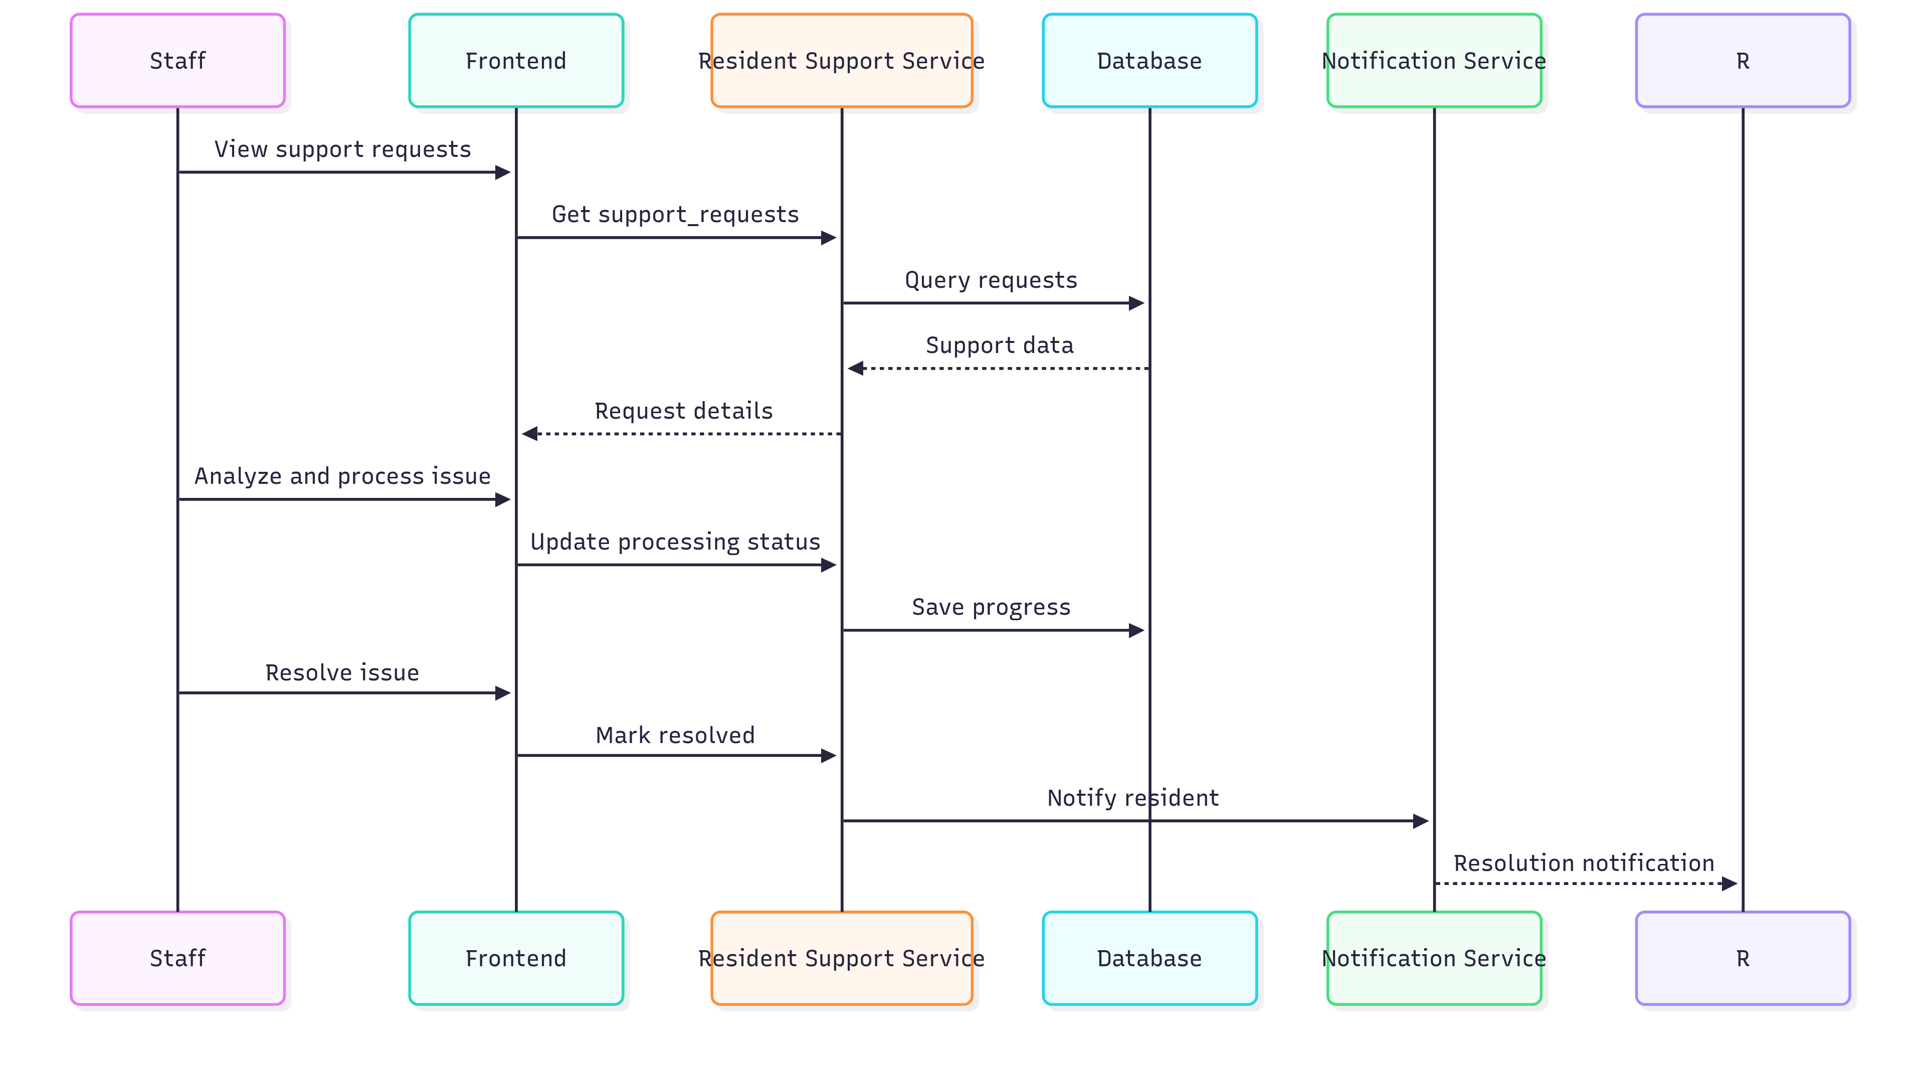

- Actor: Staff

- Description: Staff supports residents in resolving issues

- Precondition: There are resident support requests

- Main Flow:

* Staff receives support requests

* Analyzes and resolves issues

* Updates processing status

* Notifies results to the resident

- Postcondition: Issues are resolved

4. **Update resident information**

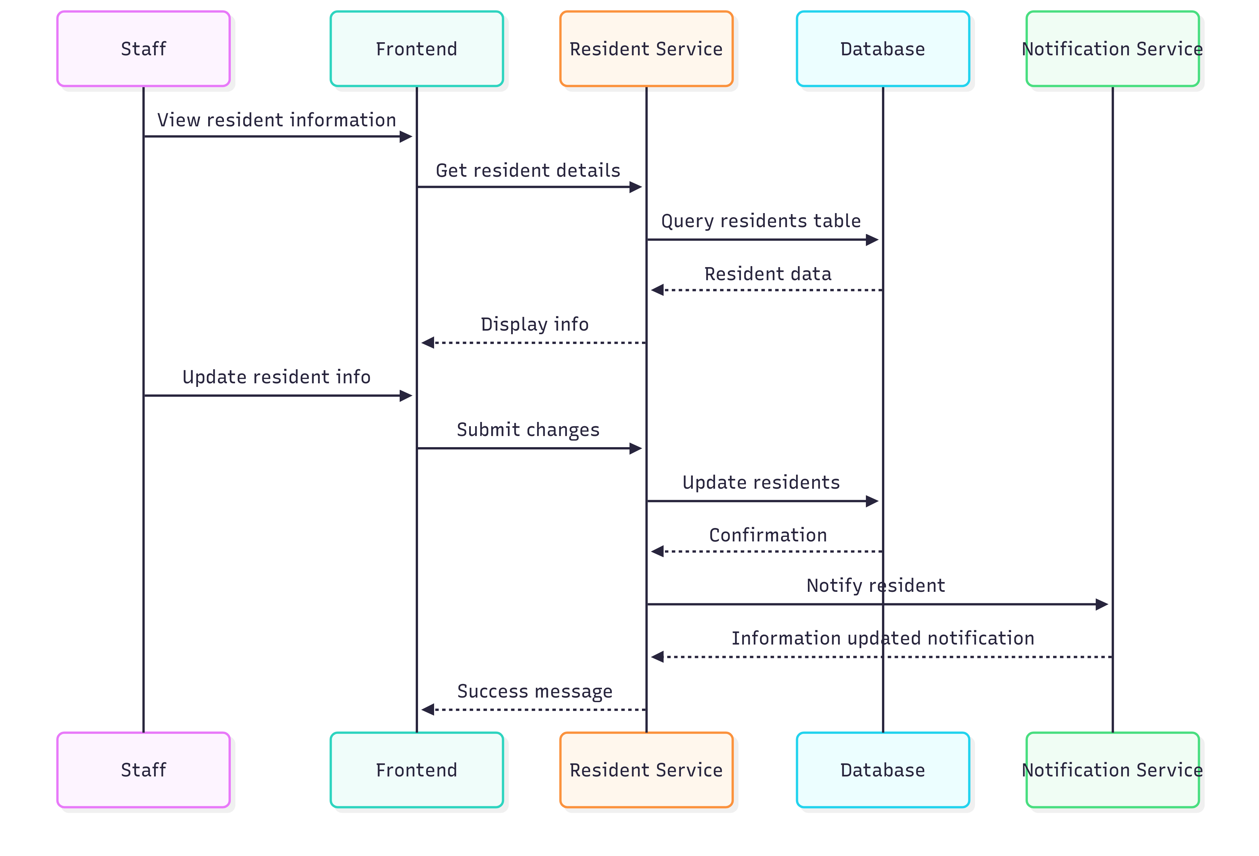

- Actor: Staff

- Description: Staff updates resident information when necessary

- Precondition: Staff has permission to update information

- Main Flow:

* Staff views resident information

* Updates information as requested

* Confirms changes

* Notifies the resident

- Postcondition: Resident information is updated

### 3.3 Resident Use Cases (Booking, payment, receiving notifications)

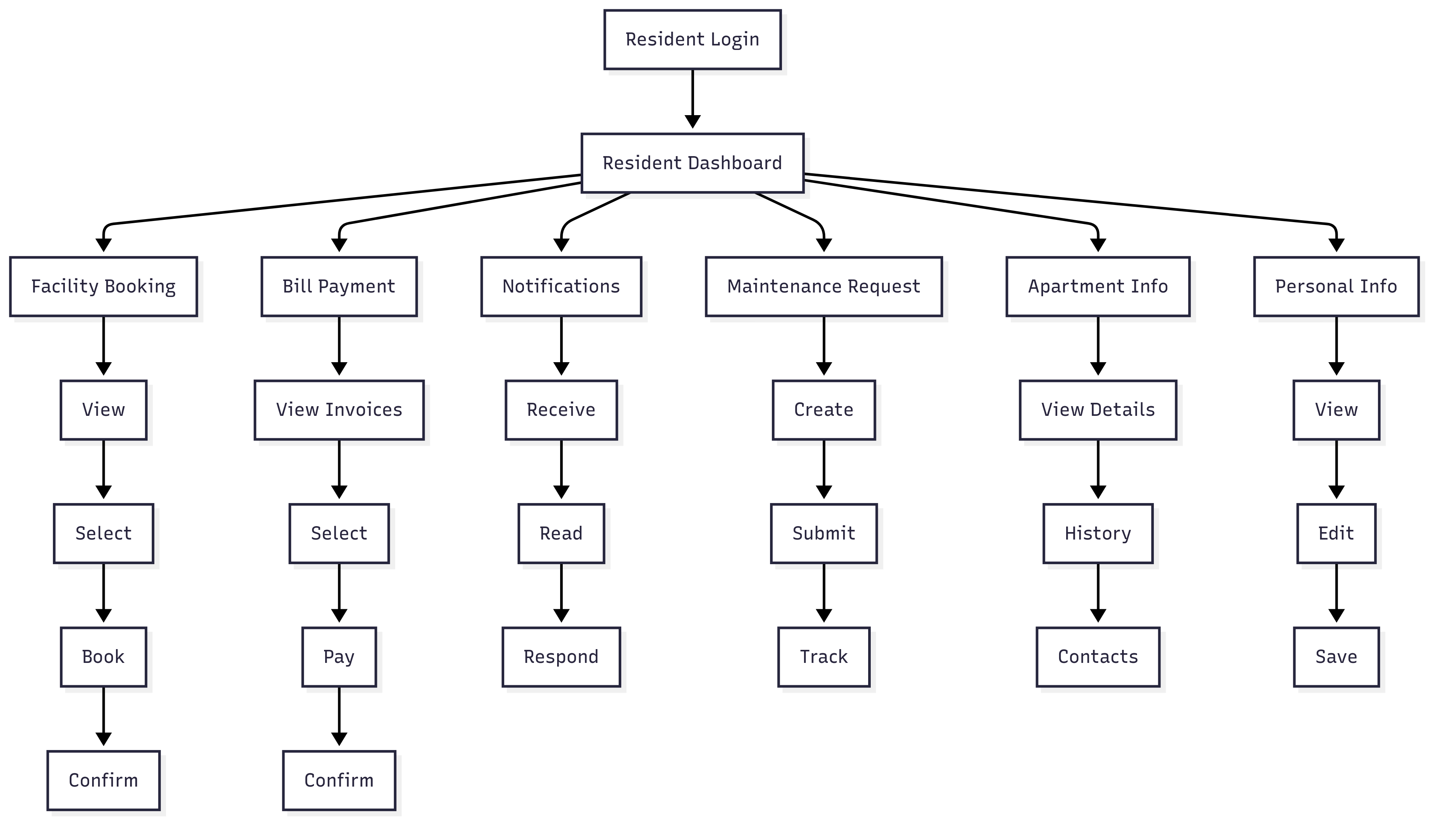

**Resident Use Case Description:**

Residents live in the building and use the system to book facilities, pay

invoices, and receive notifications.

**Main Use Cases:**

1. **Facility Booking**

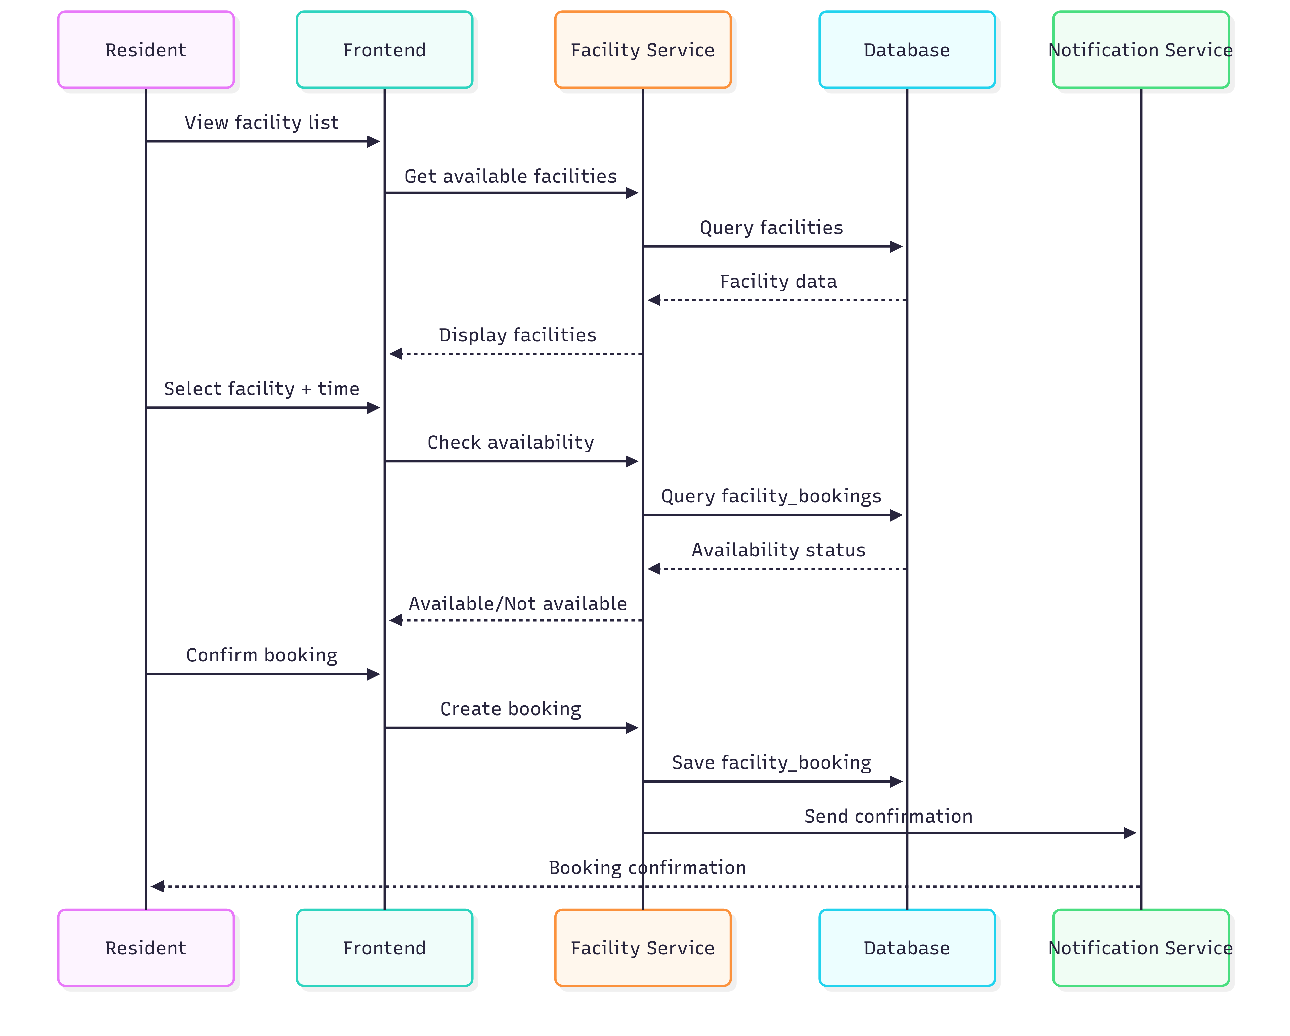

- Actor: Resident

- Description: Resident reserves usage of building facilities

- Precondition: Resident is logged in and the facility is available

- Main Flow:

* Resident views the list of facilities

* Selects a facility and time slot

* Checks availability

* Confirms the booking

* Receives confirmation notification

- Postcondition: Facility booking is successful

2. **Bill Payment**

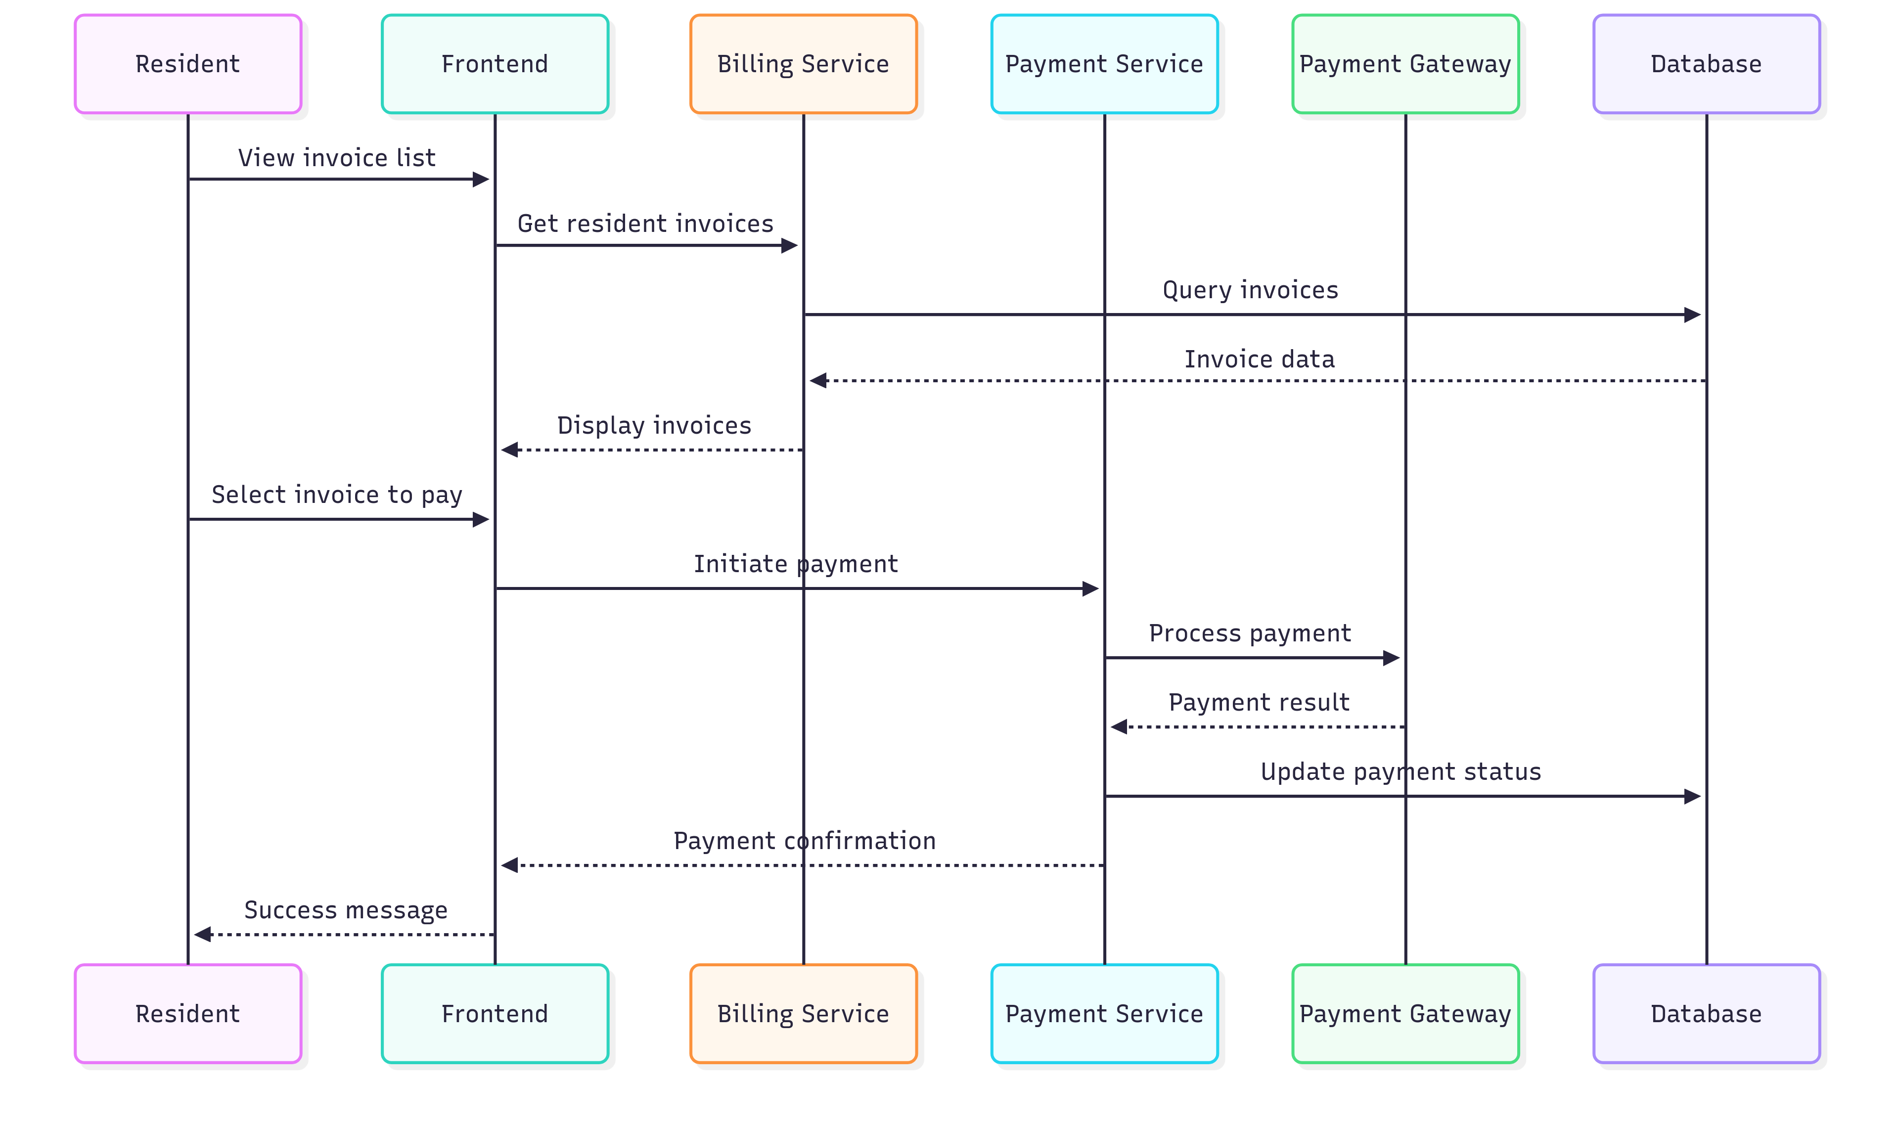

- Actor: Resident

- Description: Resident views and pays invoices

- Precondition: Resident has invoices to pay

- Main Flow:

* Resident views invoice list

* Selects invoices to pay

* Chooses a payment method

* Makes the payment

* Receives payment confirmation

- Postcondition: Invoice is paid successfully

3. **Receive notifications**

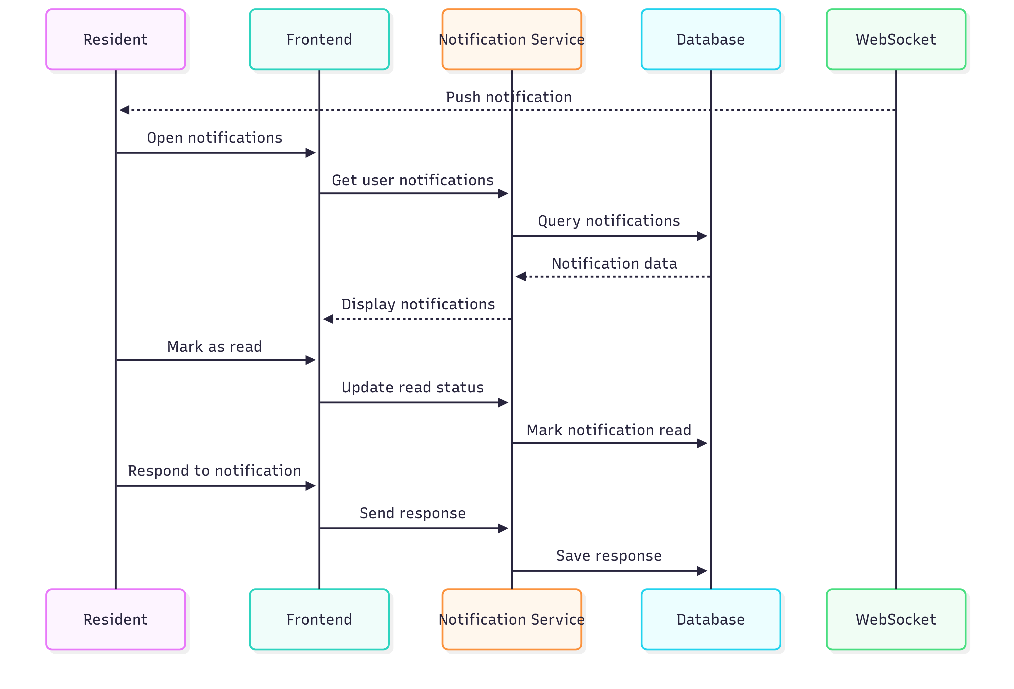

- Actor: Resident

- Description: Resident receives and views notifications from management

- Precondition: Resident is logged into the system

- Main Flow:

* Resident receives new notifications

* Views notification content

* Marks as read

* Responds if needed

- Postcondition: Notification is processed

4. **Submit maintenance request**

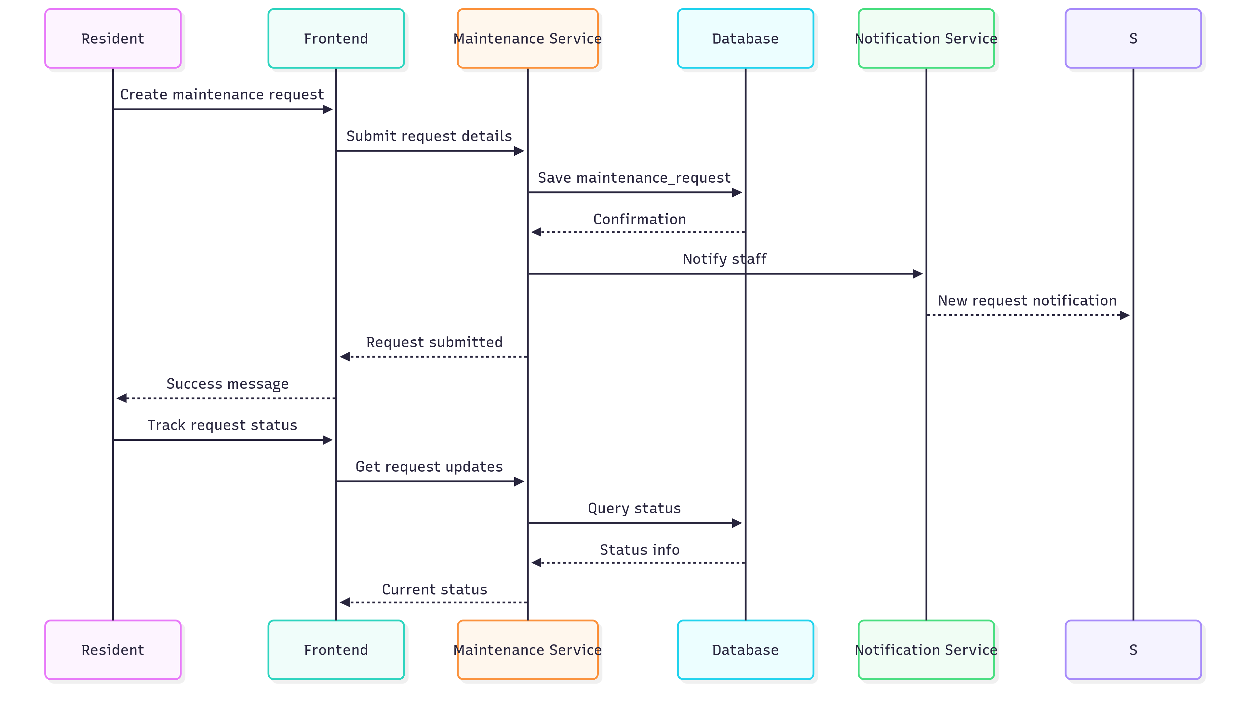

- Actor: Resident

- Description: Resident submits maintenance requests when needed

- Precondition: Resident needs maintenance for apartment or facilities

- Main Flow:

* Resident creates a new maintenance request

* Describes the issue

* Selects priority level

* Submits the request

* Tracks processing status

- Postcondition: Maintenance request is submitted successfully

5. **View apartment information**

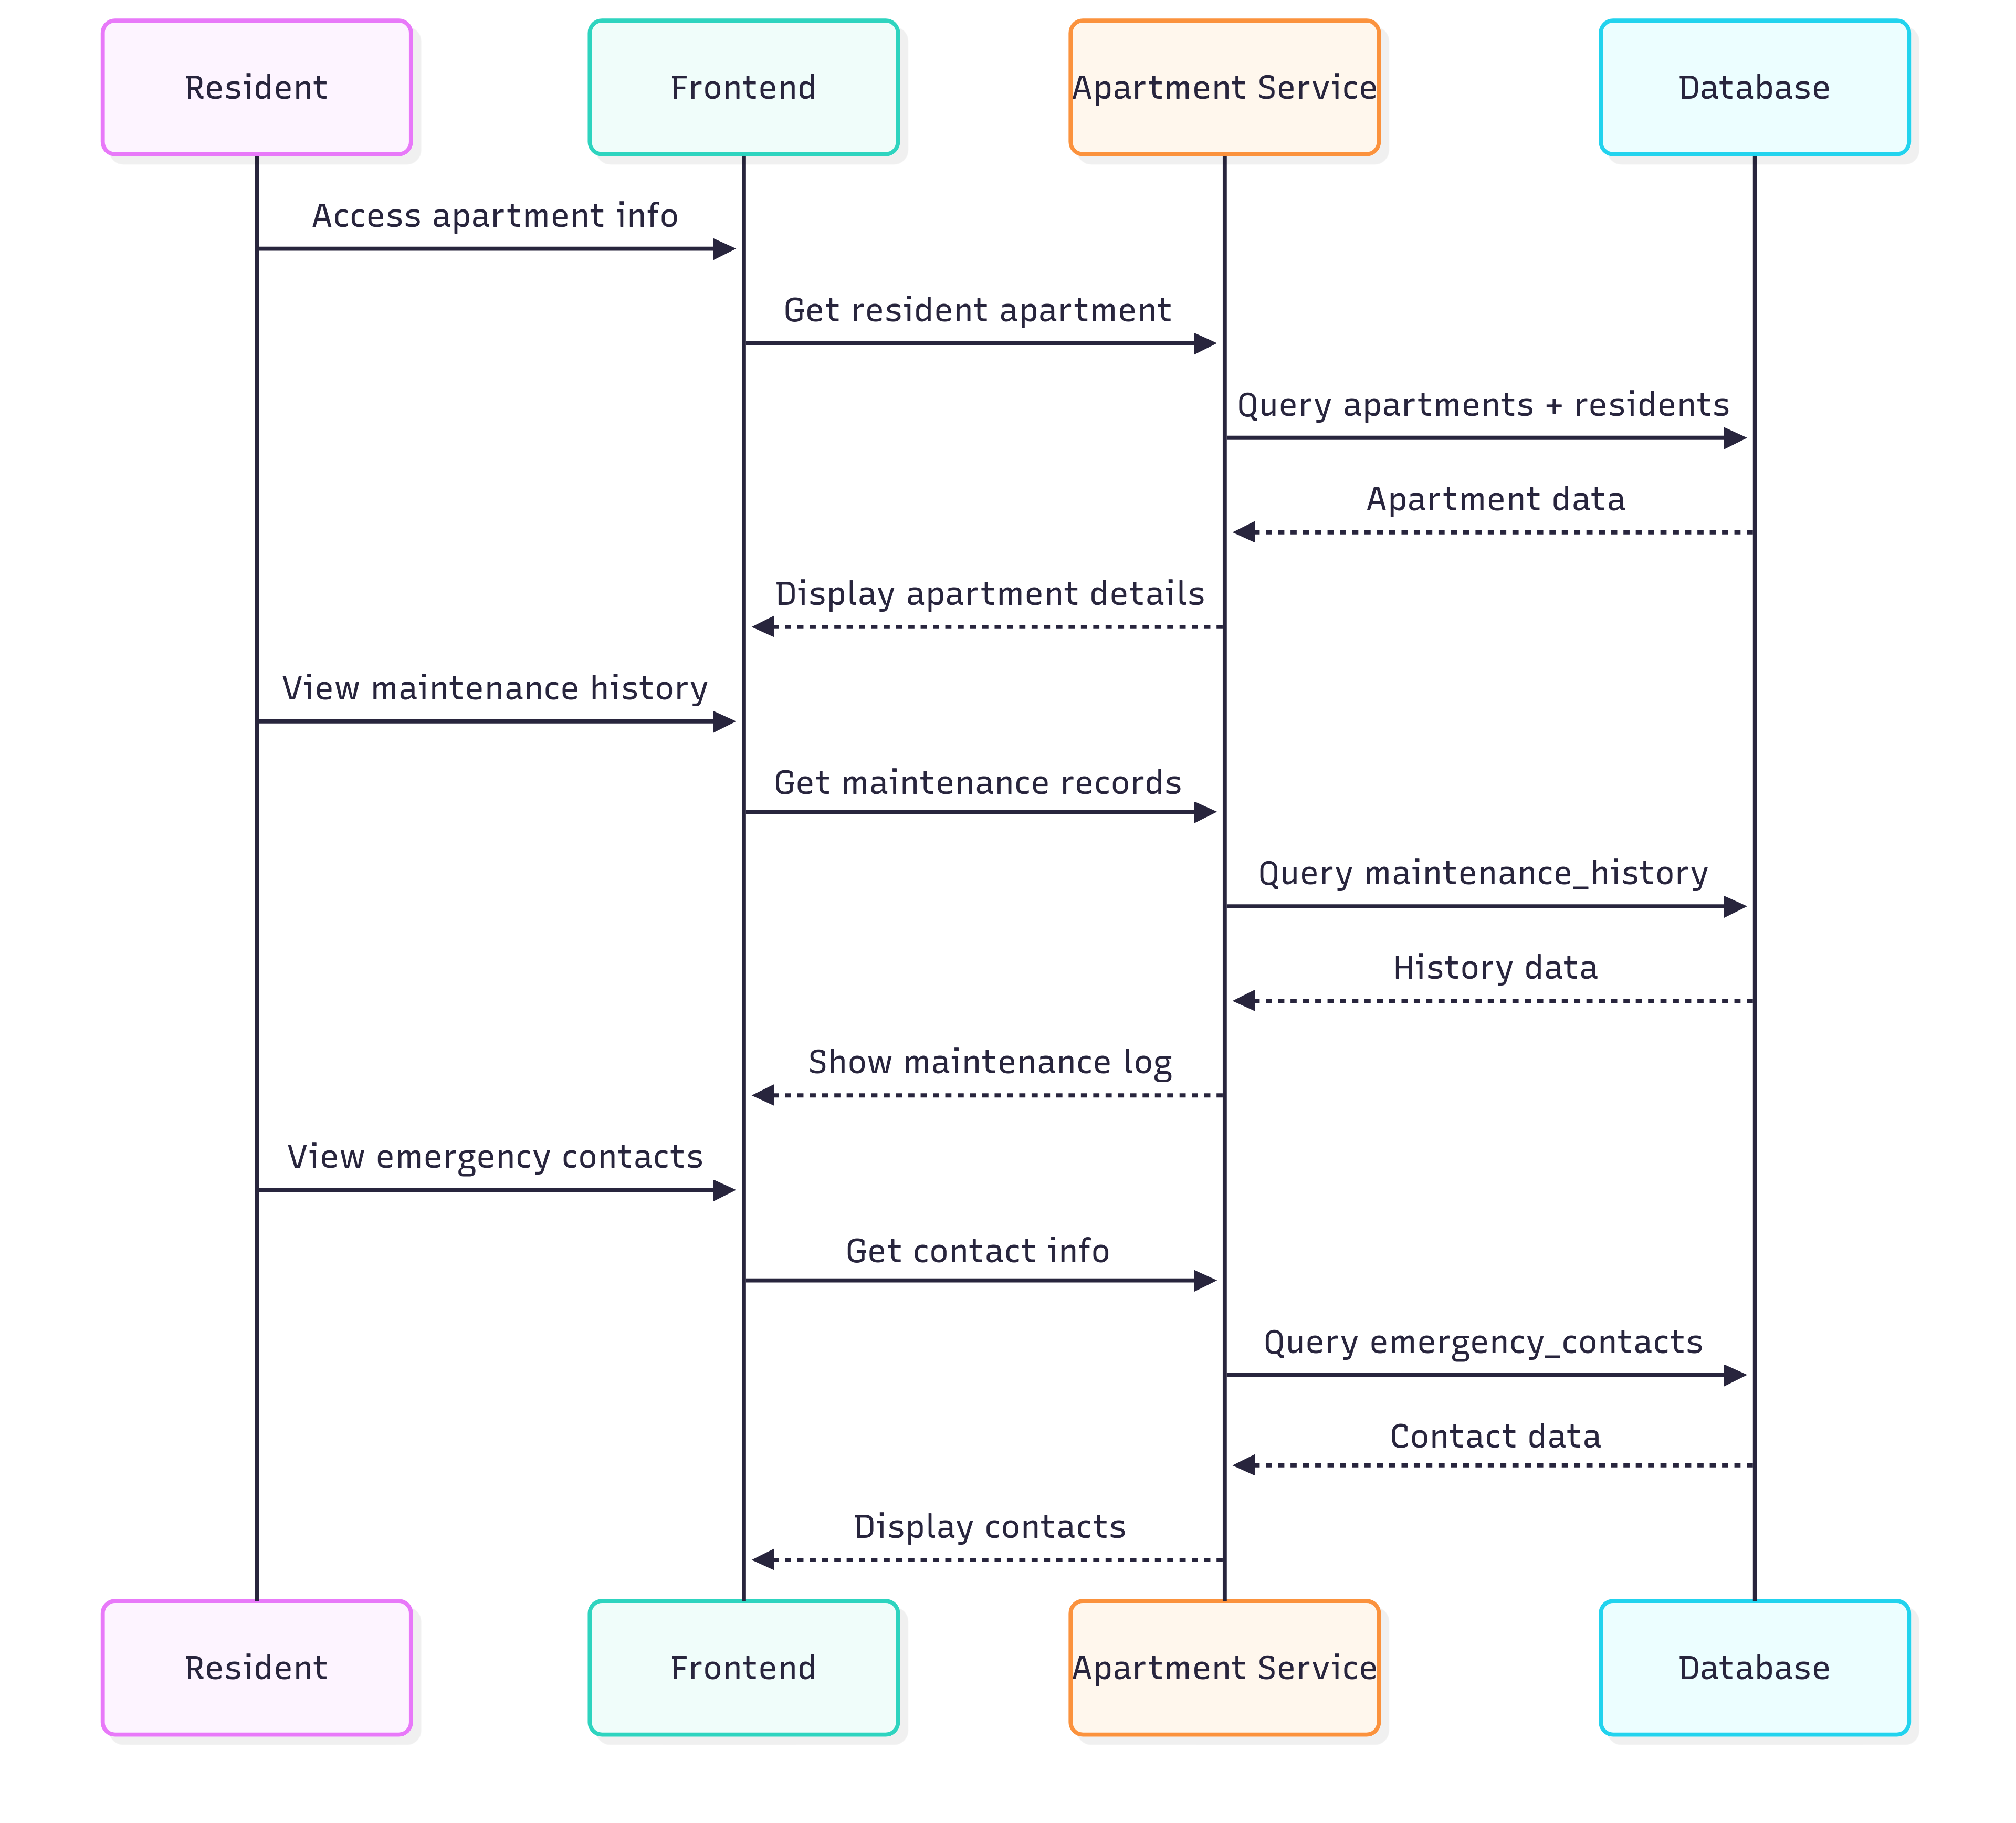

- Actor: Resident

- Description: Resident views detailed information about their apartment

- Precondition: Resident has been assigned to an apartment

- Main Flow:

* Resident accesses apartment information

* Views details

* Views maintenance history

* Views emergency contact information

- Postcondition: Resident has complete apartment information

6. **Update personal information**

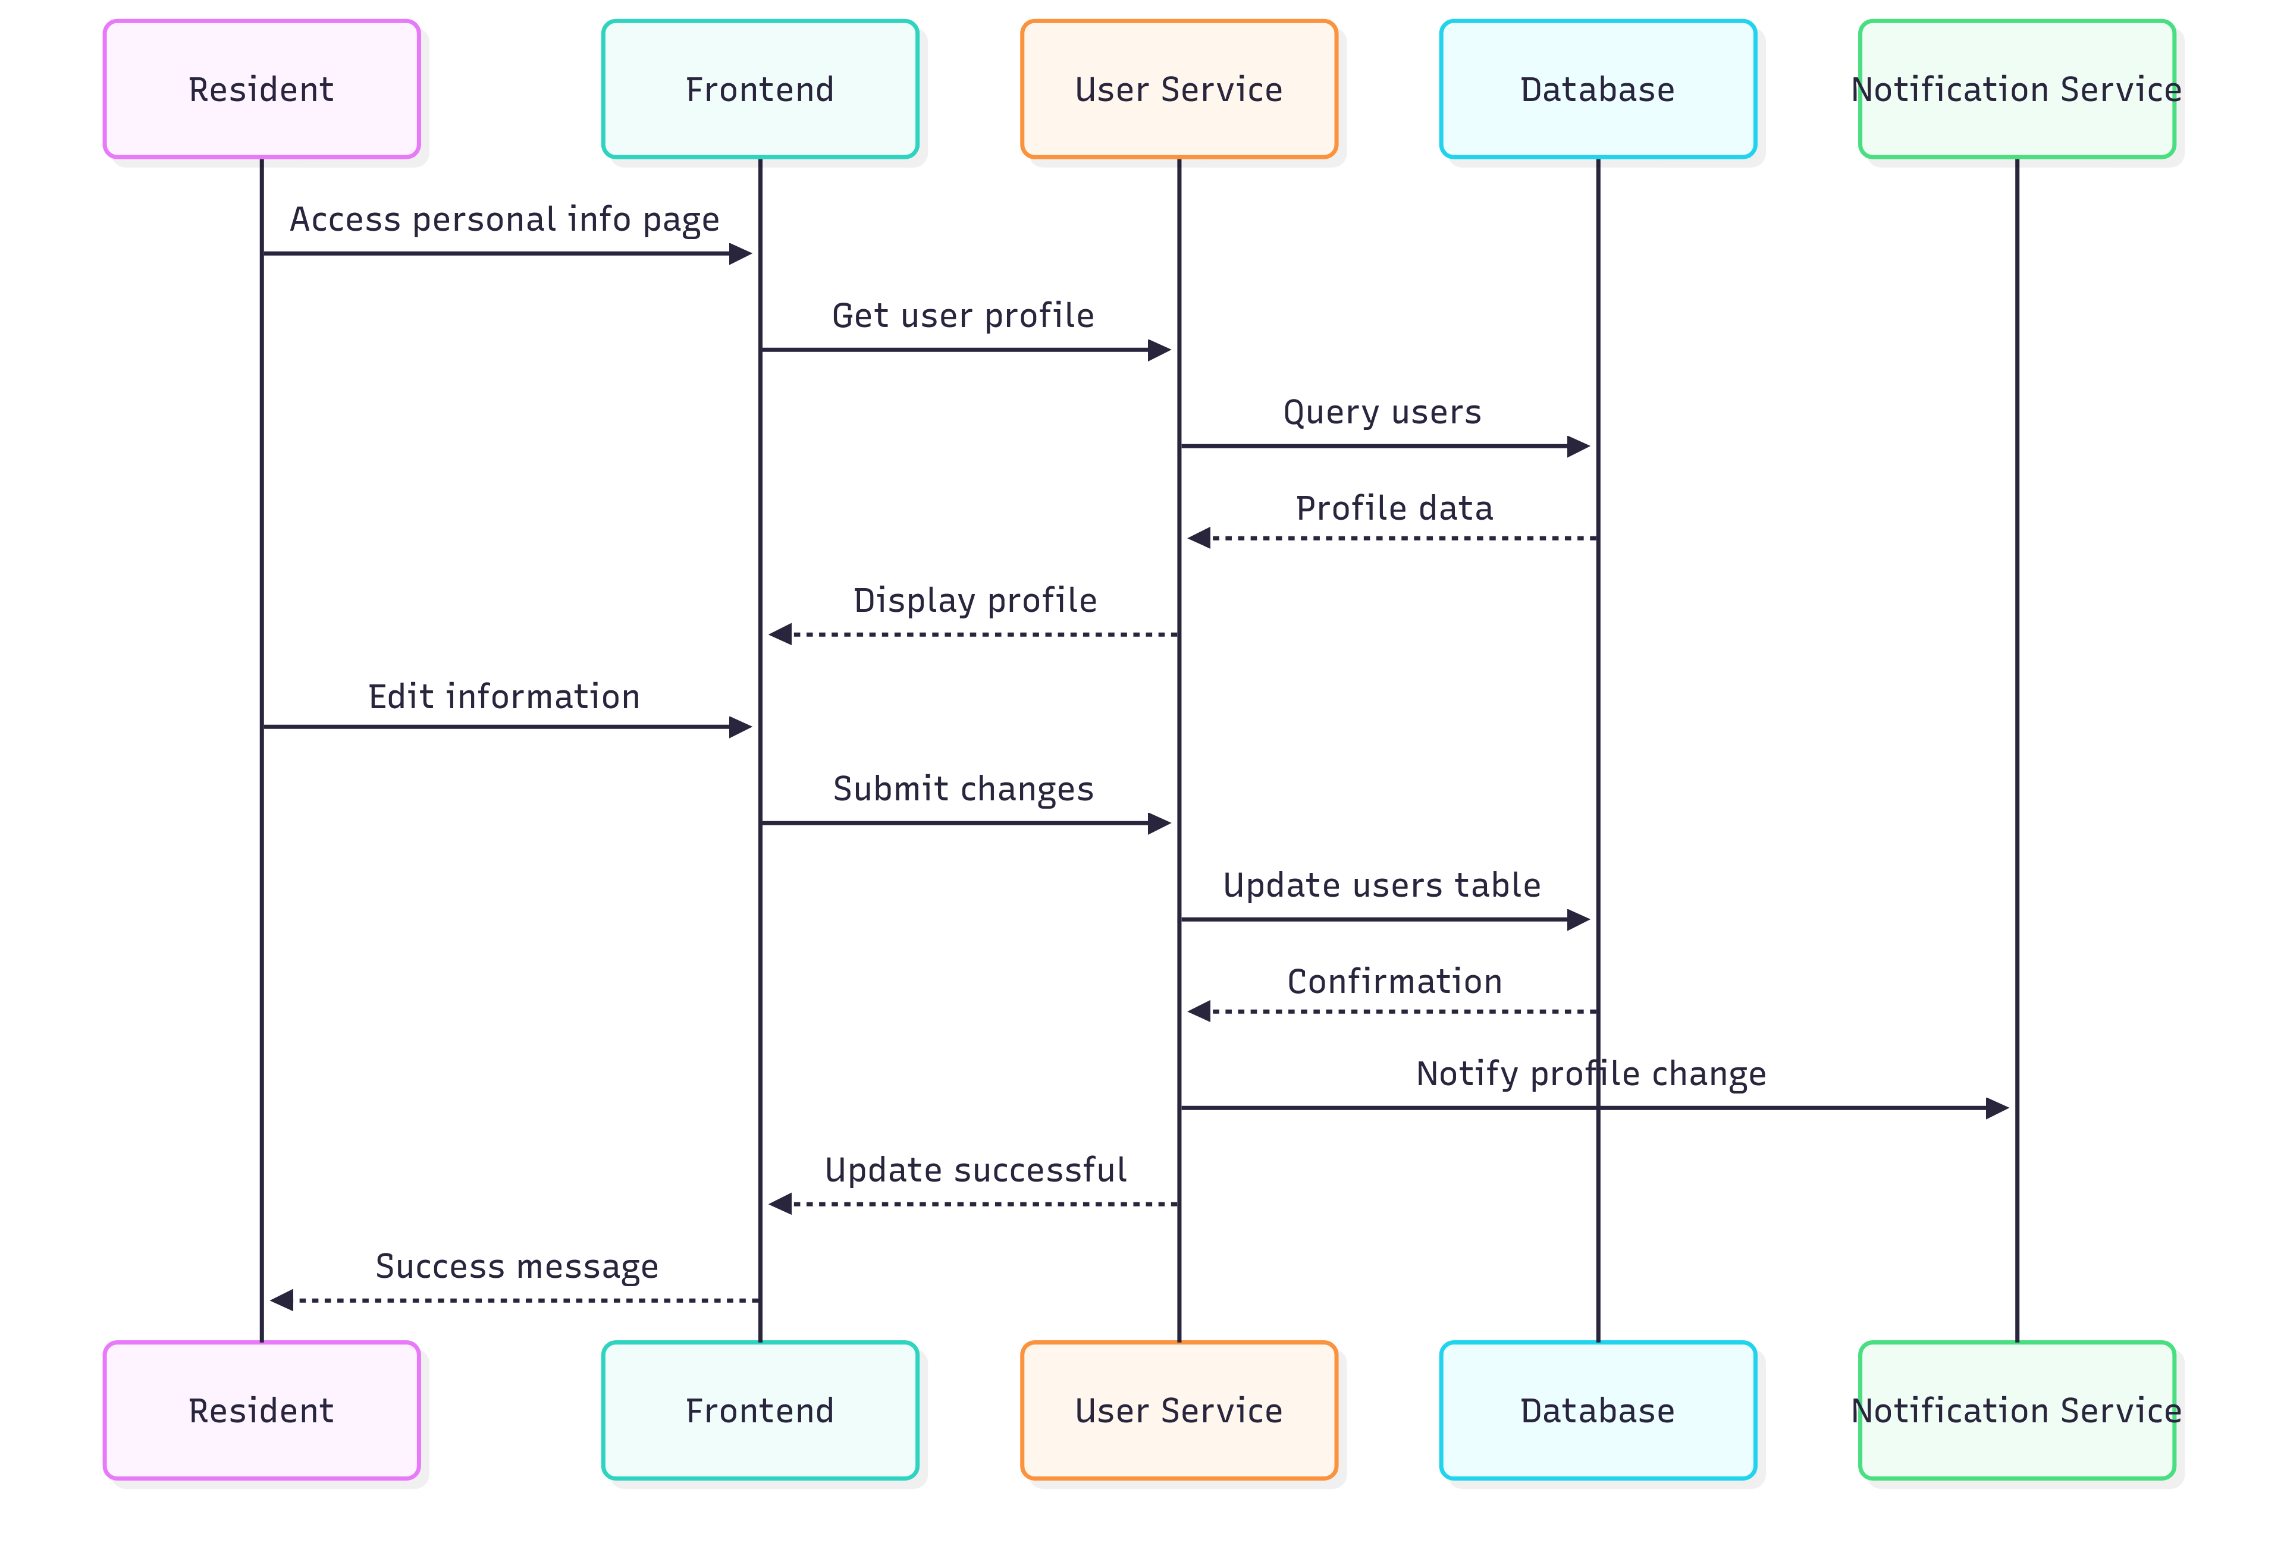

- Actor: Resident

- Description: Resident updates their personal information

- Precondition: Resident wants to change information

- Main Flow:

* Resident opens the personal information page

* Edits necessary information

* Saves changes

* Receives confirmation

- Postcondition: Personal information is updated

## TASK SHEET FOR REVIEW 2.

| Task ID | Task Description | Assignee | Start Date | End Date | Status | Notes |
| --- | --- | --- | --- | --- | --- | --- |
| R2-01 | Define 3-tier architecture (Presentation, Business Logic, Data Access) | Huỳnh Tấn Lực | 25/08/2025 | 13/09/2025 | Completed | Clear responsibilities and boundaries |
| R2-02 | Detail roles of each tier and technologies used | Đặng Trí Thức | 25/08/2025 | 05/09/2025 | Completed | React+TS, Flutter, Spring Boot, MySQL, Redis |
| R2-03 | Describe overall system architecture | Huỳnh Tấn Lực | 25/08/2025 | 05/09/2025 | Completed | Web, Mobile, RESTful APIs, 3-tier |
| R2-04 | Design microservices architecture diagram | Đặng Trí Thức | 25/08/2025 | 05/09/2025 | Pending | Draw components and inter-service communication |
| R2-05 | Document microservices details (Main, Realtime, Facility, Reporting, Payment, Security) | Huỳnh Tấn Lực | 25/08/2025 | 05/09/2025 | Completed | Responsibilities, data stores, protocols |
| R2-06 | Define data flows (user request, inter-service, data, realtime) | Đặng Trí Thức | 25/08/2025 | 05/09/2025 | In Progress | Sequence and integration points |
| R2-07 | Create Data Flow Diagrams (DFD) for main flows | Huỳnh Tấn Lực | 25/08/2025 | 05/09/2025 | Pending | Context + Level 1 diagrams |
| R2-08 | Elaborate use case diagrams and descriptions (Admin/Staff/Resident) | Đặng Trí Thức | 25/08/2025 | 05/09/2025 | Completed | Detailed flows and postconditions |
| R2-09 | Specify sequence flows for login, booking, billing, notifications, maintenance | Huỳnh Tấn Lực | 25/08/2025 | 05/09/2025 | In Progress | Convert text flows to UML sequences |
| R2-10 | Define non-functional design decisions (scalability, security, caching, backups) | Đặng Trí Thức | 25/08/2025 | 05/09/2025 | Completed | HikariCP, TLS, JWT, RBAC, Flyway, Redis |
| R2-11 | Prepare architecture diagrams (C4/Component/Deployment) | Huỳnh Tấn Lực | 25/08/2025 | 05/09/2025 | Pending | Use PlantUML/Mermaid |
| R2-12 | Consolidate Review 2 package and submit | Đặng Trí Thức | 25/08/2025 | 05/09/2025 | Pending | Final MD/PDF with diagrams |

# REVIEW 3 DATABASE & GUI DESIGN SMART BUILDING MANAGEMENT SYSTEM

## 1. DATABASE DESIGN

### 1.1 List of main entities

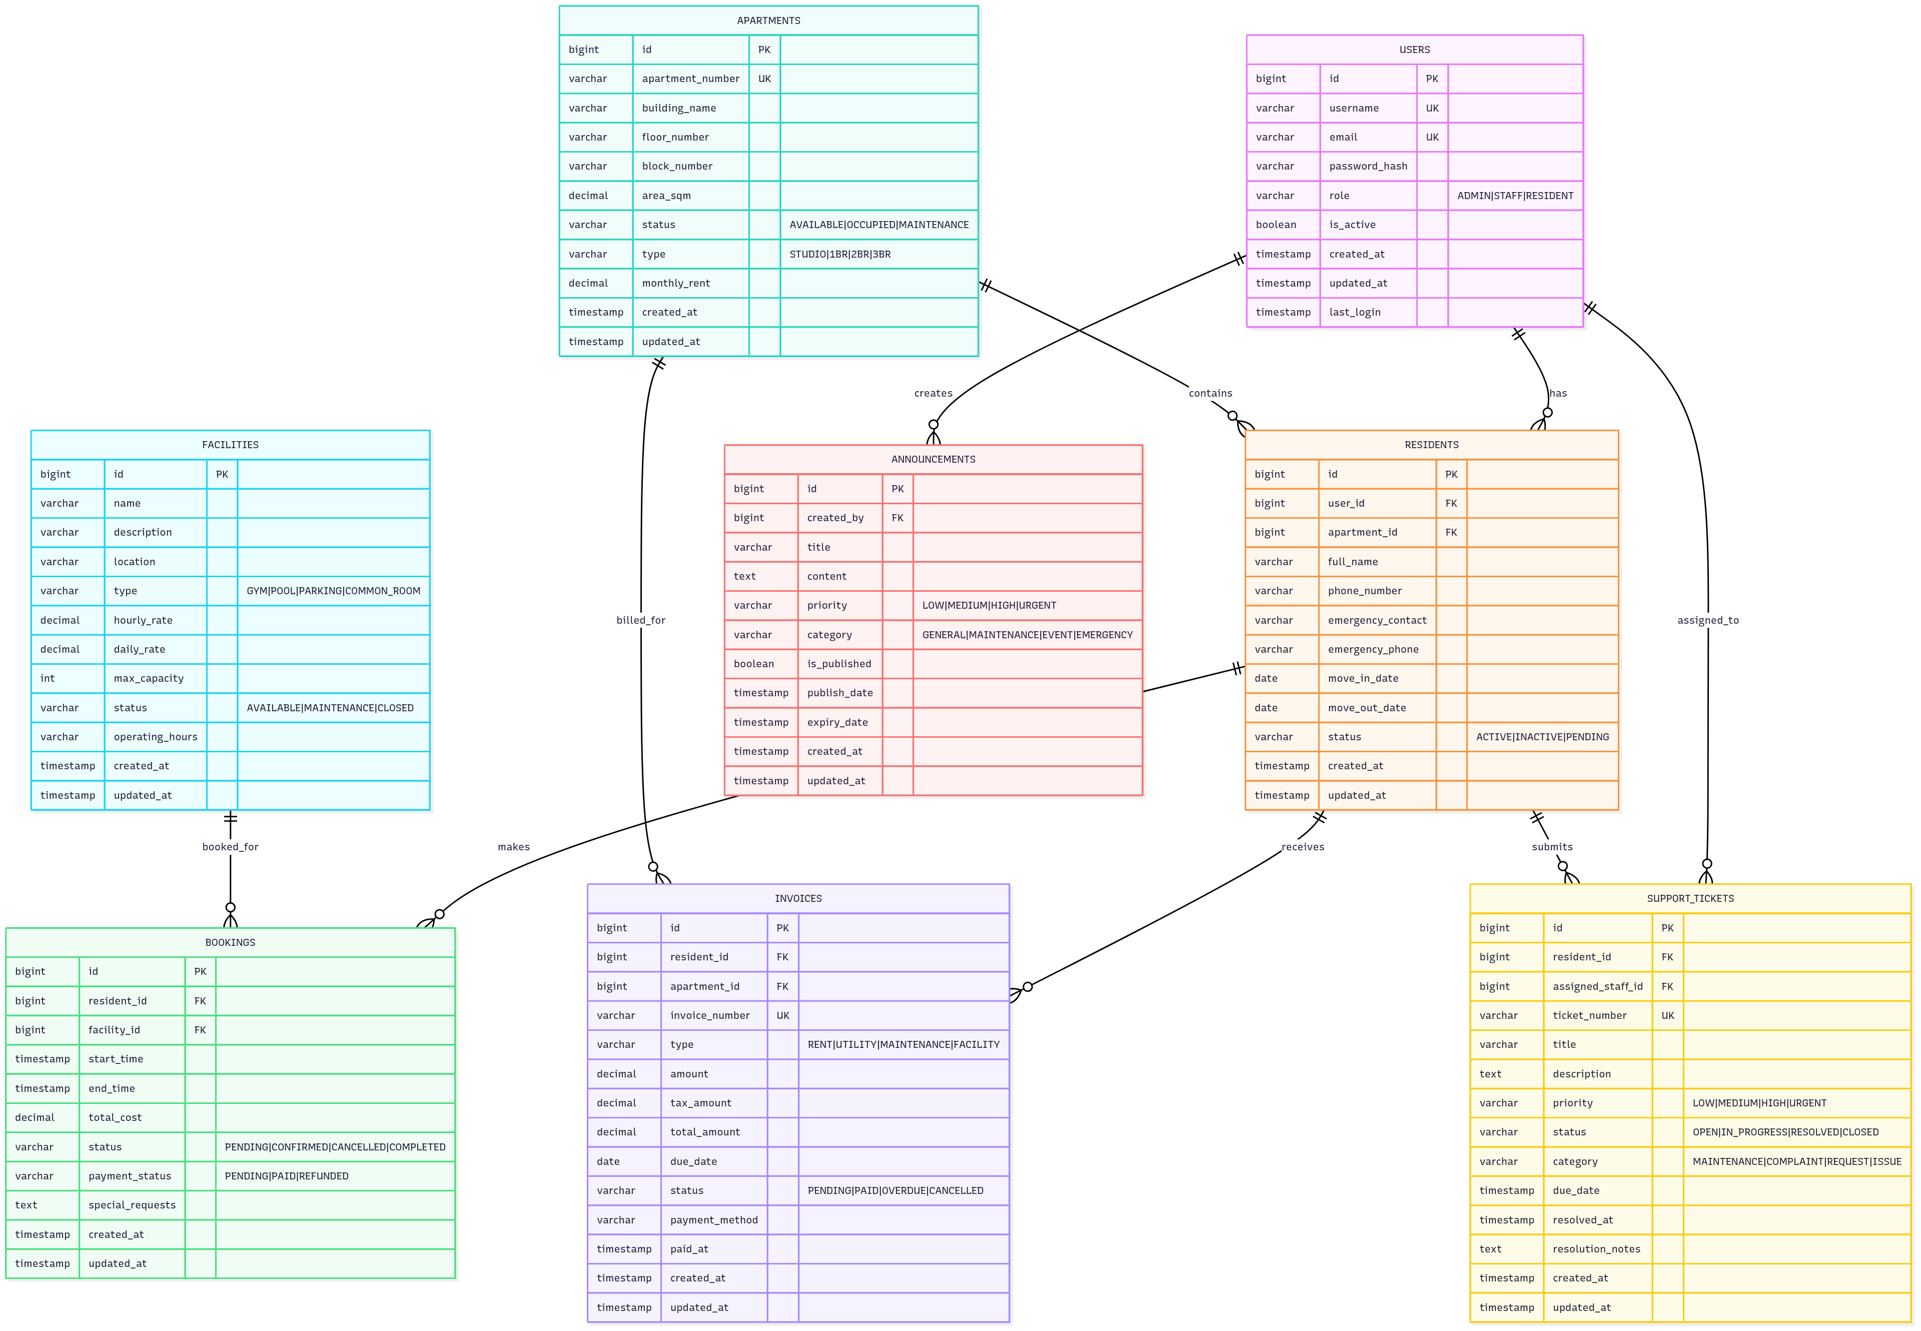

The system is designed with 8 main entities to manage the entire operation

of the apartment building:

**1. Users**

- Manage login information and roles

- Support 3 user types: Admin, Staff, Resident

**2. Apartments**

- Store detailed information about apartments

- Track statuses and apartment history

**3. Residents**

- Residents’ personal and contact information

- Linked with apartments and user accounts

**4. Facilities**

- Catalog of facilities available in the building

- Information on usage fees and maintenance schedules

**5. Bookings**

- Manage reservations for facility usage

- Track booking history and payments

**6. Invoices**

- Periodic invoices and service fees

- Track payment status

**7. Announcements**

- Notifications from management to residents

- History of sending and receiving notifications

**8. SupportTickets**

- Maintenance and support requests from residents

- Track processing progress

### 1.2 ERD (Entity-Relationship Diagram)

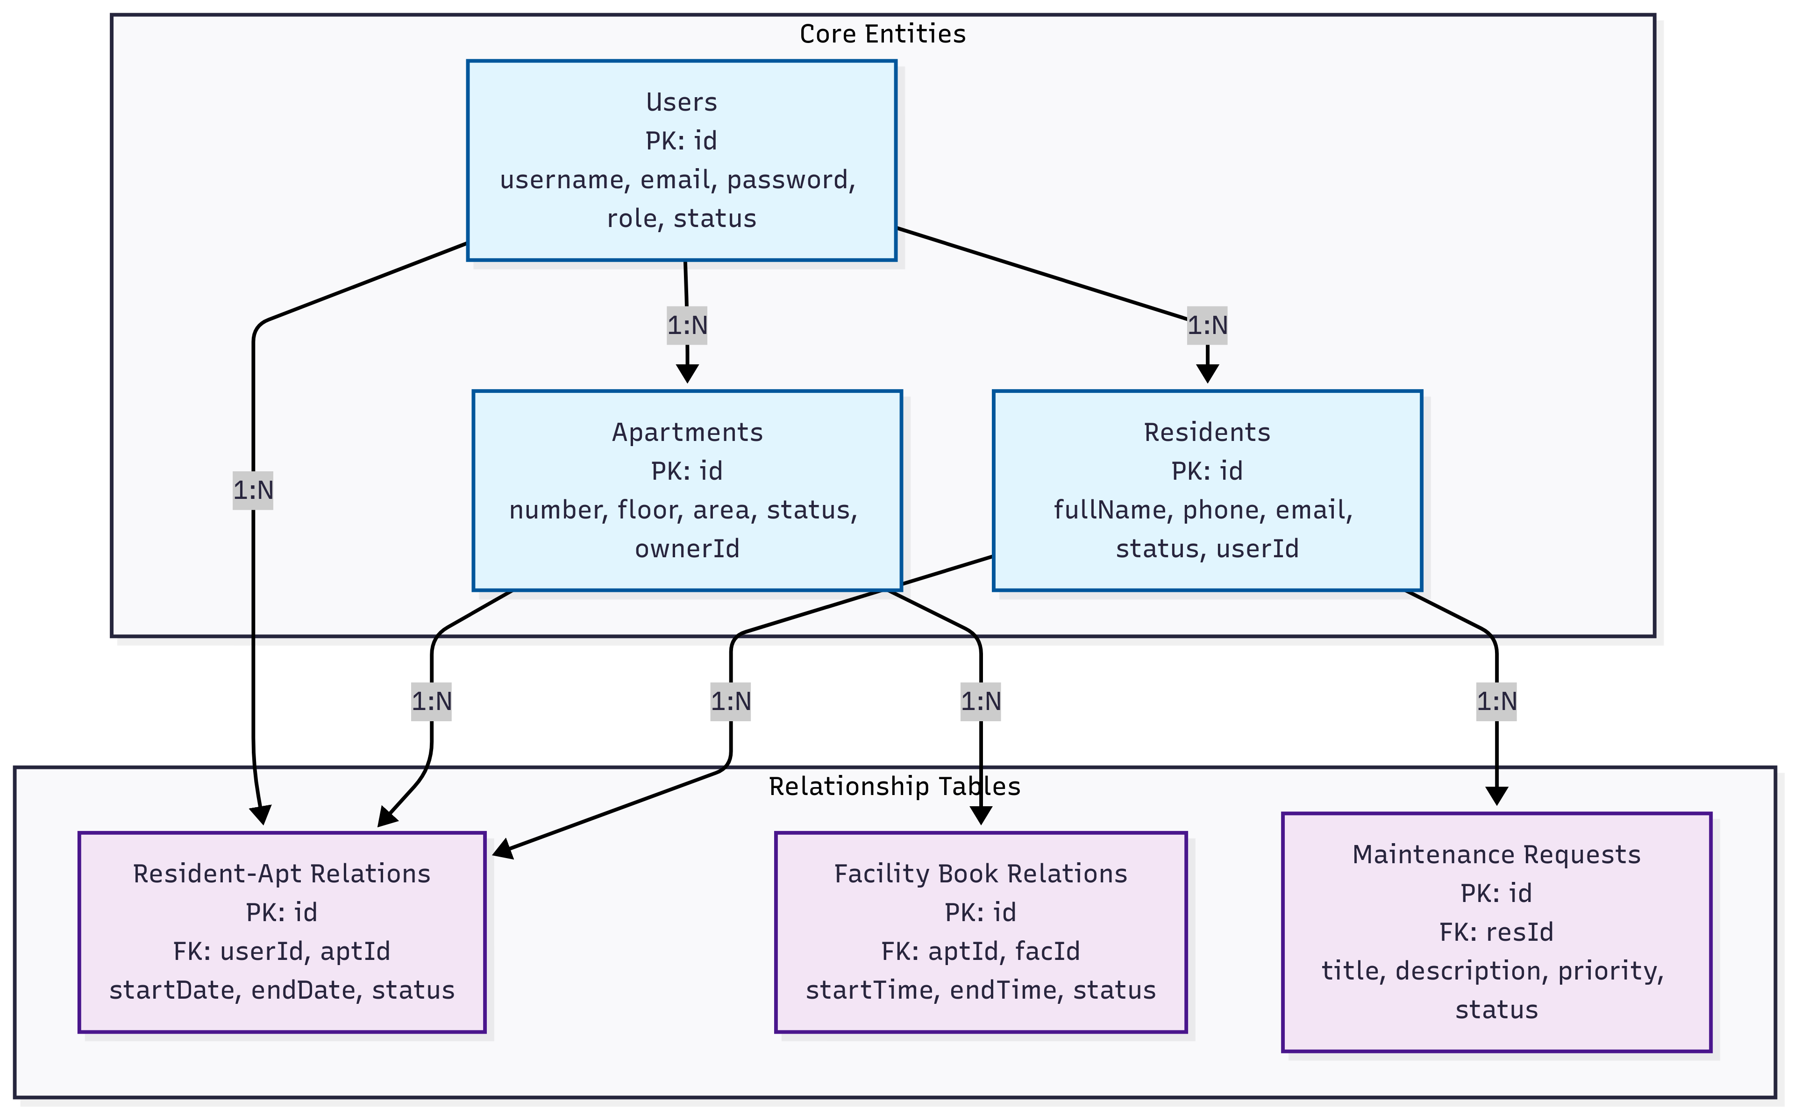

### 1.3 Detailed tables (attributes, primary keys, foreign keys)

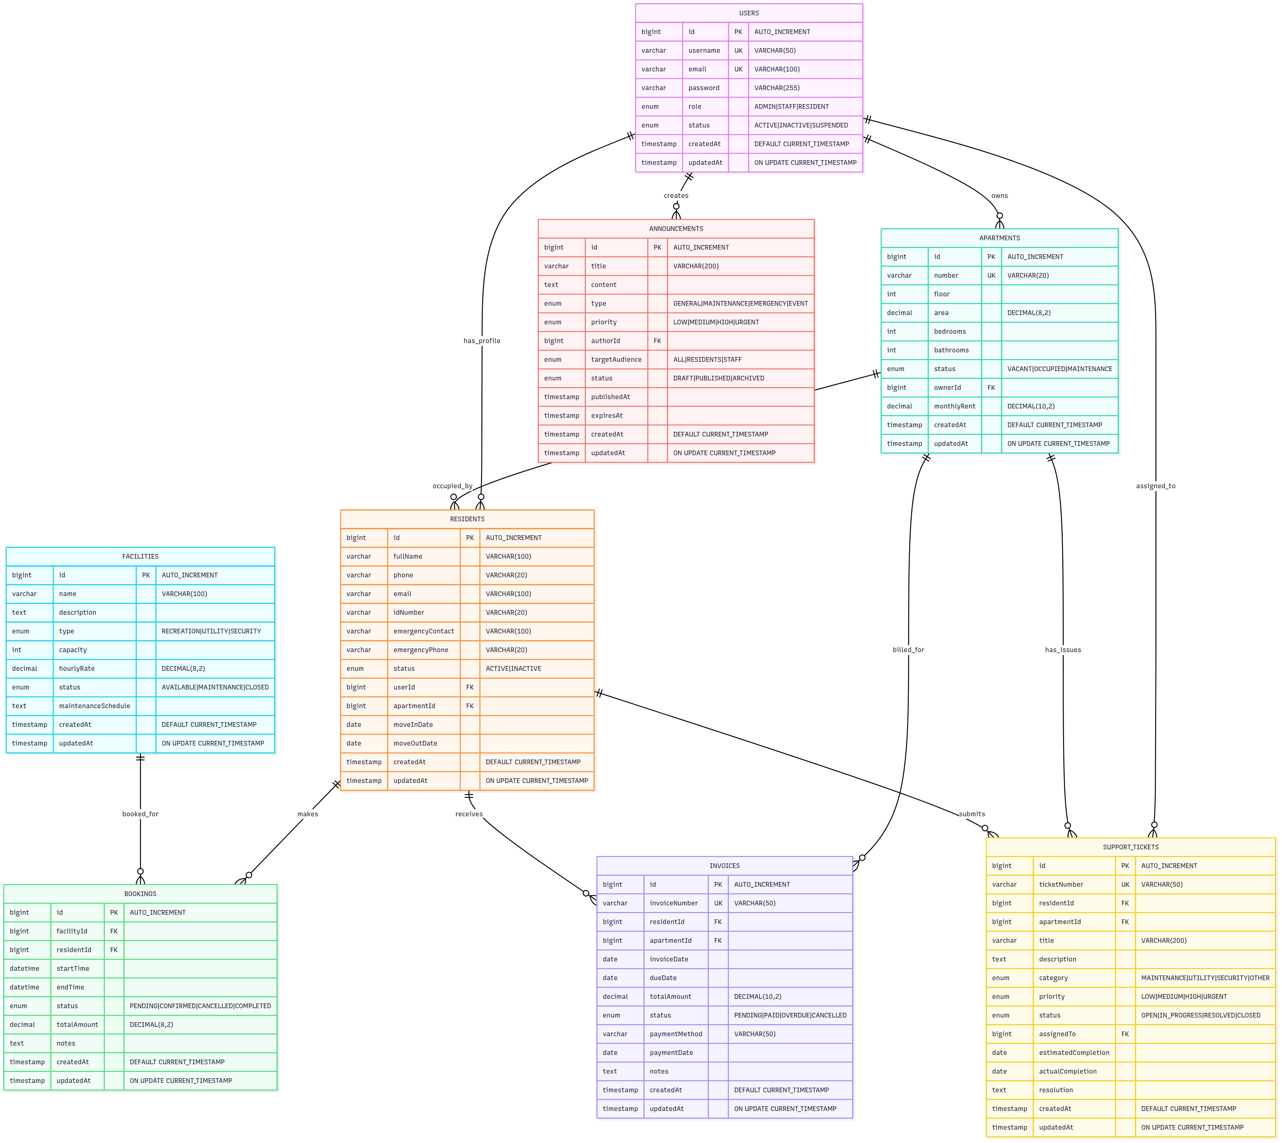

### 1.4 Relationships between tables

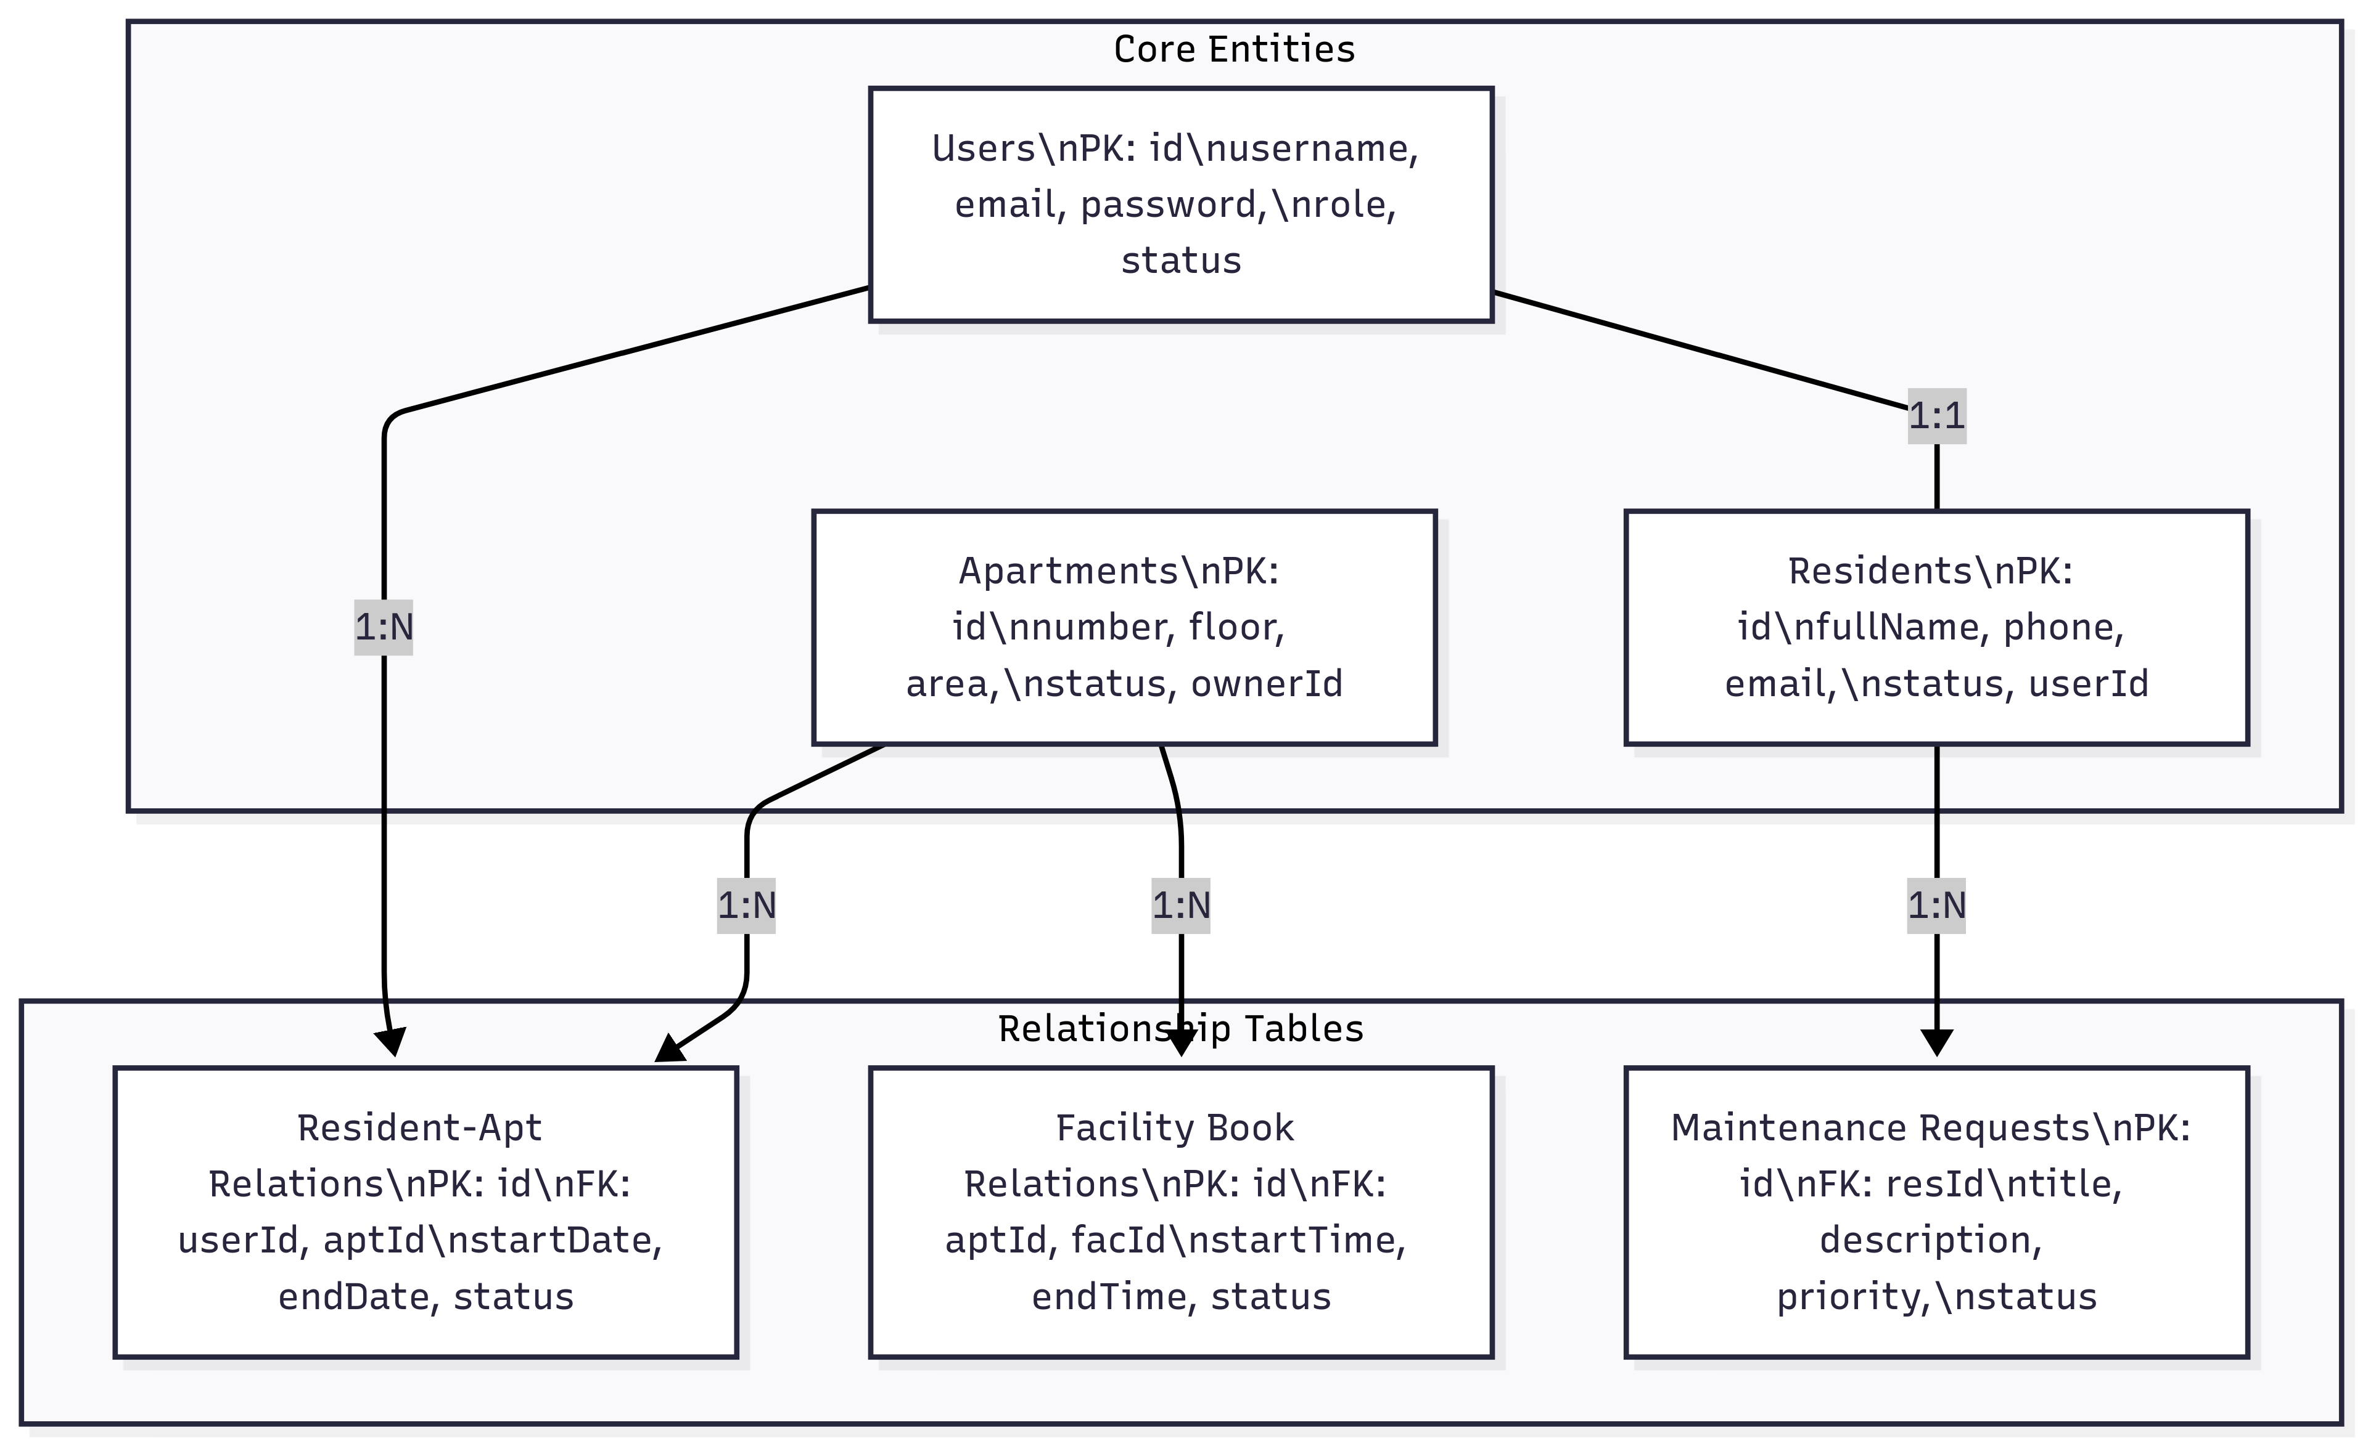

**1-1 relationships:**

- Users ↔ Residents (one user corresponds to one resident)

- Users ↔ Apartments (one owner may have multiple apartments)

**1-N relationships:**

- Users → Announcements (one user creates many notifications)

- Apartments → Residents (one apartment may have many residents)

- Facilities → Bookings (one facility has many bookings)

**N-N relationships:**

- Residents ↔ Apartments (via a junction table)

- Residents ↔ Facilities (via the Bookings table)

## 2. USER INTERFACE (UI/UX) DESIGN

### 2.1 Website interface

#### **2.1.1 Login**

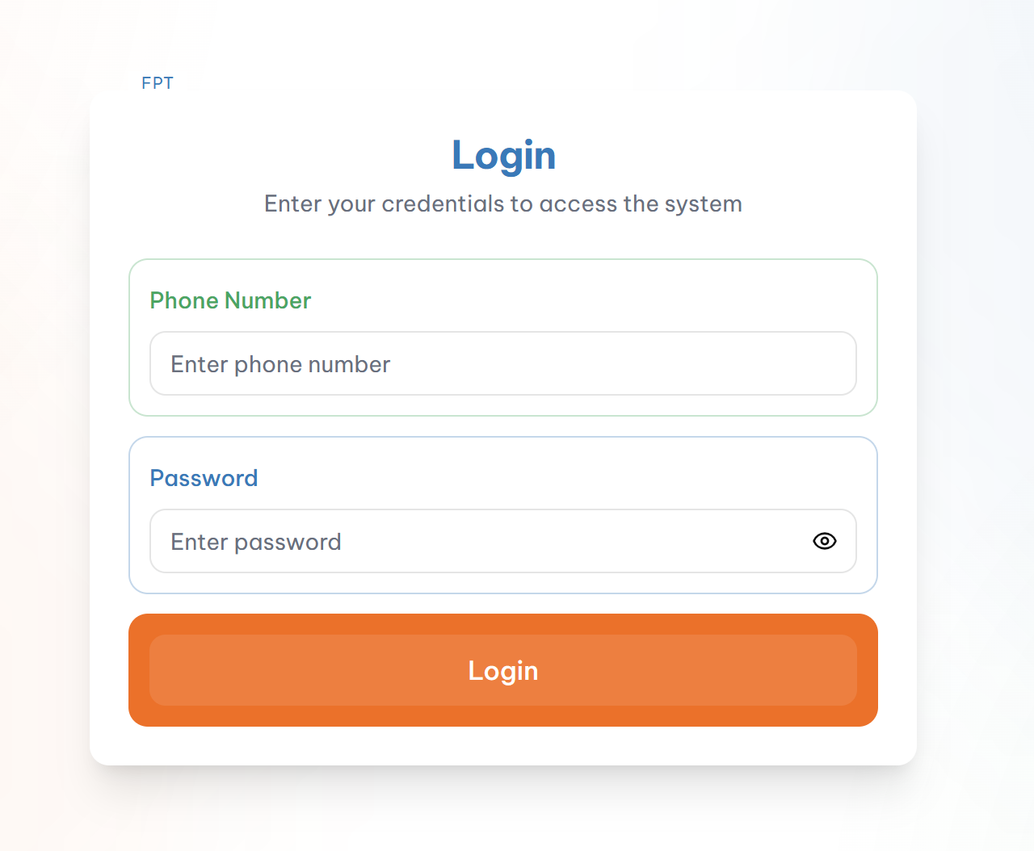

- **Layout:** Centered login form with gradient background

- **Components:**

* System logo at top

* Login form with phone number and password

* “Remember me” checkbox

* “Forgot password” and “Register” links

* Login button with hover effect

- **Responsive:** Auto-adjust for mobile and tablet

#### **2.1.2 Dashboard**

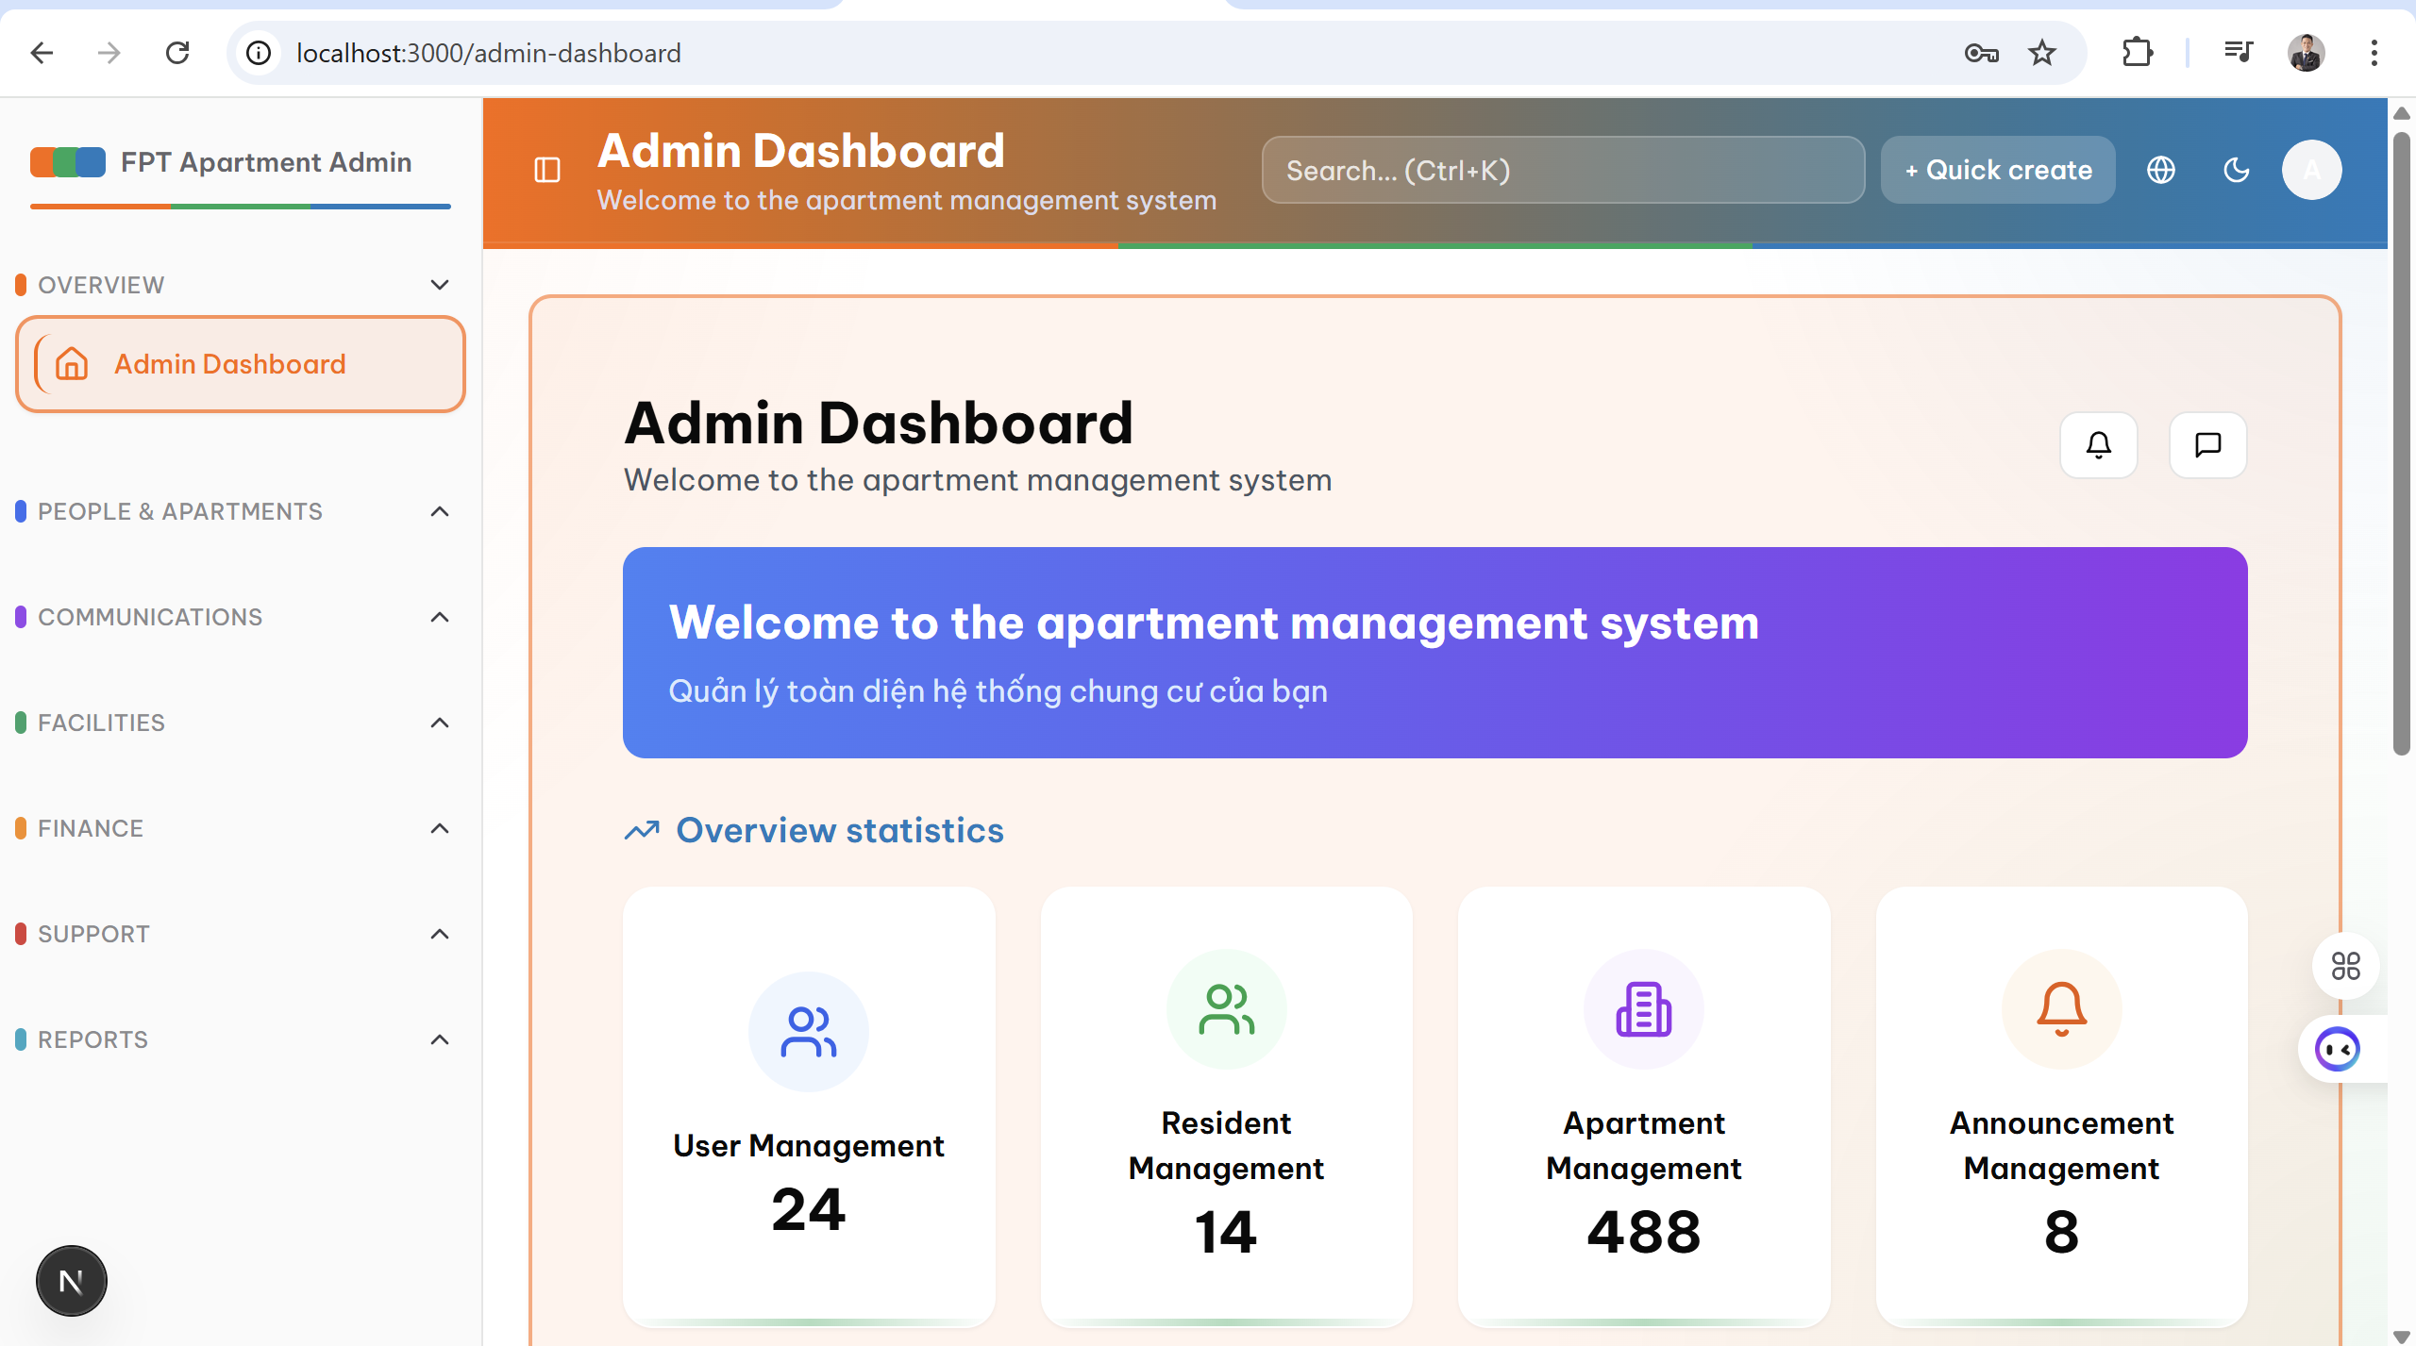

- **Layout:** Grid layout with sidebar navigation

- **Components:**

* Sidebar: Main menu, user profile, quick actions

* Header: Search bar, notifications, user menu

* Main content: Statistic widgets, charts, data tables

* Footer: System info, support links

- **Widgets:** Number of residents, apartments, facilities, unpaid invoices

#### **2.1.3 Resident Management**

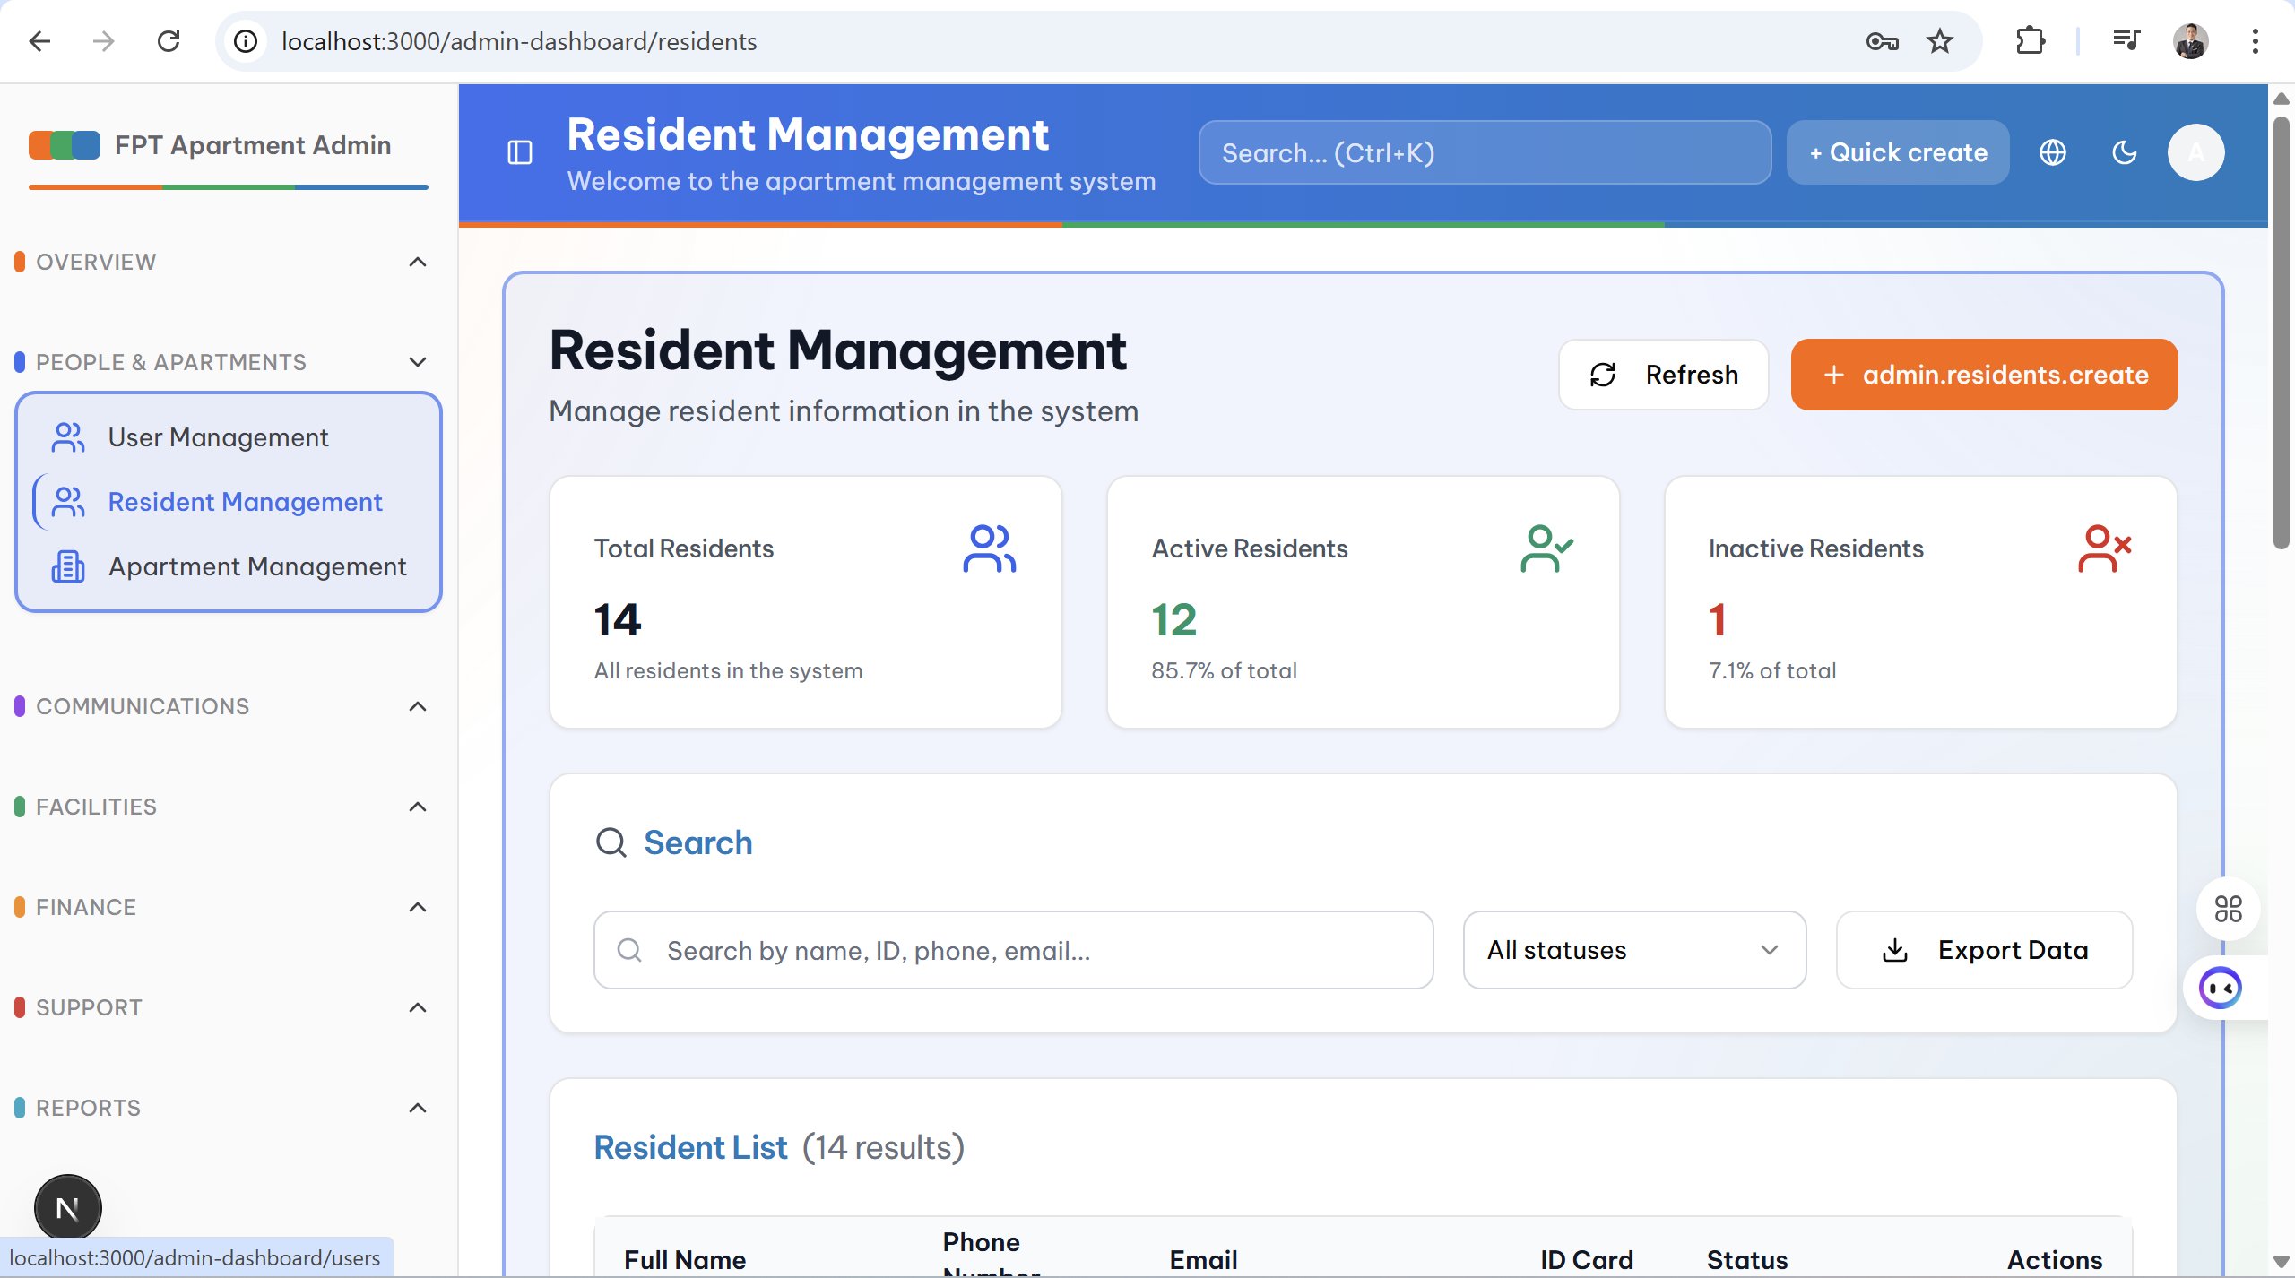

- **Layout:** Table layout with search and filter

- **Components:**

* Toolbar: Add new, import/export, bulk actions

* Search bar with filters by status, apartment

* Data table with pagination

* Modal form to add/edit resident info

- **Features:** CRUD operations, bulk delete, Excel export

#### **2.1.4 Facility Management**

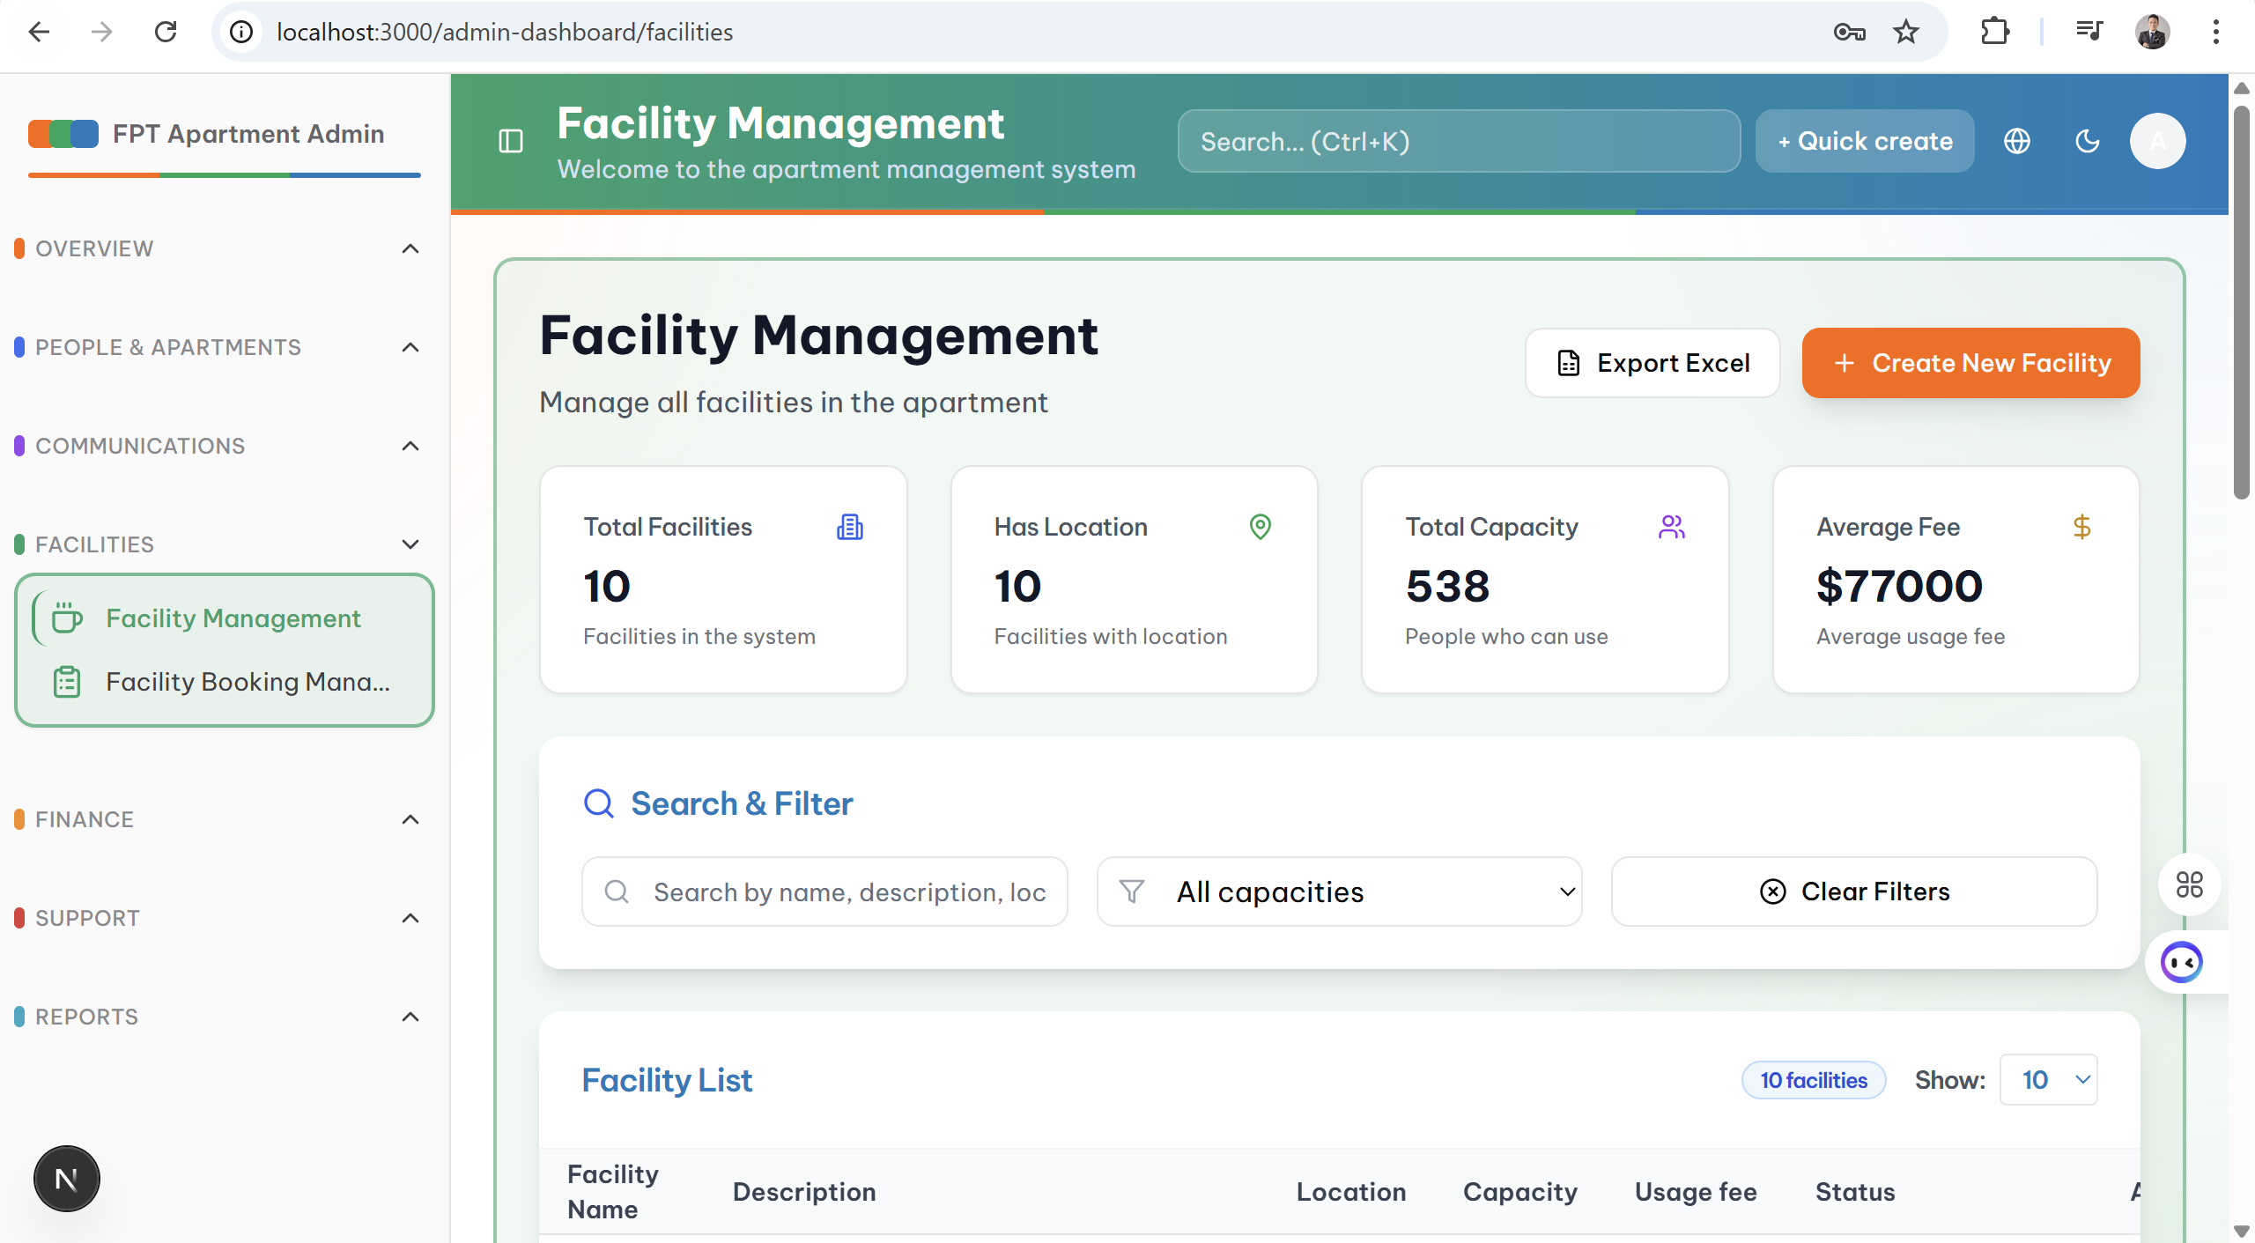

- **Layout:** Card layout with grid system

- **Components:**

* Grid cards showing facilities

* Modal form to add/edit facilities

* Calendar view for bookings

* Status indicators (available, maintenance, closed)

- **Features:** Manage maintenance schedules, update usage fees

#### **2.1.5 Invoices**

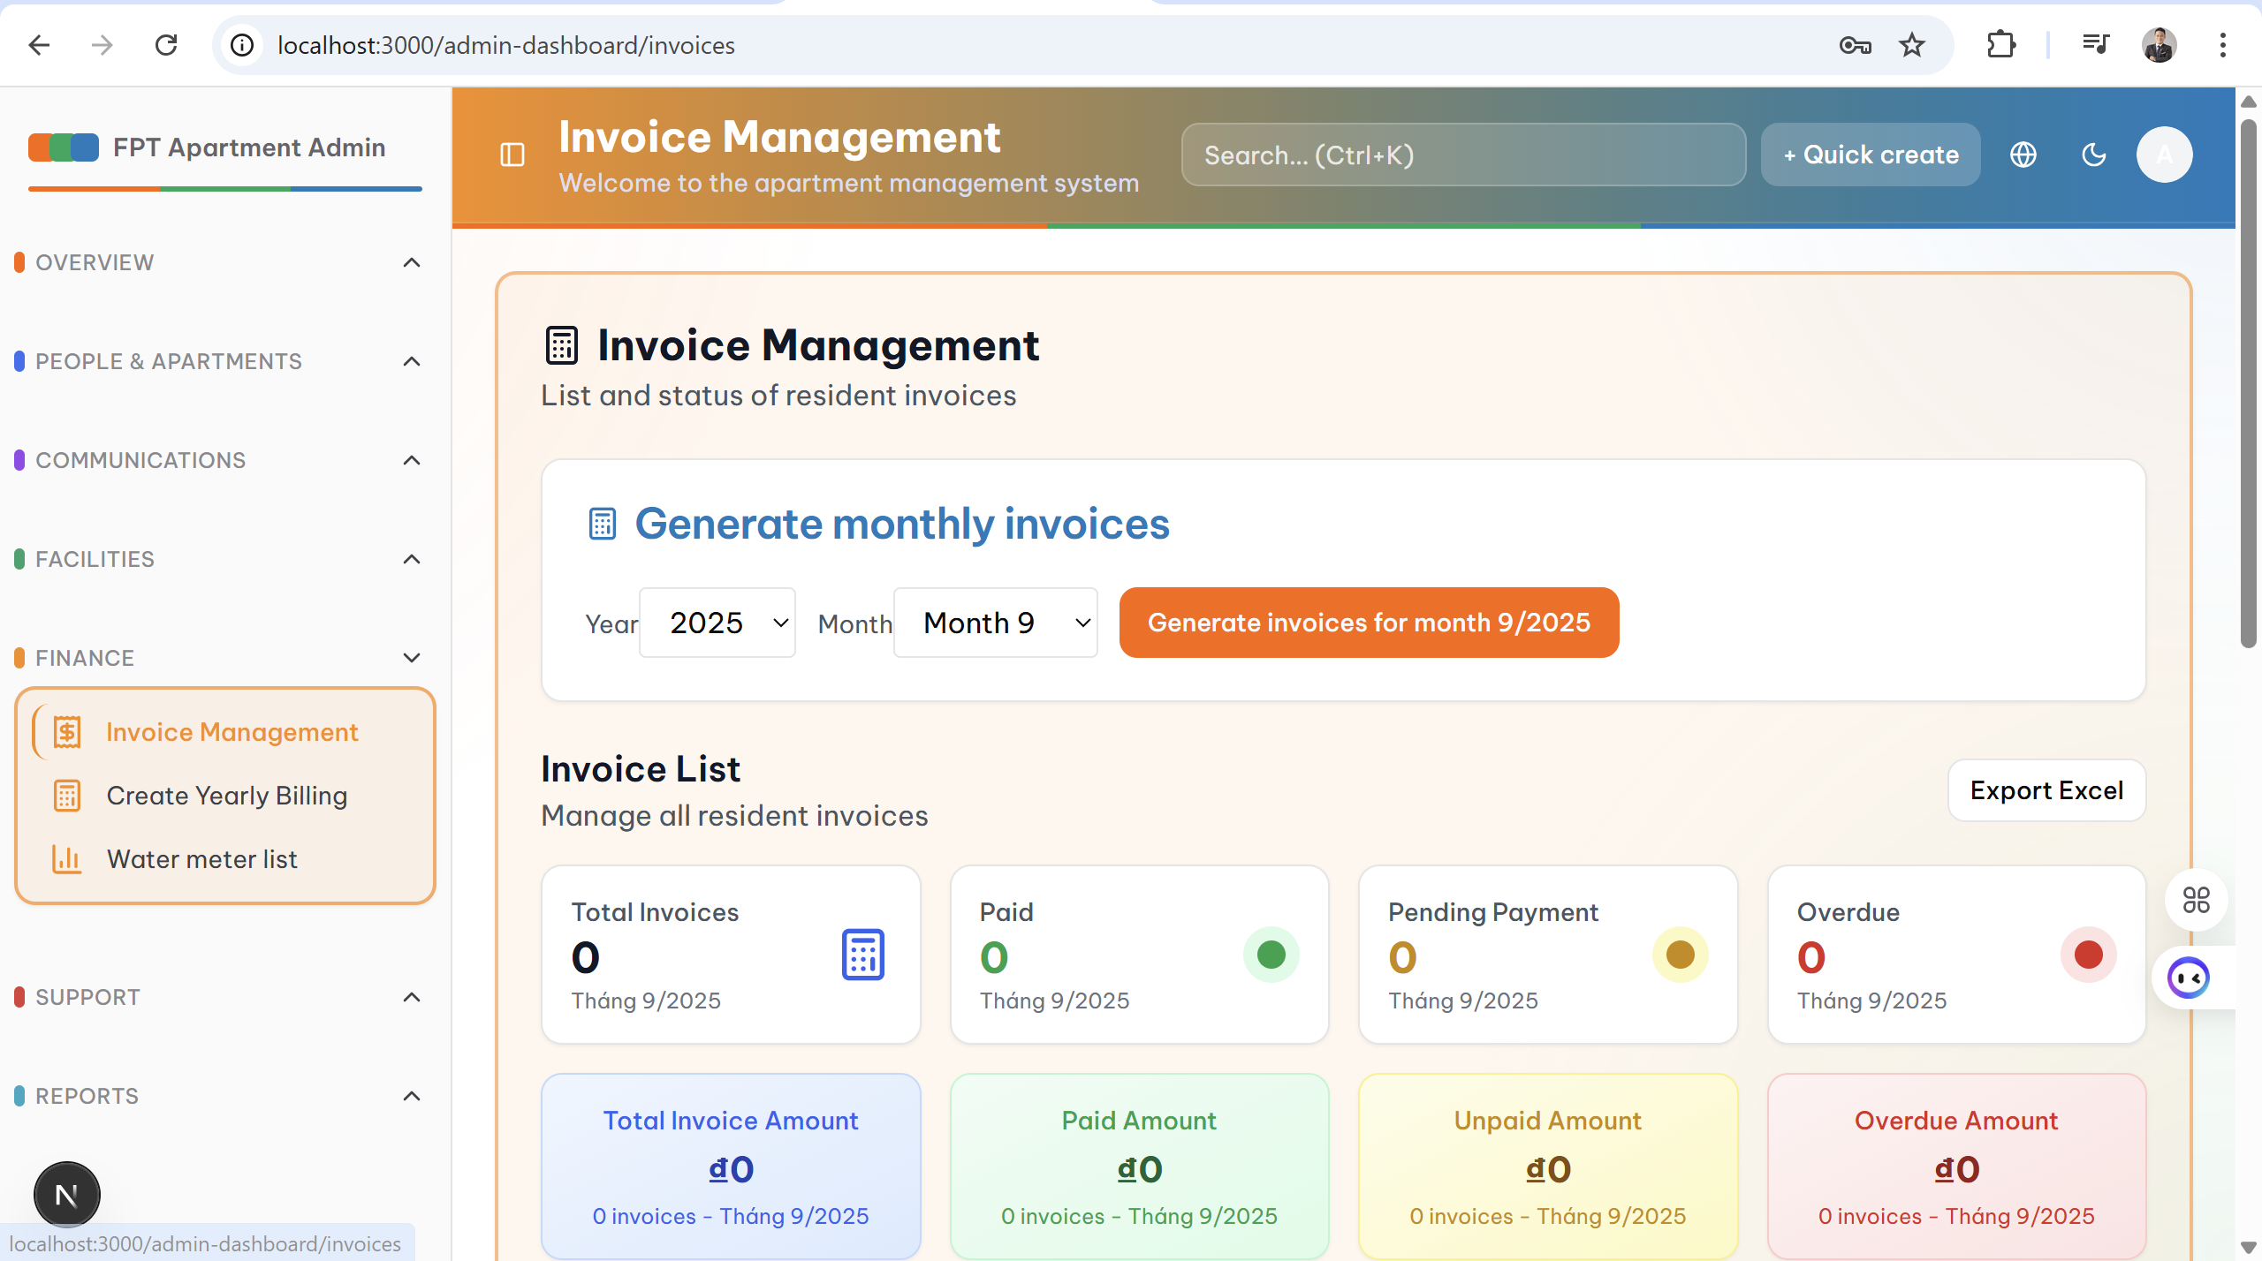

- **Layout:** Table layout with advanced filters

- **Components:**

* Filter panel: By month, status, apartment

* Data table with sortable columns

* Action buttons: View details, send email, print PDF

* Summary panel: Total invoices, total amount

- **Features:** Create manual invoices, send reminders

#### **2.1.6 Announcements**

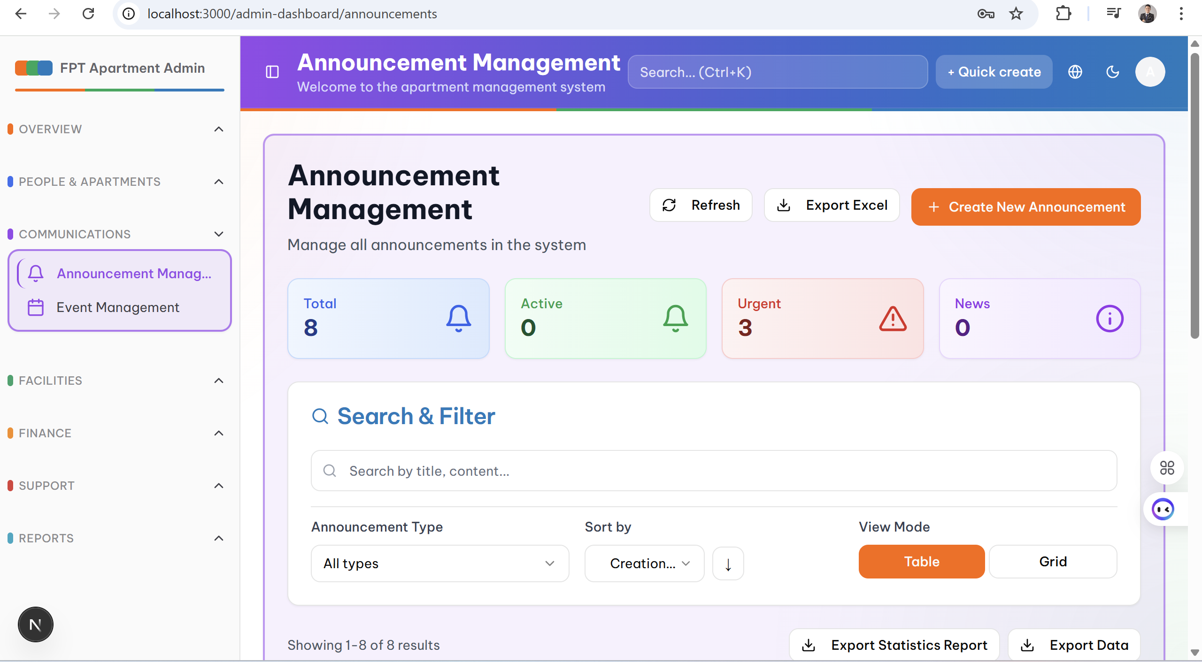

- **Layout:** List layout with timeline view

- **Components:**

* Form to create a new announcement

* Announcement list with priority indicators

* Preview panel for content

* Schedule panel for delivery time

- **Features:** Draft, schedule, target audience selection

### 2.2 Mobile App interface

#### **2.2.1 Login**

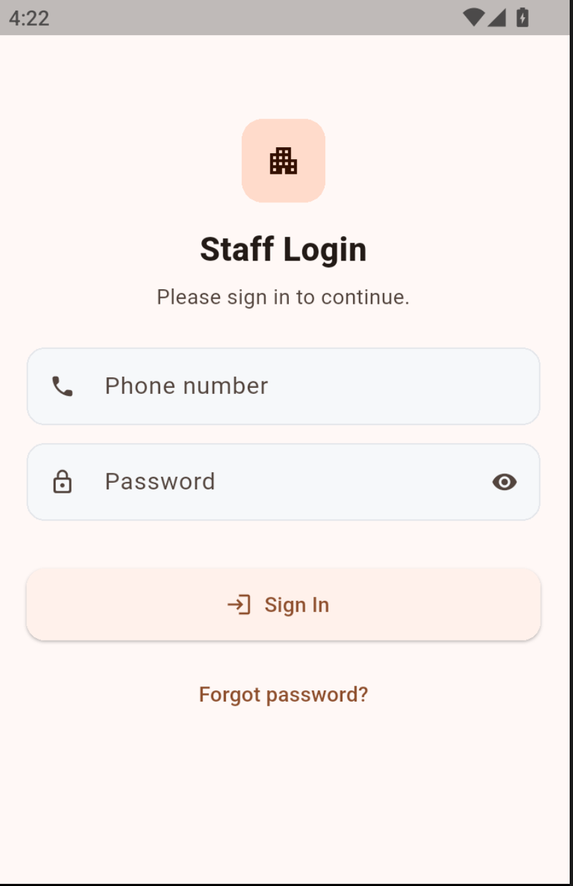

- **Layout:** Full-screen form with clean design

- **Components:**

* App logo and name at the top

* Input fields with Material Design

* Login button with loading state

- **UX:** Auto-fill, password visibility toggle, error handling

#### **2.2.2 Profile**

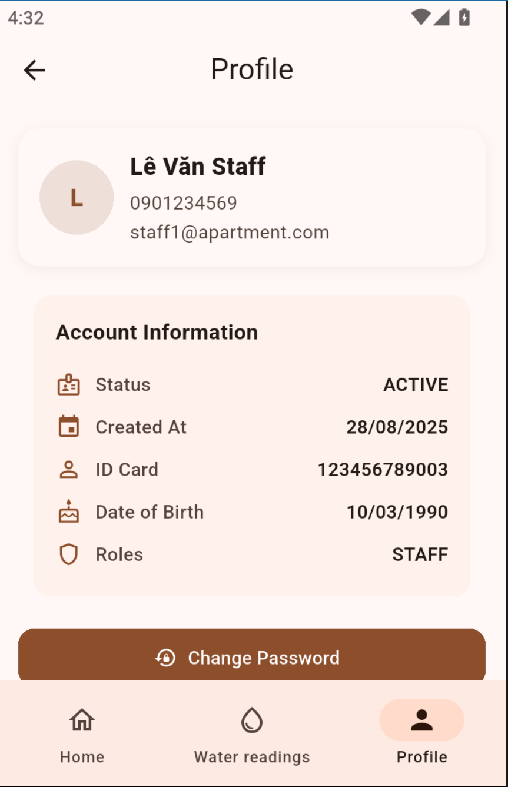

- **Layout:** Single-column layout with sections

- **Components:**

* Profile header with avatar and basic info

* Personal information section

* Apartment details section

* Settings section

* Logout button

- **Features:** Edit profile, change password, preferences

#### **2.2.3 Facility Booking**

- **Layout:** List + Calendar hybrid

- **Components:**

* Tab navigation: List view, Calendar view

* Facility cards with availability status

* Date picker for date selection

* Time slot picker for time selection

* Booking confirmation modal

- **UX:** Real-time availability, conflict detection

#### **2.2.4 Notifications**

- **Layout:** List layout with grouping

- **Components:**

* Notification list grouped by date

* Priority indicators (color coding)

* Swipe actions (mark read, delete)

* Pull-to-refresh

* Settings for notification preferences

- **Features:** Push notifications, in-app notifications

### 2.3 UI/UX principles

#### **2.3.1 Simplicity**

- **Minimalism:** Remove unnecessary elements

- **Clear hierarchy:** Use typography and spacing to structure content

- **Progressive disclosure:** Reveal information in stages

- **Consistent patterns:** Use consistent design patterns

#### **2.3.2 Consistency**

- **Design system:** Use design tokens for colors, typography, spacing

- **Component library:** Build a reusable component library

- **Icon system:** Use a consistent icon set

- **Color palette:** Apply a consistent color scheme across the app

#### **2.3.3 Responsive Design**

- **Mobile-first approach:** Prioritize mobile design first

- **Breakpoint system:** Use standard breakpoints (320px, 768px, 1024px, 1440px)

- **Flexible layouts:** Use CSS Grid and Flexbox

- **Touch-friendly:** Ensure minimum 44px touch targets

#### **2.3.5 Accessibility**

- **WCAG 2.1 compliance:** Follow accessibility standards

- **Keyboard navigation:** Support keyboard navigation

- **Screen reader support:** Compatible with screen readers

- **Color contrast:** Ensure sufficient color contrast

#### **2.3.6 Performance**

- **Fast loading:** Optimize page load time

- **Smooth animations:** Use CSS transitions and animations

- **Lazy loading:** Load data on demand

- **Caching strategy:** Apply caching for static assets